Social Studies 11: Canada and the Cold War
3 Canada and the Korean War 1950-1953 - Notes
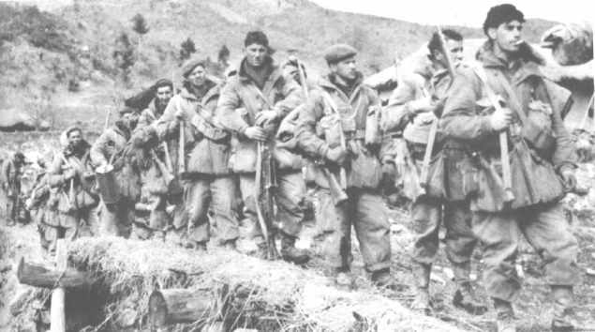  Canada’s Princess Patricia’s Light Infantry in the Korean War | Name: _______________________  Date:___________________________
Recommended Reading: Counterpoints p. 138-139 Spotlight Canada (3rd ed. 259-260 or 4th ed p. 294-295)
A. Background
1. What was the occupied condition of Korea at the end of WWII in 1945? Who “had” what?

2. When did North Korean Communist forces invade South Korea?

3. Who lead the UN response to this aggression?

4. Why did the Soviet Union not veto this UN resolution?

5. Who commanded this UN force? How many countries participated?

6. Why did the Chinese army get involved in the conflict? What provoked this involvement?

7. Why did President Truman recall (remove) General McArthur from command in Korea?

8. Where did the border stabilize in 1953 after three years of fighting?

B. Canada’s Contribution to the War
9. How many Canadians took part in the conflict?.

10. What was significant about the Canadian battle at Kapyong?

11. How many Canadians were killed in the war?

12. What was the end result of the war?



