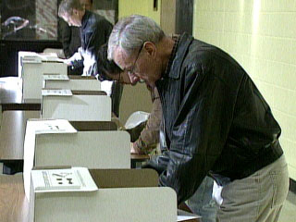 | Name: _______________________  Date:___________________________
INFLUENCING YOUR GOVERNMENT
Elections and Political Parties

I. POLITICAL PARTIES (Counterpoints p. 255-257)

Functions of Political Parties

- What is the purpose of a political party?

- What is the ideology of a political party?

- A candidate that does not belong to a party is called an _______________

- What is official party status? What main benefit of this status?

Political Influence, Media, and Protest

III. INFLUENCING GOVERNMENT (Counterpoints 258-264)
1. What is a pressure group? Think of and list two examples that are not found in the book.

2. Pressure groups can provide valuable information to government. What is the advantage of this situation? What is the disadvantage?

3. What is a lobbyist? How are they used by pressure groups?

4. How are courts used by pressure groups?

5. Read “Should Citizens Have More.......” on p. 262.
What is the Privy Council Office (PCO)?

What is the Prime Ministers Office (PMO)?

6. Describe a two ways in which mass media has a great influence on government.

7. “If the machinery of government is unjust, break the law. Let you life be a counter friction to stop the machine.” Who said this? When is it ever acceptable to break the law as a way of protesting government actions?

8. Martin Luther King Jr. and Mohandas Gandhi believed that civil disobedience should be guided by three principles. What are the three principles governing civil disobedience.
a.
b.
c.

9. Read the section in your chapter about Clayoquot Sound on page 267. What kind of tactics did the protesters use? Why do you think the penalties handed out to the arrested protesters were not harsh?

