THE EASTERN QUESTION
Confrontation in the Balkans
FOCUSING ON THE ISSUE
Events in the Balkans between 1911 and 1914 would set the stage for the First World War. How
did issues in the strategically important region of the Balkans bring the world to the brink of war?

A Vacuum of Power
At the start of the twentieth century the Ottoman Empire was in decline. By 1911 the great powers were eager to get their hands on key Ottoman territories. The strategic location of these lands, which included parts of the Balkan Peninsula and the area that is now Turkey, made them attractive to Russia, Austria, and Great Britain. The system of alliances, however, meant that all the European great powers would be affected by events in this region.
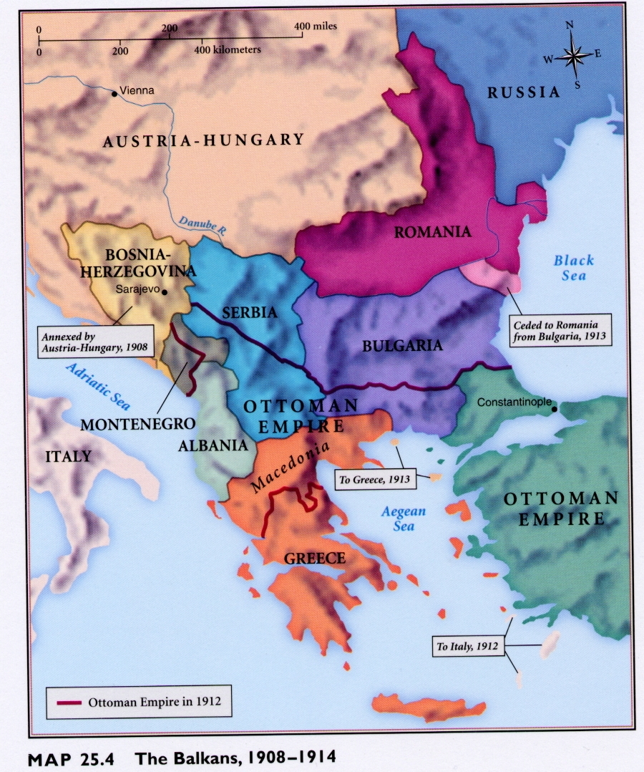
The decline of the Ottoman Empire could potentially create a vacuum of power. The problem of how to deal with this vacuum came to be known as the "Eastern Question." Russia wanted access to the Mediterranean via the Dardanelles, the waterway dividing Europe from Asia. Austria-Hungary wanted to expand its empire into the Balkans but did not want Russia to increase its influence in the region. Great Britain, fearful of Russian ambitions in the Middle East and Afghanistan, supported the Ottoman Empire, hoping to keep the Russians bottled up in the Black Sea. Germany was in the process of building a railway from Berlin to Baghdad to bypass the Suez Canal. Since the tracks would run through the Balkans, Germany wanted to maintain stability in the region.

The Balance of Power
Both Austria-Hungary and Russia took advantage of nationalist feelings among the various peoples of the Balkans. There was great resentment towards the Ottomans, who had ruled the region since the fifteenth century The Russians encouraged and supported the Slavic peoples—the Serbians and Bulgarians—with whom they shared a common religion and similar language. Austria-Hungary promoted the conflicts between the Slavic and non-Slavic peoples, especially the Greeks and Romanians. With Russian support, the Serbians and the Bulgarians were able to gain independence from the Ottoman Empire in the late nineteenth century. By 1901, Ottoman territory in the Balkans had been reduced to Macedonia and Albania in the south, and the provinces of Bosnia-Hercegovina in the north, administered for the Ottomans by Austria-Hungary
The "Young Turk" Revolution of 1908 gave new life to the dying Ottoman Empire, threatening Austria's interests in the Balkans.
When Austria decided to add Bosnia-Herzegovina to its empire, Russia agreed provided that Austria-Hungary supported opening the Dardanelles to Russian ships. Austria, however, jumped the gun by formally annexing Bosnia-Herzegovina in October 1908. This left Russia deeply humiliated and without international support for its plans to gain access to the Mediterranean. Even more upset were the Serbians, who threatened to invade Bosnia to "liberate" the region from Austrian oppression. Austria-Hungary vowed to destroy Serbia, and sought the support of Germany on this issue.
When Italy and Turkey went to war in 1911, the independent Balkan states saw this as an opportunity to drive the Ottomans out of Europe completely. In 1912, war broke out in the Balkans. Montenegro, Serbia, Bulgaria, and Greece quickly defeated the Ottoman Forces, capturing all of Turkey's European territory except Constantinople. Landlocked Serbia annexed Albania but was forced to give it up in 1913
under the terms of the Treaty of London, which ended the war. Serbian nationalists were outraged and demanded Russian assistance for the southern Slavs. Russia, seeking to avoid another humiliating blow to its prestige in the region, promised to back Serbia in any future conflict with Austria-Hungary.
A second Balkan war broke out in 1913, this time between Serbia and Bulgaria over disputed territory. Serbia and Greece declared war on the Bulgarians. They were soon joined by Romania and the Ottoman Empire. Bulgaria was swiftly defeated by this odd coalition, losing large amounts of its territory to the victors.
The Balkan Wars greatly affected the course of world history over the next two years. The wars had left the key Balkan region deeply divided and unstable. Serbia had emerged strong and ambitious, but with deep resentments. The peace settlements engendered fear and anti-Serbian sentiment in neighbouring Austria-Hungary. The dismantling of the Ottoman Empire and the weakening of Bulgaria had created dangerous tensions in southeastern Europe.
Interest in the region by the great powers remained focused. Austria-Hungary had obtained from Germany assurances that it would support Austria-Hungary in any future conflicts with Serbia. Russia, pledged to support Serbia, and reminded Great Britain and France of their alliance. The stage was now set for a much larger war should hostilities resume in the Balkans.

Name
The Eastern Question
1. The decline of which empire led to a Power Vacuum in the Balkan region?

2. Four world powers were trying to assert their influence in this region. This brought them into conflict with each other. What was each of these powers trying to accomplish?
a. Russia -
b. Austria Hungary -
c. England -
d. Germany -

3. Explain how Austria-Hungary and Serbia were in conflict with each other.

4. Why would the Serbian Nationalists be outraged that they had to give up Albania in 1913?

5. Why do the Russians agree to back the Serbians in future conflicts with Austria-Hungary (give multiple reasons)?

