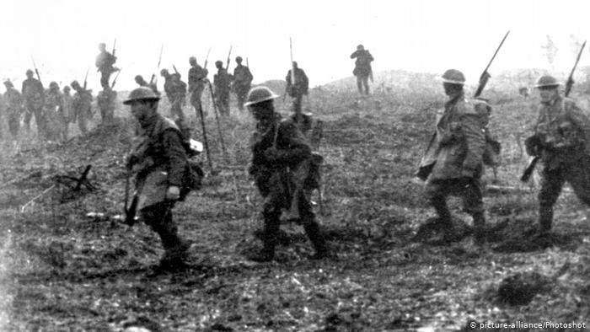 | Social Studies 10  Canada to 1919:  Key Canadian Battles of WWI

THESE NOTES CAN BE SUPPLEMENTED BY THE MATERIAL FROM Think History pages 33-35.

Key events
Oct. 14, 1914 - First contingent of the Canadian Expeditionary Force arrives in the UK.
April 24, 1915 - Poison gas first used against Canadians at St. Julien.
May 8, 1915 - Lt.-Col. John McCrae writes "In Flanders Fields."
July 1, 1916 - Royal Newfoundland Regiment takes heavy casualties in the Battle of the Somme.
April 9, 1917 - Battle of Vimy Ridge begins.
Aug. 29, 1917 - Conscription becomes law in Canada.
Dec. 6, 1917 - Halifax explosion.
Aug. 8, 1918 - Battle of Amiens. The period that came to be known as "Canada's Hundred Days" begins.

1915 – Ypres

The Salient (a bulge in the line of trenches) that formed around the town was held by British and Commonwealth troops during the next four years of war. In that time Ypres was to witness the first use of gas in warfare at the beginning of the Second Battle of Ypres in 1915 and the first use of flame-throwers at Hooge.

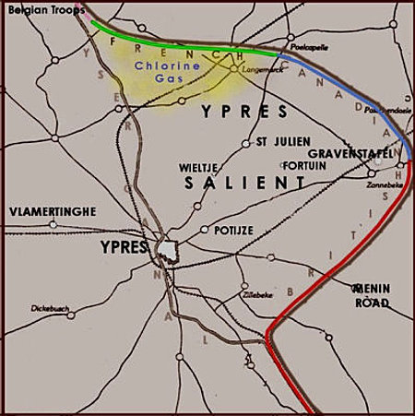
In the first week of April 1915 the Canadian troops were moved from their quiet sector to a bulge in the Allied line in front of the City of Ypres. This was the famed - or notorious - Ypres Salient, where the British and allied line pushed into the German line in a concave bend. The Germans held the higher ground and were able to fire into the allied trenches from the north, the south and the east. On the Canadian right were two British divisions, and on their left a French division, the 45th (Algerian).

Here on April 22 the Germans sought to remove the Salient by introducing a new weapon, poison gas. Following an intensive artillery bombardment, they released 160 tons of chlorine gas from cylinders dug into the forward edge of their trenches into a light northeast wind. As thick clouds of yellow-green chlorine drifted over their trenches the French defences crumbled, and the troops, completely bemused by this terrible weapon, died or broke and fled, leaving a gaping four-mile hole in the Allied line.

German troops pressed forward, threatening to sweep behind the Canadian trenches and put fifty thousand Canadian and British troops in deadly jeopardy. Fortunately the Germans had planned only a limited offensive and, without adequate reserves, were unable to exploit the gap the gas created. In any case their own troops, themselves without any adequate protection against gas, were highly suspicious of the new weapon. After advancing only two miles they stopped and dug in.
All through the night the Canadian troops fought to close the gap. In addition they mounted a counter-attack to drive the enemy out of Kitcheners' Wood, an oak plantation near St. Julien. In the morning two more disastrous attacks were made against enemy positions. Little ground was gained and casualties were extremely heavy, but these attacks bought some precious time to close the flank.

- 6,035 Canadian Casualties
- 2,000 Canadians Dead
Heavy losses from Canada's little force whose men had been civilians only several months before with no idea of fighting in a war - a grim forerunner of what was still to come.
John MacRae at Ypres
During the second battle of Ypres, the Canadian Army surgeon John McCrae wrote "In Flanders Fields" near here in 1915. The site of an Advanced Dressing Station, the surgeons' dug-outs can still be seen next to the cemetery.

1916 – The Somme (July 1 to November 18) and (March 21 – April 5, Aug 21 – Sept 5)

Canadian troops fought on the Somme in a series of battles that stretched from the last days of summer until winter's first wet snows. The broad objective of this campaign was to pierce the heavy defences that the Germans had been constructing in this area since the start of 1916. Cavalry would then be poured through the breaches to advance deep into German-held territory. Canadian infantry and artillery played major roles in these bloody, but inconclusive battles.
The year 1916 was the year of the battle of the Somme. But before the Canadians joined in that ill-fated operation they were engaged in local offensives, in the southern part of the Ypres Salient, intended to keep the Germans occupied.
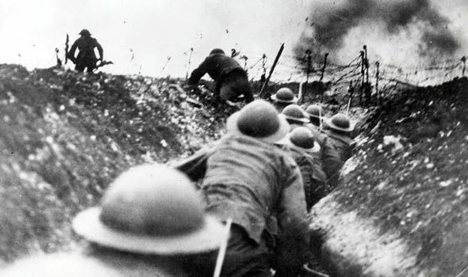
At the battle of St. Eloi the 2nd Division received its "baptism of fire" in a battlefield of water-filled mine craters and shell holes. The Canadians, wearing the new steel helmets which had just been introduced, suffered 1,373 casualties in thirteen days of confused attacks and counter-attacks over possession of six water-logged craters and the dominating land on which they sat.
In February the Allied scheme was upset when the German Chief of the General Staff, General Erich von Falkenhayn, seized the initiative. For his battlefield he chose the fortress-ringed city of Verdun, a position, he correctly believed, so essential to the French that France would fight to the last man to hold it.
He hoped to lure French forces into the narrow, dangerous salient, slaughter them with artillery fire, and thus "bleed France to death". He was the first commander to state clearly that the aim of an offensive was attrition - though he did not tell his field Army commander, the Crown Prince, this.
On February 21 the German barrage began and for the next ten months both sides threw soldiers and shells at each other in a nightmare of death. But the German army bled as well. As Verdun was a symbol of life for France, its fall became a moral necessity for the prestige of the German army. By Christmas, when the battle finally ended, casualties for both sides totaled 680,000, of whom some quarter of a million were killed.
During this holocaust of fighting, the French sent frantic appeals to Sir Douglas Haig, the new British commander, to hasten the Somme offensive and take the pressure off Verdun. With French forces being so thoroughly decimated at Verdun, the British now had to assume a far greater burden of the attack, so what was planned as a French dominated offensive in terms of manpower became a British dominated one.
The campaign was planned well in advance with a massive build-up of men and munitions. By the end of June all was ready for the "Big Push", and Haig was quietly confident that his planned assault would destroy the enemy lines and open the way for the cavalry to ride into open countryside and attack the German rear areas, battery positions, headquarters and communications. Meanwhile, the German army, long forewarned of the attack, had engaged in a massive restructuring of their defences, most especially in the northern area of the British attack. They were firmly entrenched along the ridges and the villages of the northern Somme countryside.
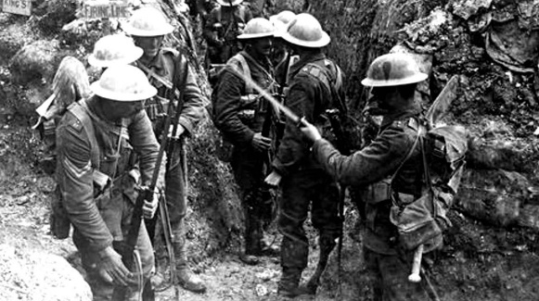
On July 1, at 7.30 a.m, at a time dictated by the French to allow their artillery observers clear views, thousands of Britsih and French troops began their advance across No Man's Land on a front of over forty kilometres towards the German positions The result was slaughter - 57,500 British soldiers killed, wounded or missing in one day - the heaviest day's combat losses ever suffered by the British army. At the end of the day the French had gained nearly all of their objectives as had the British divisions to the south; but for two thirds of the British sector almost nothing at all had been gained.
At Beaumont Hamel, the 1st Battalion of the Newfoundland Regiment, part of the 29th British Division, lost two thirds of its entire strength in about an hour's exposure to German artillery and machine guns. July 1 in Newfoundland is still a day of commemoration and mourning.

The Battle of the Somme was not a one day affair, and the fighting continued, notably with a largely successful dawn attack by the British on July 14, through the summer months. In late August of 1916, the "Byng Boys" moved from the muddy fields of Flanders to the Somme, where they took over a section of the front line west of the village of Courcelette. They ran into heavy fighting and suffered some 2,600 casualties before the full-scale offensive even got underway.
In the major offensive which began at dawn on September 15 the Canadian Corps, on the extreme left of the attack, assaulted on a 2,200 yard sector west of the village of Courcelette. Advancing behind a creeping barrage (a tactic which had recently been introduced by the British, a consequence of adequately trained gunners, more and better guns and more reliable ammunition), the infantry was aided by the "new engine of war", the armoured tank.
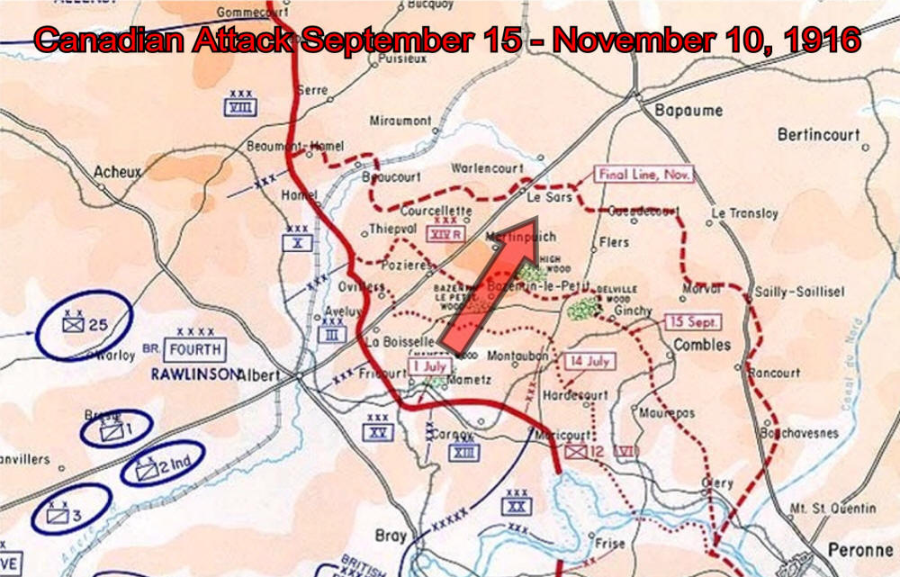
There were only a few of these and they were extremely unreliable and very vulnerable to artillery fire. However, at this early stage of the war their sheer presence often threw the enemy into confusion. The attack went well. By 8 a.m. the main objective, a defence bastion known as the Sugar Factory, was taken, and the Canadians pushed ahead to Courcelette. Numerous German counter-attacks were successfully repulsed and by the next day the position was consolidated. The enemy then brought up reinforcements, the fighting intensified, and gains became microscopic.
In the weeks that followed the three Canadian divisions again and again attacked a series of German entrenchments. The final Canadian objective was that "ditch of evil memory", Regina Trench. It repeatedly defied capture, and when the first three divisions were relieved in the middle of October, Regina Trench was closer, but still not taken.
When the newly arrived 4th Division took its place in the line it faced an almost unbelievable ordeal of knee-deep mud and violent, tenacious, enemy resistance. However, despite the almost impenetrable curtain of fire, on November 11 the Division captured Regina Trench - to find it reduced to a mere depression in the chalk. A week later, in the final attack of the Somme, the Canadians advanced to Desire Trench - a remarkable feat of courage and endurance. The 4th Division then rejoined the Corps opposite Vimy Ridge.
There were no further advances that year. The autumn rains turned the battlefield into a bog and the offensive staggered to a halt. The line had been moved forward only six miles, though ground of itself was not particularly important except in terms of morale.
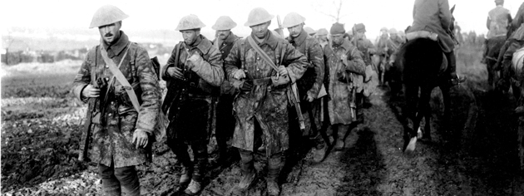
The Allies had suffered some 650,000 casualties, and both sides had about 200,000 killed. Well might the Germans refer to the Battle of the Somme as das Blutbad - the blood bath. One German officer described the Somme as 'the muddy graveyard of the German army'; for the British it turned an army of eager, inexperienced recruits into a fighting machine on a par with those of France and Germany, but at a terrible cost in human life.
The Somme had cost Canada 24,029 casualties, but it was here that the Canadians confirmed their reputation as hard-hitting shock troops. "The Canadians", wrote Lloyd George, "played a part of such distinction that thenceforward they were marked out as storm troops; for the remainder of the war they were brought along to head the assault in one great battle after another. Whenever the Germans found the Canadian Corps coming into the line they prepared for the worst."

1917 – Vimy Ridge (April 9-14)

The Battle of Vimy Ridge is one of the greatest battles in Canada’s history. For the first time in the Great War, all four Canadian divisions fought together on the same battlefield. Canadian valour and bravery brought about a fantastic victory, not only for Canadians but for the entire Allied force.

Canada casualties | 3,598  dead | 10,602  wounded

No Allied operation on the Western Front was more thoroughly planned than this deliberate frontal attack on what seemed to be virtually invincible positions. Vimy Ridge was so well fortified that all previous attempts to capture it had failed. However, Canadian commanders had learned bitter lessons from the cost of past frontal assaults made by vulnerable infantry. This time their preparations were elaborate. As the Canadian Commander of the 1st Division, Major-General Arthur Currie, said,"Take time to train them." This is exactly what the Canadian Corps did, down to the smallest unit and the individual soldier.
In the late autumn of 1916, the Canadians moved north, capping their ordeal on the Somme, to relieve British troops opposite the western slopes of Vimy Ridge. They spent the coldest winter of the war strengthening defences, carrying out increasingly frequent raids on enemy trenches and gathering intelligence, in preparation for the spring offensive. Continual raiding from mid-March on cost the Canadians 1,400 casualties. However, the knowledge gained would later help the Canadians take their Vimy objectives with lighter losses.
A full-scale replica of the battle area was laid out with reams of coloured tape and flags behind the Canadian lines. Here Canadian units carried out repeated exercises, rehearsing exactly what they would do throughout the day of the attack. Maps were given out to guide the smallest units. The troops were fully informed about their objectives and their routes.
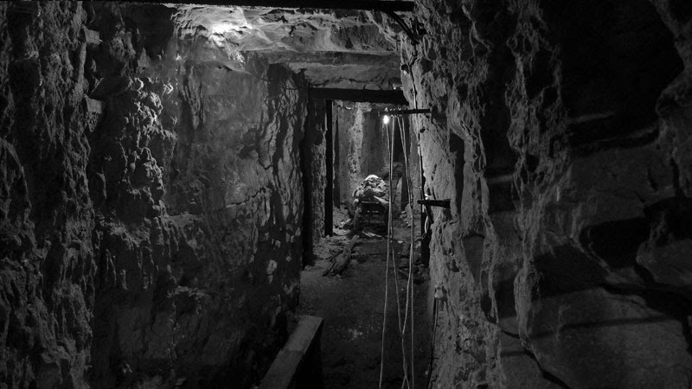
Military mining had long been a feature of war on Vimy Ridge. German, French and British engineers had dug many long tunnels under No Man's Land. They filled them with explosive charges, which blew up enemy trenches, leaving huge craters as new features of the landscape. Working at night, tunnelling companies used the existing tunnels to build a new underground network for the Vimy assault. As well, they dug 12 deep subways, totalling more than five kilometres in length, through which assault troops could move to their jumping-off points. The subways protected them from shelling and permitted the wounded to be brought back from the battlefield. Some subways were quite short, while one, the Goodman Subway, opposite La Folie Farm, was 1.2 kilometres long. All had piped water and most were lit by electricity provided by generators. They also housed telephone lines.
Into the walls of the subways were cut chambers for brigade and battalion headquarters, ammunition stores, communications centres and dressing stations. The largest of several deep caverns, the Zivy Cave could hold a whole battalion.
Smaller tunnels leading off the subways to the front line—saps they were called (the title, sapper, meaning military engineer or engineer private, derives from this term)—were sealed until Zero Hour and then blown out. At that point, the Canadians would push out to attack, right onto the battlefield.
The maze of tunnels and caverns was one of the most remarkable engineering feats of the war. The extensive underground network would reduce casualties amongst the advancing infantry and returning wounded, and enable supplies to be brought up under less hazardous conditions.
In addition to constructing this network, Canadian and British engineers repaired 40 kilometres of road in the Corps' forward area and added 4.8 kilometres of new plank road. They also reconditioned 32 kilometres of tramways, over which light trains, hauled by gasoline engines or mules, carried stores and ammunition.
The infantry assault was preceded by a massive artillery barrage, which began on March 20. This involved 245 heavy guns and howitzers, and more than 600 pieces of field artillery. Supporting British artillery added 132 more heavy guns and 102 field pieces. All this firepower amounted to one heavy gun for every 20 metres of frontage and one field gun for every 10 metres.
On April 2, the bombardment was stepped up. By the time the infantry set out, a million artillery shells had battered the Germans. One Canadian commented that shells poured over his head onto enemy positions "like water from a hose". More than 80 per cent of the German guns had been identified by aerial reconnaissance and by other spotting methods which Canadians had perfected. Few survived intact. The Germans called the period "the week of suffering." Trenches were shattered and a new artillery shell-fuse demolished many barbed-wire entanglements, thereby easing the Canadians' dangerous path to combat.
The impact of the air war was significant at Vimy. While aerial reconnaissance yielded valuable intelligence about enemy positions and artillery sites, fighter aircraft prevented the enemy from gaining a clear idea of Allied intentions. German observation aircraft and balloons were attacked and shot down. This work was important and dangerous—balloons were defended by fighters and anti-aircraft guns. The soon-to-be-famous Canadian fighter pilot, Billy Bishop, won the Military Cross on April 7 for shooting down a balloon near Vimy. He had begun his remarkable career in March.
At 5.30 a.m., April 9, 1917, Easter Monday, the creeping artillery barrage began to move steadily toward the Germans. Behind it advanced 20,000 soldiers of the first attacking wave of the four Canadian divisions, a score of battalions in line abreast, leading the assault in a driving north-west wind that swept the mangled countryside with sleet and snow. Guided by paint-marked stakes, the leading infantry companies crossed the devastation of No Man's Land, picking their way through shell-holes and shattered trenches. They were heavily laden. Each soldier carried at least 32 kilograms of equipment, plus, some say, a similar weight of the all-pervasive mud on uniform and equipment. This burden made climbing in and out of the numerous trenches and craters particularly difficult.
There was some hand-to-hand fighting, but the greatest resistance, and heavy Canadian losses, came from the strongly-emplaced machine-guns in the German intermediate line. Overcoming this resistance, three of the four divisions captured their part of the Ridge by midday, right on schedule. In the final stage, the 2nd Canadian Division was assisted by the British 13th Brigade, which fell under its command for the operation.
The 4th Canadian Division's principal objective was Hill 145, the highest and most important feature of the whole Ridge. Once taken, its summit would give the Canadians a commanding view of German rearward defences in the Douai Plain as well as those remaining on the Ridge itself.
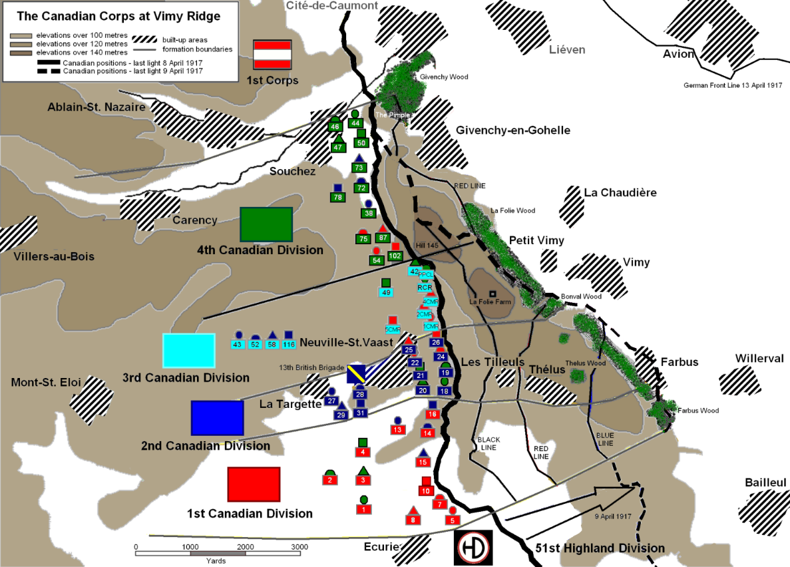
Because of its importance, the Germans had fortified Hill 145 with well-wired trenches and a series of deep dug-outs beneath its rear slope. The brigades of the 4th Division were hampered by fire from the Pimple, the other prominent height, which inflicted costly losses on the advancing waves of infantry. Renewed attacks were mounted using troops that were originally scheduled to attack the Pimple. Finally, in the afternoon of April 10, a fresh assault by a relieving brigade cleared the summit of Hill 145 and thus placed the whole of Vimy Ridge in Canadian hands. Two days later, units of the 10th Canadian Brigade successfully stormed the Pimple. By that time, the enemy had accepted the loss of Vimy Ridge as permanent and had pulled back more than three kilometres.
Vimy Ridge marked the only significant success of the Allied spring offensive of 1917. But though they had won a great tactical victory, the Canadians were unable to exploit their success quickly with a breakthrough, mainly because their artillery had bogged down and was unable to move up with them through the muddy, shell-torn ground. Instead, some Canadian artillerymen took over captured German guns which they had earlier been trained to fire.
The Canadian achievement in capturing Vimy Ridge owed its success to sound and meticulous planning and thorough preparation, all of which was aimed at minimizing casualties. But it was the splendid fighting qualities and devotion to duty of Canadian officers and soldiers on the battlefield that were decisive. Most of them citizen-soldiers, they performed like professionals.
Canadians attacked German machine-guns, the greatest obstacles to their advance, with great courage. They saved many comrades' lives as a result. Four won the Victoria Cross for their bravery in such dangerous exploits. Of these, three were earned on the opening day of the battle.
Private William Milne of the 16th Battalion won the VC when he crawled up to a German machine-gun that had been firing on the advancing Canadians, bombed its crew and captured the gun. Later, he stalked a second machine-gun, killing its crew and capturing it, but was himself killed shortly thereafter. The whereabouts of Private Milne's grave is unknown.
Lance-Sergeant Ellis Sifton of the 18th Battalion charged a machine-gun post single-handed, leaping into the trench where it was concealed and killing its crew. Soon after, he was met by a small party of Germans who were advancing through the trench. He managed to hold them off until his comrades arrived, but then one of his victims, gasping a last breath of life, fired upon him.
During the fight for Hill 145, Captain Thain MacDowell of the 38th Battalion entered an enemy dug-out, where he tricked 77 Prussian Guards into surrendering and captured two machine-guns by pretending he had a large force behind him. His large force consisted of two soldiers. MacDowell had earned the Distinguished Service Order on the Somme.
On April 10, Private John Pattison of the 50th Battalion jumped from shell-hole to shell-hole until, 30 metres from an enemy machine-gun, he was in range to bomb its crew. He then rushed forward to bayonet the remaining five gunners. Pattison was killed two months later.
Of the four Vimy VCs, only Captain MacDowell survived the War.
At Vimy, the Canadian Corps had captured more ground, more prisoners and more guns than any previous British offensive in two-and-a-half years of war. It was one of the most complete and decisive engagements of the Great War and the greatest Allied victory up to that time. The Canadians had demonstrated they were one of the outstanding formations on the Western Front and masters of offensive warfare.
Though the victory at Vimy came swiftly, it did not come without cost. There were 3,598 dead out of 10,602 Canadian casualties. Battalions in the first waves of the assault suffered grievously. No level of casualties could ever be called acceptable, but those at Vimy were lower than the terrible norm of many major assaults on the Western Front. They were also far lighter than those of any previous offensive at the Ridge. Earlier French, British and German struggles there had cost at least 200,000 casualties. Care in planning by the Corps Commander, Sir Julian Byng, and his right-hand man, Arthur Currie, kept Canadian casualties down.
The Canadian success at Vimy marked a profound turning-point for the Allies. A year-and-a-half later, the Great War was over. The Canadian record, crowned by the achievements at Vimy, won for Canada a separate signature on the Versailles Peace Treaty ending the war. Back home, the victory at Vimy, won by troops from every part of the country, helped unite many Canadians in pride at the courage of their citizen-soldiers, and established a feeling of real nationhood.
Brigadier-General Alexander Ross had commanded the 28th (North-West) Battalion at Vimy. Later, as president of the Canadian Legion, he proposed the first Veterans' post-war, pilgrimage to the new Vimy Memorial in 1936. He said of the battle:
"It was Canada from the Atlantic to the Pacific on parade. I thought then . . . that in those few minutes I witnessed the birth of a nation."

1917 – Passchendale (Oct. 12, Oct. 26- Nov. 10)
"The returning Canadians who fought at Ypres in 1915 and 1916 are shocked at the scenes in the salient. Everything is destroyed, nothing green remains. The dead of the earlier battles are everywhere and the ground is a maze of interconnected, water-filled shell holes. Canadian soldiers have heard rumours about the upcoming battle and are unnerved."

Canadian troops captured Belgium’s Passchendaele ridge, ending a gruelling offensive that had begun on July 31, 1917. The Battle of Passchendaele is remembered for its atrocious conditions, heavy casualties and Canadian valour. Canadians, instrumental in securing victory, earned a total of nine Victoria Crosses for their courage.
The Cost
- 4,028 Canadians Killed
- 15,654 wounded
Overview & Background
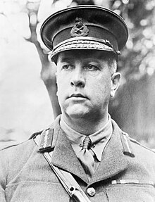
By the time the Canadians entered the battle on the Passchendaele Ridge, British and Australian troops had fought there for more than three months. Their efforts had been unsuccessful: 100,000 casualties for very little ground won. Strategy here had changed little from the time the Canadians had last battle at Ypres in 1916. The situation looked hopeless and Canadian Commander Sir Arthur Currie was reluctant to become involved. Although his objections were overruled by British Field Marshal Sir Douglas Haig, his reluctance won the Canadians a delay that allowed them to prepare for the battle.
The Objectives
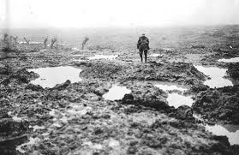
The Allies' objective in this battle was to break through the German defences, seize the highlands of Passchendaele Ridge and from there capture the German-occupied Belgian channel ports. These ports were important to the German strategy, as many of their deadly submarines operated from them. Once Passchendaele Ridge was captured, this high ground could be used to launch a decisive attack on the German-occupied channel ports.
At this time the only part of Belgium that remained in allied hands was a bulge of land around Ypres, known as the Ypres Salient. It was here that the allied forces launched their attacks. The Ypres Salient was one of the most dangerous places on the entire Western Front as it was vulnerable to German attack from its front or either side at any time; however the allies were intent on keeping this last bit of Belgium free and were prepared to defend Ypres at all costs.
To the south the French offensive on the Chemin des Dames under General Nivelle was a disaster - although some ground was gained, the results were nowhere near as good as Nivelle had promised. With losses in the neighbourhood of 200,000 men it precipitated a wave of mutinies which semi-paralyzed the French army for some months and generally made it only capable of defensive activity.

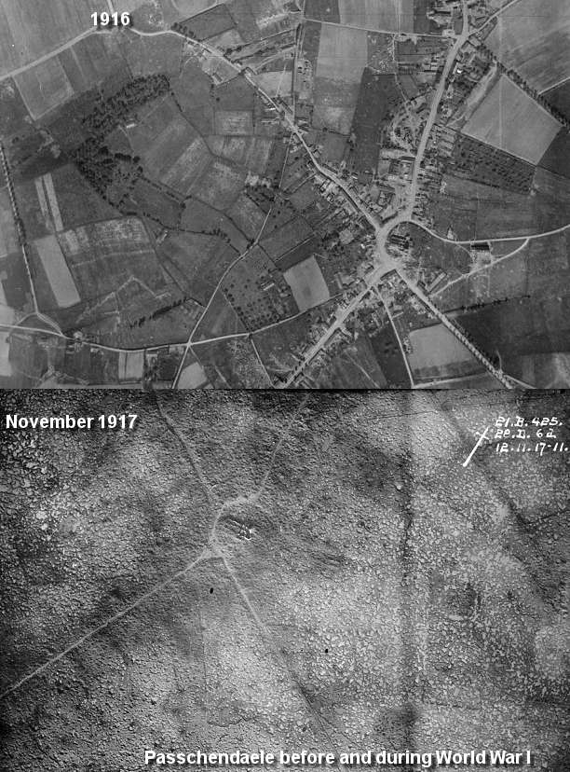
The Canadian Plan
The Canadian plan in taking Passchendaele was simple: they would attack in a series of battles, each with a limited objective. Step by step, they would take the village, the overall objective being to secure a defensible position on the Passchendaele Ridge. If successful, they would drive a thin wedge into the German positions, leaving them exposed to enemy fire from all directions.
A final note on the terrain: The Ypres Salient was utter desolation. The continuous bombardment and shelling of the area had destroyed the existing drainage system, and the heavy rains that lasted days on end had turned the entire salient into an oozing quagmire of yellow mud. In this terrain, it was impossible to dig trenches, so the Germans had devised a system of interlocking square rooms of reinforced concrete, called pillboxes.

Non-Canadian Battles:

Jutland: 1916
The greatest naval battle of the First World War. Jutland had all the ingredients to be a great British naval victory, but in the event the result was much less clear-cut.
The Germans lost one battle cruiser, one pre-Dreadnought, four light cruisers and five destroyers, while the British lost three battle cruisers, four armored cruisers, and eight destroyers. However, many of the surviving German heavy ships had suffered serious damage, and one result of the battle was to increase the British dominance in heavy ships.
Jutland was the last, and largest, of the great battleship battles. Neither submarines or aircraft played any part in the battle, despite the plans of both sides. Never again did battle fleets meet again in such numbers. While the Royal Navy suffered more loses, the battle effectively ended any threat from the German High Seas Fleet, which now knew it could not contest control of the North Sea with the Royal Navy.

