Ohm’s Law

Key Concepts
- I can describe how voltage, current, and resistance in a circuit are related by Ohm’s Law.

Ohm’s Law
- German physicist George Ohm studied the relationship among electrical potential difference, current, and resistance in electrical circuits
- discovered that when he raised the electrical potential difference and kept the resistance the same, the current increased

Ohm’s Law
The electrical potential difference between two points in a circuit is equal to the current times the resistance between those two points.
V=IR
V is the symbol for electrical potential difference, I is the symbol for current, and R is the symbol for resistance.

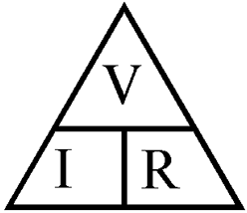
Cover the one you want to find.

Sample Problem
Imagine that you are testing an electrical toy. You are going to plug it into your home outlet, which provides an electrical potential difference of 120V. The wires are small and you do not want the current to go above 1.5A. How high must the resistance of the electrical toy be?

Further Questions
- A television that is plugged into a wall socket has an electrical potential difference of 120V. If a current of 1.25A is flowing through the television, what is its resistance?

- The filament of a flashlight bulb has a resistance of 40Ω. If a 6.0V battery is used in the circuit, what is the current?

- A circuit board has a resistance of 12Ω and requires a current of 0.25A. What electrical potential difference is required to operate the circuit board?

Assignment:
- Ohm’s Law Worksheet

