Cells, Conductors, and Insulators

Key Concepts
- I can describe how chemical energy separates electrical charges in cells.
- I can explain how charges can flow through conductors, but not through insulators.

Batteries, Cells, and Sources
- Source
- anything that supplies electrical energy
- Cells
- a device consisting of a positive and negative electrode connected by an electrolyte that converts chemical energy into electrical energy
- when the ends (terminals) of the electrodes are connected in a pathway or circuit, charges flow through it
- a dry cell contains a moist paste as an electrolyte
- a wet cell contains a liquid electrolyte
- most household cells produce 1.5 volts of electrical energy
- Battery
- two or more cells connected together

  AA cell | 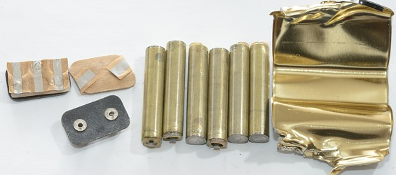  9V battery made up of 6 cells

How A Cell Works
- because opposite charges attract each other, it takes energy to separate positive and negative charges
- in a cell, chemical reactions separate the positive and negative charges
- since work went into separating the charges, the electrons now have the energy to do other work
- ex: run a fan or a watch
- the electrical energy now stored in the cell is a form of potential energy

Coulomb
- SI unit for measuring electrical charge
- equal to the charge of 6.24x10¹⁸ electrons

Electrical Potential Differences
- a measure of the difference in electrical potential energy per unit of charge (coulomb) between the positive terminal and the negative terminal in a cell
- electrons gain electrical potential energy (a charge) when they pass through a source such as a battery
- measured in volts (V)

Conductors and Insulators
- a conductor is any material that electrical charges can move through
- electrons can move through almost all metals
- but they move through some metals more easily than others
- conductivity refers to how easily charges move through a material
- an insulator is any material through which charges cannot travel
- most electrical wiring is made out of a conductor (copper) covered with an insulator (rubber or plastic)

Assignment
Page 216 Q1-2
Page 217 Q1
Page 227 Q1,2,7
Page 272 Q 10, 11
Booklet & Below
- Why is the electrical potential difference of a source referred to as a difference?
- Explain why electrical wire are covered by an insulator.

