Electric Charges

Key Concepts
- I can describe that electrons carry a negative charge and protons carry a positive charge.
- I can describe that opposite charges attract each other and like charges repel each other.

Charges
- negative charges the charges of electrons
- positive charges the charges of protons
- electrons can be rubbed off because they surround the nucleus and some are not tightly bound to it

Electrically Neutral and Electrically Charged Materials
- Electrically Neutral Materials
- uncharged materials
- objects that have equal numbers of positively charged protons and negatively charged electrons
- the equal numbers of positive and negative charges cancel each other out
- the materials are electrically neutral
- Electrically Charged Materials
- a material or object that is electrically charged has an unequal number of positive and negative charges
- when two objects are rubbed together electrons may be rubbed off one material
- if electrons are rubbed off a material it becomes positively charged
- the material that gains electrons becomes negatively charged
- charging a material by rubbing is called charging by friction
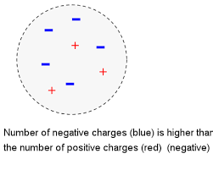
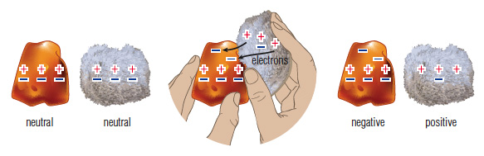

Law of Electric Charge
- Opposite charges attract each other.
- Like charges repel each other.
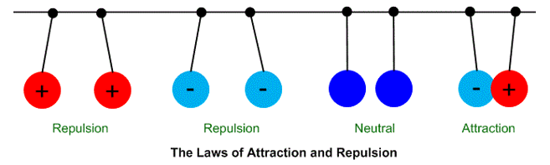

Attraction Between Charged Objects and Neutral Objects
- neutral objects have an equal number of protons and electrons or an equal number of positive and negative charges
- when you bring a negatively charged object near a neutral object
- the electrons in the neutral object are pushed away leaving a positively charged surface
- objects are attracted to each other
- when you bring a positively charged object near a neutral object
- the electrons in the neutral object are attracted creating a negatively charged surface
- objects are attracted to each other

Assignment:
- Pg. 209 #1-5
- Pg. 272 #5-9,13

Additional Assignment
- Explain the relationship among negative charges, positive charges, electrons, and protons.
- You have two objects. One is neutral and one is negatively charged. Use sentences and sketches to compare the numbers of positive and negative charges in each of these objects.
- You have four different materials labelled A, B, X, and Y. After you rub A and B together, they attract each other. After you rub X and Y together, they attract each other. Now you bring A near to X and observe that they attract each other. What would happen if you brought B near to Y? Explain your reasoning.

