Generating Electrical Energy

Key Concepts
- I can describe how electrical energy is generated in different ways from different sources.

Kinetic Energy to Electrical Energy
- most electrical energy in Canada is generated by transforming kinetic energy into electrical energy
- kinetic energy – the energy an object has due to its motion
- energy in motion
- sources of kinetic energy are water or wind
- electrical energy is generated by converting this kinetic energy using a generator system

Generator System
- three parts
- Turbine
- steam, water, or wind cause the turbine to spin
- Shaft
- connects the turbine to the generator
- as the turbine spins, it makes the shaft spin
- Generator
- the kinetic energy of the spinning shaft is transformed into electrical energy
- the shaft turns a wire loop or coil surrounded by a magnet
- this causes electrons to move back and forth = electrical energy

Typical Generator Systems
- Hydroelectric
- water stored behind the dam has potential gravitational energy
- as is flows downhill, the potential energy is converted into kinetic energy
- kinetic energy turns a turbine connected to a generator
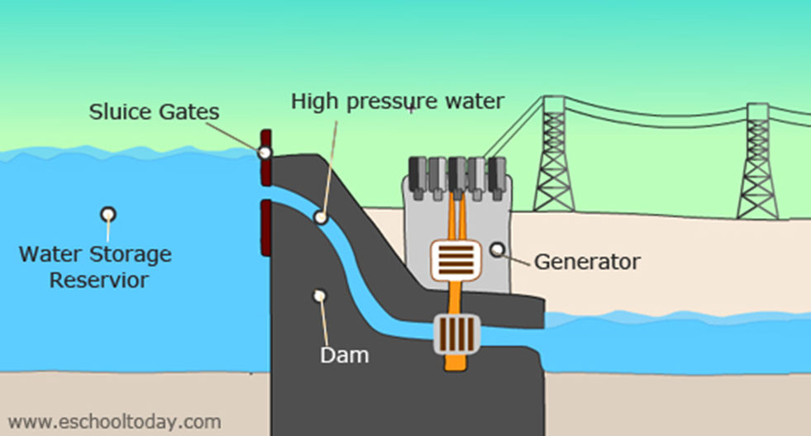
- Fossil Fuels
- coal or natural gas is burned producing thermal energy that is used to boil water into steam
- pressurized steam is used to turns the blades of a turbine connected to generator
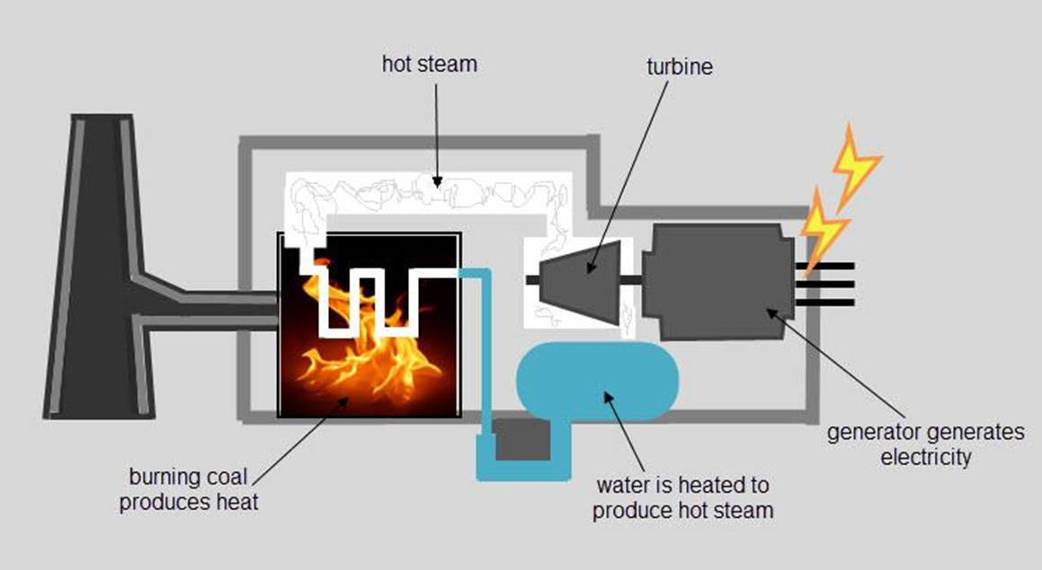

- Nuclear Reactions
- uranium or plutonium atoms undergo fission (splitting) reactions
- splitting one atom sets off a chain reaction that causes more atoms to split
- creates large amount of thermal energy which is used to boil water into steam
- 1 kg of uranium = 14,000 kg of coal
- pressurized steam turns a turbine connected to generator
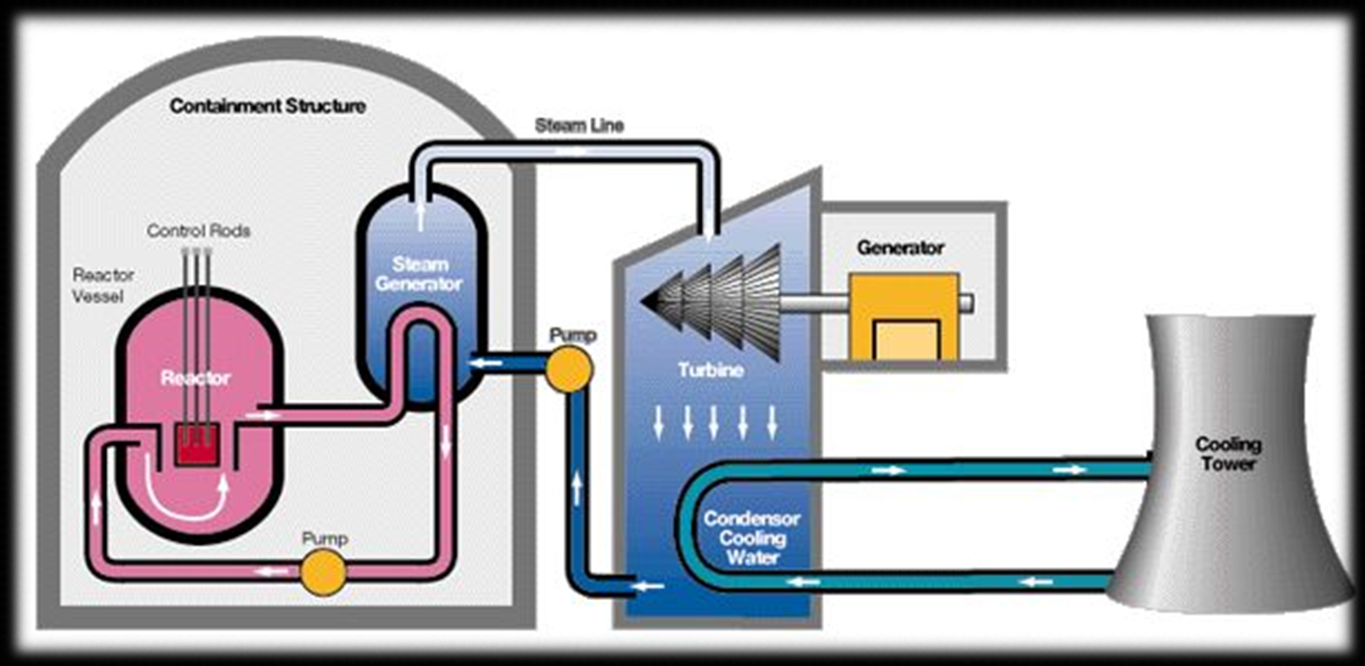

- Electrical Energy from Wind
- kinetic energy of wind is used to turn a turbine
- requires a wind speed of about 13 km/h
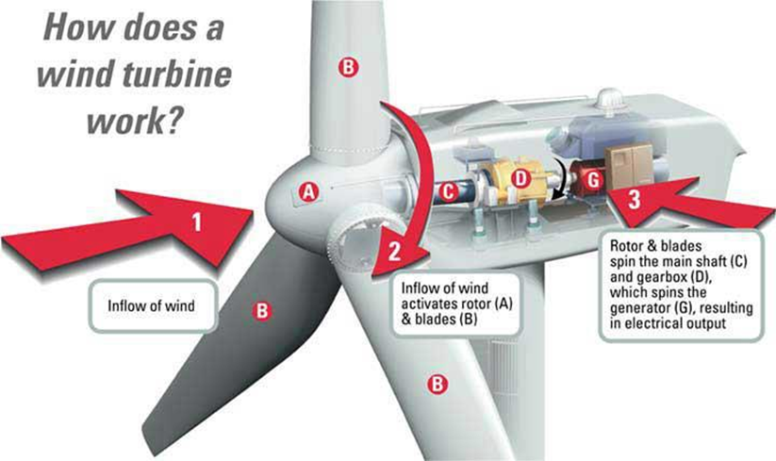

- Geothermal Energy
- uses internal heat of the Earth to boil water into steam which is used to turn a turbines
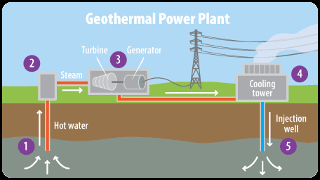

- Waves
- the vertical fall and rise of the waves captured by buoys or other devices drive hydraulic pumps which spins a turbine

- Tides
- tides can spin turbines to produce electrical energy
- locations where tidal water moves into constricting channels are very good for this (Bay of Fundy)

- Sunlight
- photovoltaic cells made of thin layers of silicon crystals produce electrical energy when they are exposed to light
- when visible light strikes the electrons trapped in the cells, the electrons absorb enough energy to flow freely and generate electrical energy

Assignment
Answer the following questions on a separate sheet of paper.
- List the three key parts of a generator system. Briefly describe their functions.
- Use a flowchart to explain how water can generate electrical energy.
- Name two places in Canada in which a tidal generating system would be a good choice for the community. Briefly explain why.
- Name two places in Canada in which a wind turbine generating system would be a good choice for the community. Briefly explain why.
- A generating system is sometimes referred to as simply a generator. Why is this technically incorrect?
- Consider the terms nuclear fission and nuclear fusion.
  - How do these two nuclear reactions differ?
  - Which is currently used to generate electrical energy in Canada?
- Your family is trying to decide whether to install photovoltaic cells on your roof.
  - Identify one benefit or installing photovoltaic cells.
  - Identify one problem related to installing them.
  - Describe what other factors you would take into account when choosing whether to install this technology.
  - Many provinces offer subsidies that help homeowners pay for renewable energy technology they install in their homes. Others buy back excess electrical energy produced by the consumer. Do you think these programs will increase the number of people using this technology? Would it influence your decision? Explain.

