Energy Transfer In The Biosphere

Key Concepts:
- I can explain how energy enters the biosphere through the Sun.
- I can explain how energy moves within the biosphere.

How does energy enter the biosphere?
- energy enters the biosphere when producers use solar energy for photosynthesis
- solar energy is converted into chemical energy when plants use it to convert water and carbon dioxide into glucose (sugar) and oxygen
- include plants, photosynthetic bacteria and photosynthetic protists (phytoplankton)
- matter and energy are transferred between trophic levels within the biosphere
- a trophic level is a category of organisms that is defined by how the organism gains energy
- 4 Trophic Levels
- Primary Producers
- first trophic level
- organisms that can make their own food
- examples: plants and phytoplankton
- Primary Consumers
- second trophic level
- living things that eat producers
- examples: deer and seed eating birds
- Secondary Consumers
- third trophic level
- feed on primary consumers
- examples: wolves and snakes
- Tertiary Consumer
- fourth trophic level
- feed on secondary consumers
- examples: bald eagles and killer whales

- some organisms can exist on more than one trophic level
- example: a grizzly bear can be a
- primary consumer – eats berries
- secondary consumer – eats deer
- tertiary consumer – eats salmon

Food Chains
- a model that describes how food energy is passed from one living thing to another
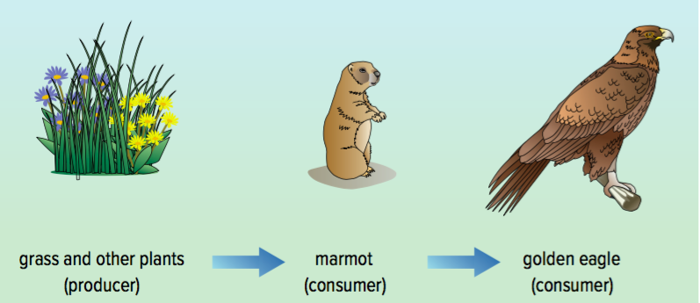

- three trophic levels in the food chain above
- first trophic level primary producers grass and other plants
- second trophic level primary consumer marmot
- third trophic level secondary consumer golden eagle
- both energy and matter, including nutrients, move through the trophic levels of this food chain
- all the levels of this food chain are linked to decomposers
- a separate trophic level
- living things that break down dead organic material
- move the nutrients in the decaying bodies and wastes of producers and consumers back to the abiotic parts of the ecosystem

- Other Terminology
- herbivore – consumers that only eats plants
- carnivores – consumers that only eat other consumers
- omnivores – consumers that eat both producers and other consumers
- detrivores – organisms that feed on dead organic matter (plant or animal)

Food Webs
- a model of feeding relationships that shows a network of interacting and overlapping food chains
- show that all organisms in an ecosystem are connected and depend on each other for survival
- show how a change in the numbers of one organism could affect several food chains in the food web

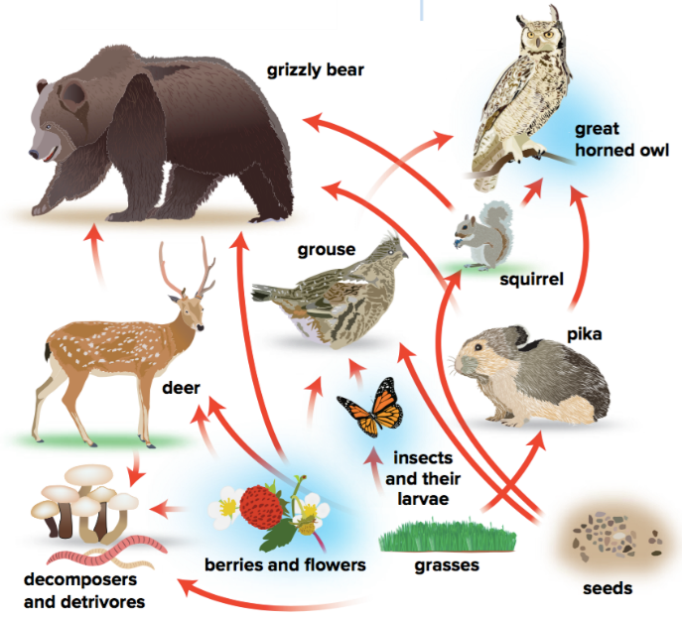

Question Set
Using the food web shown above:
- Name two producers.
- Name two primary consumers.
- Name two secondary consumers.
- Name one tertiary consumer.
- Write out a food chain that identifies the grizzly bear as a:
- Primary Consumer
- Secondary Consumer
- Write out a food chain that identifies the great horned owl as a:
- Secondary Consumer
- Tertiary Consumer

