Sun’s Influence on Earth
Key Concepts:
- I can explain what happens to solar energy that reaches the Earth.
- I can explain how uneven warming of the Earth’s surface results in global winds and currents that redistributes thermal energy around the Earth.
- I can explain how ocean currents redistribute thermal energy around the Earth.

Solar energy that reaches Earth is absorbed and reflected.
Earth’s Surface
- some areas of the Earth absorb solar energy and other areas reflect solar energy
- heat reflection – snow, ice and sand (deserts)
- heat absorption – forests and oceans

Earth’s Atmosphere
- some of the gases in the atmosphere trap solar energy
- some absorb solar energy
- some prevent reflected solar energy from the Earth’s surface from escaping
- called greenhouse gases
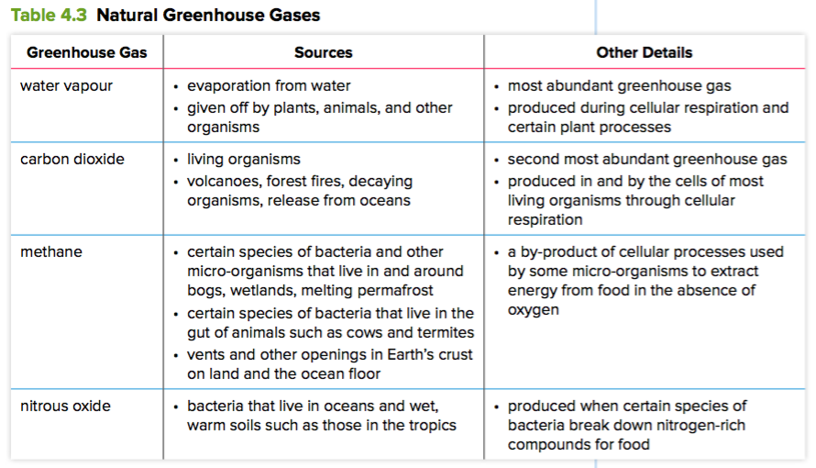
- greenhouse gases can also be released into the atmosphere from human activities
- carbon dioxide – released when fossil fuels (oil, natural gas, coal) are burned
- nitrous oxide – spray fertilizer applied to crops
- methane – released in large amounts by herds of cattle
- without greenhouse gases, Earth’s temperatures would average less than 0°C
- excess release of greenhouse gases impact Earth’s climate

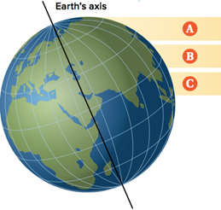
Wind Systems
- caused by the uneven heating of the Earth’s surface
- because the Earth is spherical, solar energy strikes the Earth at different angles
- Equator – more direct solar energy so more energy is absorbed
- Poles – more angled so more energy is reflected
- causes the atmosphere to heat up unevenly
- uneven heating results in pressure differences in the atmosphere
- cause the movement of air, or wind, worldwide
- wind redistributes thermal energy around Earth

- Global Wind Systems
- result of convection currents and the Coriolis effect
- Coriolis effect
- a change in the direction of moving air or water due to Earth’s rotation
- any location at the equator travels much faster than a location at either pole
- causes the air at the equator to move faster
- warm air rises at the equator and moves north or south
- cooled air sinks at 30° N and S pushing surface air north and south
- warmed air at 60° N and S rises
- cooled air sinks at 90° N and S
- creates three major wind patterns in each hemisphere

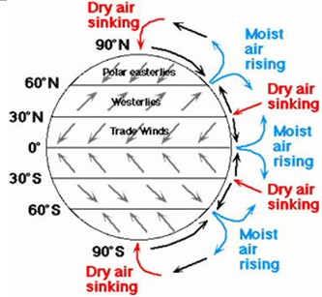
- Trade Winds
- between 0° and 30°
- wind feels like it is moving from the east

- Westerlies
- between 30° and 60°
- wind feels like it is moving from the west
- steady winds that move much of the weather across North America

- Polar Easterlies
- between 60° and 90°
- wind feels like it is moving from the east
- starts to move cold air from polar regions back toward equator

- Jet Streams
- narrow bands of fast-moving wind
- caused by large temperature gradient in upper-level air combined with the Coriolis effect results in strong westerly winds
- position of a jet stream varies with the seasons

Ocean Currents
- ocean currents also move thermal energy around Earth
- Surface Currents
- created by wind
- warm currents move warm water from the equator towards the poles
- cold currents bring cold water from the poles to tropical regions
- Southern Hemisphere – westward winds produce the world's largest current, called the Antarctic Circumpolar Current
- Gulf Stream – warm current that moves north through the Caribbean Sea and Gulf of Mexico, then along the east coast of North America and across to England
- Kuroshio Current is a warm current that flows north along the east coast of Asia and then towards North America as the North Pacific Drift
- Deep-Water Current
- called the Great Ocean Conveyor Belt
- a massive system of deep-water currents that moves deep water, thermal energy, and nutrients around Earth
- caused by:
- temperature
- cold water is more dense and sinks
- warm water is less dense and rises
- salinity
- saltier water is more dense and sinks
- less salty water is less dense and rises
- cycles deep ocean nutrients up to the surface


