Earth’s Spheres are Interconnected

Key Concepts:
- I can describe how sustainability ensures balanced, healthy systems now and for the future.
- I can explain how being a scientifically literate citizen matters to me both locally and globally.

Parts of the Environment
- Biotic
- living parts of an environment
- include plants, animals, and micro-organisms
- Abiotic
- non-living parts of an environment
- include water, oxygen, light, nutrients, and soil
- biotic and abiotic parts of the environment are connected through the ways in which they interact with one another

Earth’s Spheres
- Atmosphere
- gaseous part of Earth up to 100 km high
- Troposphere (0 – 20 km) – layer in which life exists and weather patterns form
- Stratosphere (20 – 50km) – layer that contains the ozone layer
- Geosphere
- also called the lithosphere
- solid, rocky part of Earth
- Hydrosphere
- all the water (liquid, solid, gaseous) on and within the geosphere
- Biosphere
- all the areas in the geosphere, atmosphere, and hydrosphere that are inhabited by and support life

- at any time, matter occupies one of Earth’s four spheres
- natural processes move matter in cycles from the biotic and abiotic parts of the environment
- Earth’s spheres interact with and affect each other in different ways
- Example: Landslides
- occur when soil and rock from the geosphere are pulled downward by gravity
- affects the biosphere since they can cause habitat loss

Sustainability ensures balanced systems now and for the future.
- ecosystems provide services that all living things depend on
- Ecosystem Services
- the benefits that organisms receive from the environment and its resources
- examples:
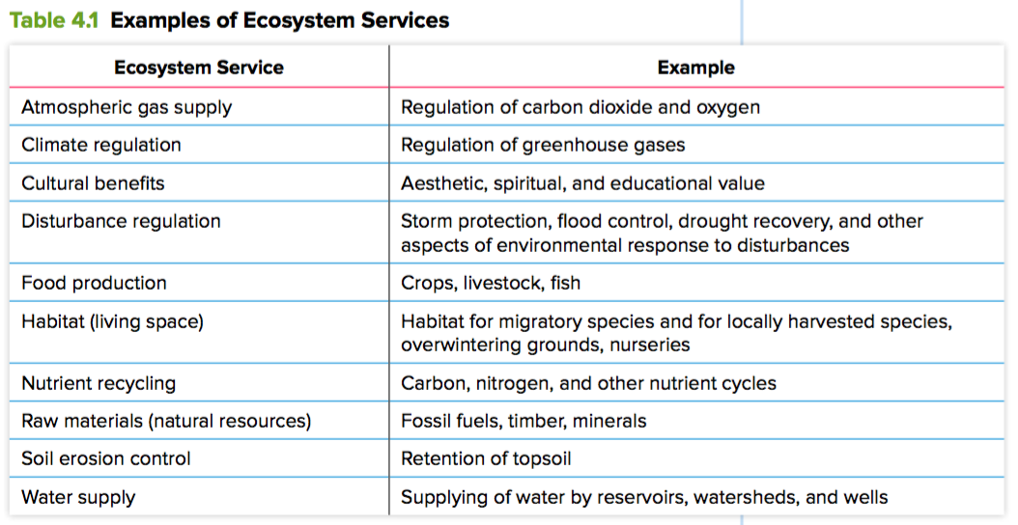

- Ecosystem
- includes all the interacting parts of a biological community and its environment
- includes all biotic and abiotic parts
- all living things require the abiotic parts of ecosystems to survive

Ecosystem Interconnectedness
- belief that not only are the components of an ecosystem interconnected, but that all ecosystems are also interconnected
- this idea is at the heart of many First Peoples beliefs
- growing belief among other societies since the modern environmental movement began in 1970 with the first Earth Day
- challenged the prevailing paradigm or thought of infinite development and growth
- a new mindset that sees our planet and all its human and non-human inhabitants, as well as its resources, as a single interconnected whole
- a shift toward an awareness and embrace of sustainability

Importance of Scientifically Literacy
- enables a person to make their own informed decisions
- promotes recognition and evaluation of bias in sources of information
- Personal Bias
- a judgement that is based on a person’s knowledge, understanding and beliefs
- Information Bias
- presenting information to lead others to a desired belief
- Example: Both photos show open-pit mining in Fort McMurray, AB. Which photo do you think would be used by a person who is against the processing of Alberta’s oil resources?


