Covalent Compounds

Key Concepts
- I can describe how covalent compounds are made up non-metal atoms.

Covalent Compounds
- a compound that results when atoms of two or more non-metal elements share electrons
- Covalent Bond – a strong attraction between atoms that forms when atoms share valence electrons
- sharing of electrons results in all atoms having a full valence shell
- a covalent bond is the result of a single pair of shared electrons

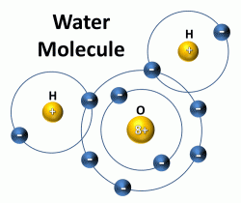

Properties of Covalent Compounds
- low melting and boiling points
- covalent bonds are relatively weak so little energy is needed to overcome the attraction between the molecules
- relatively soft
- compared to ionic compounds, it is easier for molecules to shift and move relative to one another
- poor conductors
- covalent compounds do not have free electrons or ions and are relatively poor conductors of electric current and heat

Diatomic Elements
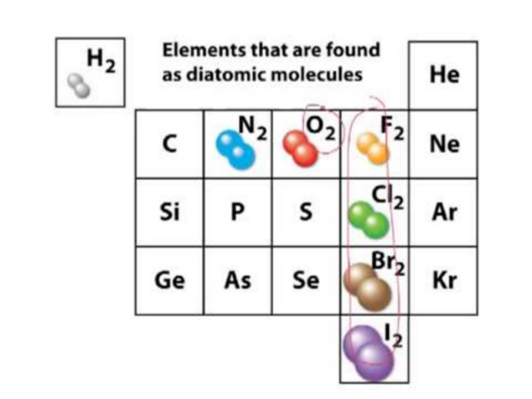
- elements in their natural form that form pairs of atoms held together by with a covalent bond
- seven elements – H₂, N₂, O₂, F₂, Cl₂, Br₂, I₂

Network Solids
- compounds and non-metal elements that contain covalent bonds that connect their atoms in one large network
- essentially, they are one giant molecule
- example: carbon in the form of diamonds

Assignment:
- Page 149 #1-3
- Page 151 #5-9

