Ionic Compounds

Key Concepts
- I can explain why compounds account for the huge variety of matter on Earth.
- I can explain how ionic compounds are formed.

Ionic Compounds
- a compound made of oppositely charged ions (positive and negatively charged ions)
- Ionic Bond – a strong attraction that forms between oppositely charged ions

Formation of Ionic Compounds
- simplest types of ionic compounds are made up of two elements: a metal and a non-metal
- called binary ionic compounds
- form when atoms of the metal element each lose one or more electrons to atoms of the non-metal element
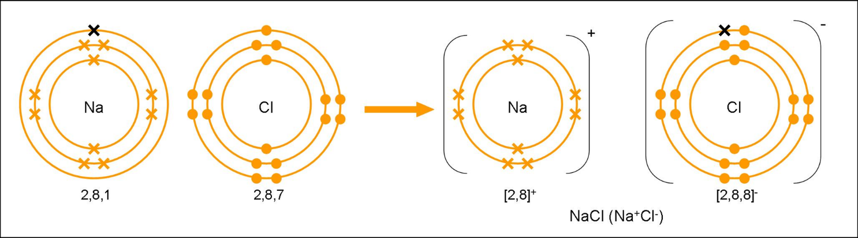

Example: Lithium + Fluorine

Example: Lithium + Oxygen

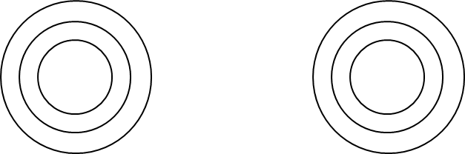

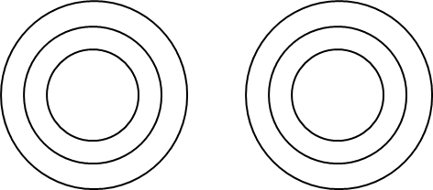

Lewis Dot Diagram
- diagram that demonstrates how ions combine by only showing the number of electrons in the valence shell
- example: Lithium + Oxygen

Circle Diagrams
- diagrams that uses full and empty circles to show how ions combine
- full circle = electron present (use for metals)
- empty circle = electron needed (used for non-metals)
- example: Lithium + Oxygen

Structure of Ionic Compounds
- ionic compounds consist of positive and negative ions arranged in regular repeating patterns called lattices
- the cube shape structure of sodium chloride is an example of a lattice
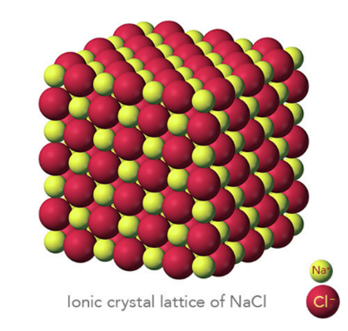

Properties of Ionic Compounds
- high melting point
- ionic bonds are very strong and require large amounts of energy to break them
- hard and brittle
- very hard due to strength of ionic bonds
- with enough force, ions shift out of alignment which causes like charges close together and then the compound will break apart
- conduct electric current when liquid or dissolved
- electric current is caused by the movement of charged particles
- solids – ions are too rigid to conduct electric current

Assignment
- Page 143 #1-4
- Page 151 #1-4
- Worksheet

