Trends In The Period Table

Key Concepts
- I can identify trends on the periodic table.

Periodic Trends
- refers to a regular variation in the properties of elements based on their atomic structure

Atomic Size Trends

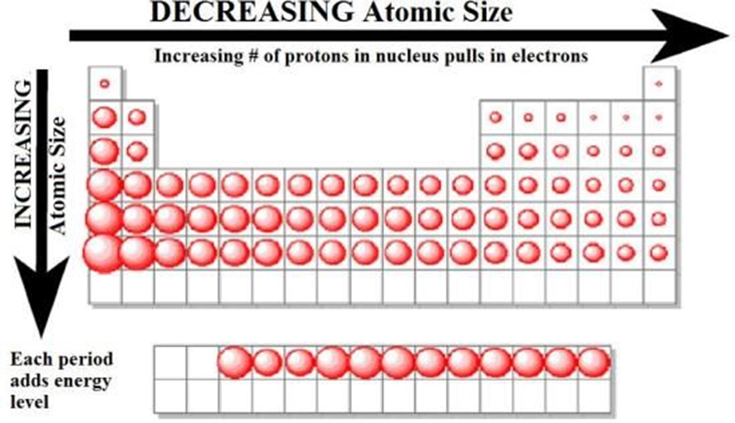

- Atomic size increases moving down a group
- increasing number of electrons and orbitals increases the overall size of the atom

- Atomic size decreases moving from left to right across a period.
- increasing number of protons in the nucleus increases the amount of attraction of the electrons which are pulled more tightly towards the nucleus
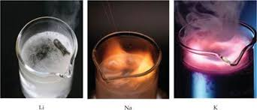
- Atom reactivity
- Metals
- moving down and left electrons get further away from nucleus easier to lose electrons reactivity increases
- Non-Metals
- moving up and right outer shell gets closer to the positive nucleus easier to attract electrons reactivity increases

Assignment
- Page 131 #1-3
- Page 133 #1-9

