Bohr Models

Key Concepts
- I can use Bohr diagrams to represent the structure of an atom.
- I can explain why elements in chemical groups or families have similar electron arrangements.

Atomic Structure
- the atom is the smallest unit of an element that has the properties of that element
- each atom has a tiny, dense nucleus containing neutrons and protons
- electrons surround the nucleus in specific energy shells or orbitals
- most of the mass of the atom is in the nucleus

Name | Symbol | Charge | Relative Mass | Location
proton | p⁺ | 1+ | 1836 | nucleus
neutron | n⁰ | 0 | 1837 | nucleus
electron | e⁻ | 1- | 1 | surrounding nucleus
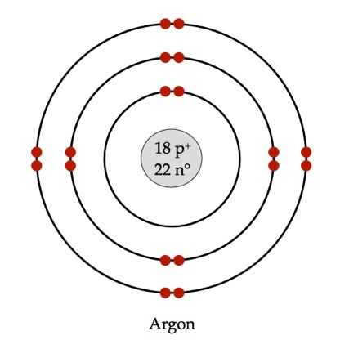
18 p = 18
Ar e = 18
40 n = 22
Bohr Diagrams
- used to show electrons placement in an atom
- first energy shell can hold 2 electrons
- second and third energy shells can hold 8 electrons
- outermost occupied shell of an atom is called a valence shell
- electrons in the valence shell are called valence electrons

Trends in Bohr Models
- Atoms in the same group have the same number of valence electrons.
- Atoms in the same period have the same number of occupied energy shells.
Practice: Draw Bohr diagram for oxygen (8p,8n,8e), fluorine (9p,10n,9e) and chlorine (17p,18n,17e)

8 9 17 O F Cl 16 19 35

Noble Gases
- Full valence shells make noble gases unusually stable
- Their atoms do not tend to gain, lose, or share electrons with other elements.
Practice: Draw Bohr diagram for helium (2p,2n,2e) and neon (10p,10n,10e)

2 10
He Ne
4 20

How Other Elements Achieve Full Valence Shells
- all atoms start out as neutral
- number of protons (+) equals the number of electrons (-)
- atoms want to have a full valence (outer) orbital
- achieve this by gaining or losing electrons
- called an ion
- metals lose electrons = lose negative charges become positive ions
- non-metals gain electrons = gain negative charges become negative ions
- the reactivity of an element is linked to how close it is to having a full valence shell
- fewer electrons to gain or lose means it is more reactive
- the most reactive elements are those in Groups 1 and 17
Practice: Draw Bohr diagram for fluorine ion (9p,10n,9e) and beryllium (4p,5n,4e)

Assignment
- Page 125 #1-2
- Page 127 #1-2
- Worksheets

