Modern Periodic Table

Key Concepts
- I can describe how the periodic table of elements organizes elements into groups and periods based on repeating element properties.
- I can classify elements as metals, non-metals and semi-metals.

Modern Periodic Table
- developed by Henry Moseley
- elements ordered by increasing atomic number (the number of protons)
- Groups (1-18): A vertical column of elements; also called a family
- Periods (1-7): A horizontal row of elements
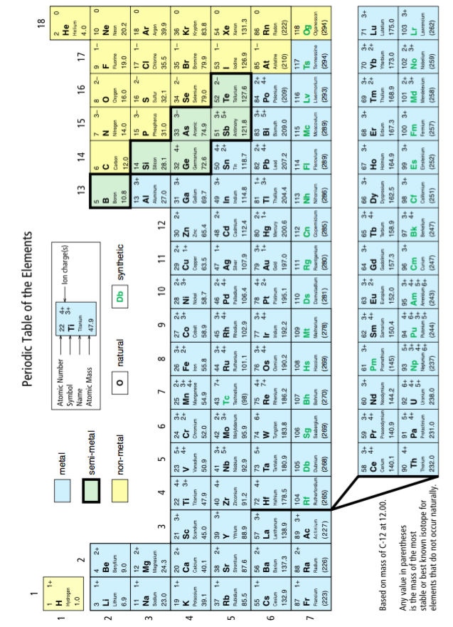
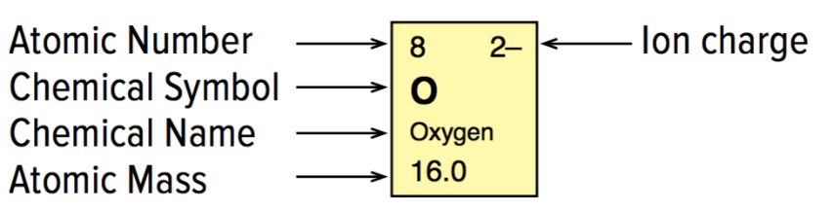

- elements are classified as metals, non-metals, or semi-metals
- elements of Groups 1, 2, and 13 to 18 are called main-group elements or representative elements
- elements in Groups 3 to 12 are called transition elements

Metals
- usually shiny and hard
- malleable and ductile
- conducts electricity and heat
- left side of the periodic table
- exhibit metallic bonding.
- positive nuclei are close together and the negative electrons can move freely between different atoms
- "sea of electrons" is used to describe the behaviour of the electrons in this type of bonding

Alkali metals:
- Group 1 (all elements, except hydrogen)
- shiny and soft
- highly reactive with water and oxygen

Alkaline-earth metals:
- Group 2
- shiny and soft (but not as soft as alkali metals)
- highly reactive (but not as reactive as alkali metals)

Non-metal:
- gases or dull, brittle solids
- poor conductor of electricity and heat
- right side of the periodic table

Hydrogen:
- usually placed at the top left of the periodic table
- lightest element
- colourless, odourless, tasteless
- highly flammable
- makes up over 90% of atoms in the universe
- on Earth, most hydrogen is found combined with oxygen as water
- a special case because it has the physical characteristics of a non-metal but it has some chemical properties that make it like a metal

Halogens:
- Group 17
- highly reactive non-metals
- usually found in nature as part of compounds

Noble gases:
- Group 18
- odourless, colourless gases
- least reactive elements
- helium and neon never form compounds
- other noble gases form compounds with great difficulty

Semi-metals:
- also called metalloids
- found in a staircase shape
- have physical and chemical properties of both metals and non-metals
- shiny (like metals)
- brittle and not ductile (like non-metals)
- Example: Silicon
- second most abundant element in Earth’s crust (after oxygen)
- used in many electronic devices (computers, smartphones)
- used to make silicone (material used in cookware, contact lenses, prosthetics)

Assignment:
- Page 107 #1, 2
- Page 113 #2, 3
- Page 115 #1-7, 9, 10

