Elements Are The Building Blocks Of Matter

Key Concepts
- I can state that elements are the building blocks of matter.
- I can organize elements by their properties

Elements
- basic building blocks of matter
- composed of only one type of atom
- atoms are made up of protons, electrons and neutrons (sub-atomic particles)
- an element is only defined by the number of protons in the atom
- an atom is the smallest particle that has the physical properties of that element
- gold consists of gold atoms
- carbon consists of carbon atoms
- Isotopes
- atoms of the same element that contain different numbers of neutrons
- example: carbon has 3 isotopes
- carbon-12, carbon-13, and carbon-14
- all have 6 protons, but they have different numbers of neutrons
- Allotropes
- different molecule or crystal forms of an element that have different properties
- example: carbon – graphite and diamond
- example: oxygen – oxygen gas (O₂) and ozone (O₃)

Naturally occurring elements
- between 88 and 98 naturally occurring elements depending on how the term is defined
- some elements don't exist in sufficient quantities for there to be natural sources
- some form naturally during nuclear decay but are unstable
- first synthetically produced element was technetium
- which was first isolated in 1937 by Emilio Segrè
- found in molybdenum that had been exposed to radiation

Summary
- elements are the basic building blocks of matter
- made up of only one type of atom
- about 90 elements occur naturally
- some elements are synthesized in labs
- each element has distinct properties

Element Names and Symbols
- Chemical name
- Based on Latin words, countries, names of famous scientists
- Chemical symbol
- one or two letters (first letter is capitalized)
- synthetic or unnamed elements have placeholder names or three-letter symbols
- each element has a unique symbol that is used internationally
- elements can be called different names in different languages but only one symbol
- example: nitrogen
- nitrogen in English and azote in French
- symbol is N

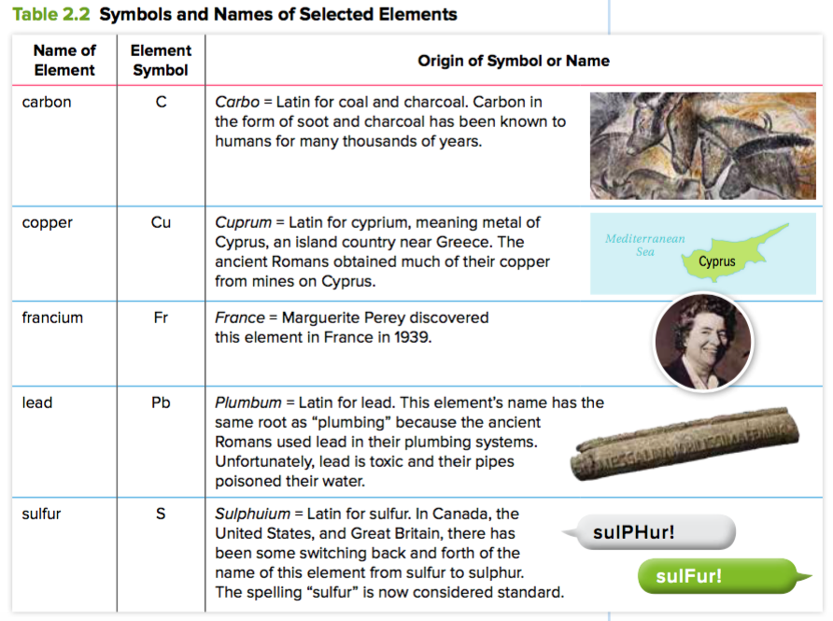

Organizing elements
- Antoine Lavoisier (1789) – grouped elements based on their properties into gases, non-metals, metals, and earths
- Johann Döbereiner (1829) – chemical triads with similar properties
- noted that the properties of one element could be predicted from the properties of the other two
- 1860 – first international chemistry conference in Karlsruhe, Germany
- atomic masses were standardized with hydrogen having a mass of 1, carbon a mass of 12, and oxygen a mass of 16
- chemists started to organize the elements based on mass
- John Newlands (1865) – noticed that there were similarities between elements with atomic weights that differed by seven
- called this The Law of Octaves
- some groupings had less than or more than 7 elements
- credited with the discovery of the periodic law
- Dmitri Mendeleev (1869) – father of the modern periodic table
- arranged all the known elements into columns by their atomic mass and shared physical properties
- left gaps when the next known element didn’t fit
- let him predict the properties of some undiscovered elements
- switched the order for elements such as tellurium and iodine where the atomic mass order didn't fit the pattern

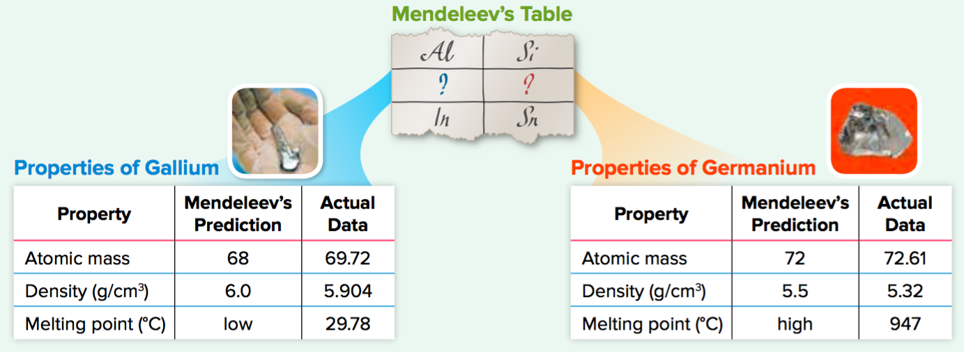

- William Ramsay – discovered argon (1894) and helium (1895)
- added another column to Mendeleev's table called the noble gases

Assignment:
- Page 103 #1-2
- Page 105 #1-2
- Worksheet

