Physical and Chemical Properties

Key Concepts
- I can explain how matter and its interactions make up our world.
- I can describe matter by its physical and chemical properties.

Matter:
- anything that has mass and takes up space

Classification of Matter
- Pure Substance
- made up of one type of particles
- cannot be separated by physical means
- Elements
- made up of one type of atom
- cannot be broken down into simpler substances
- example: pure gold, oxygen
- Compounds
- made up of two or more elements
- can be chemically broken down into simpler substances
- example: sodium chloride, carbon dioxide

- Mixture
- made up of two or more pure substances; can be separated by physical means
- Homogeneous mixtures
- also known as solutions
- mixed uniformly throughout and cannot see their components
- example: air (nitrogen, oxygen, hydrogen), steel (iron and other elements)
- Heterogeneous mixture
- have different components that you can see
- example: beach sand, salad dressing

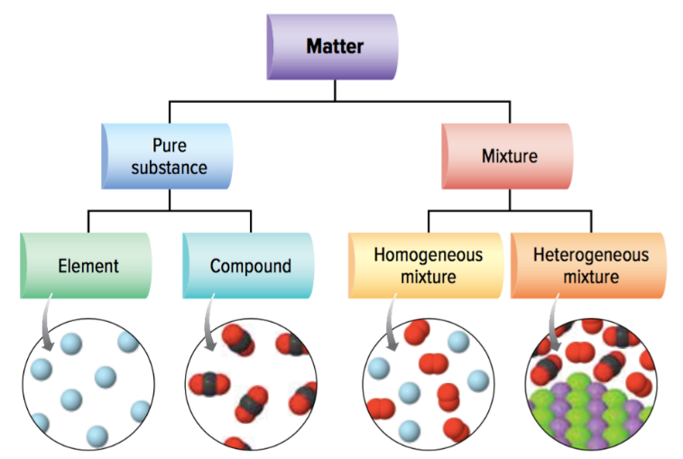
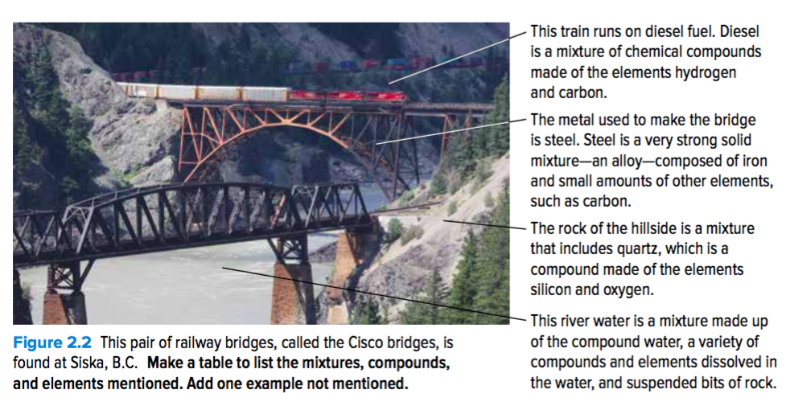

Physical Properties
- a characteristic that can be observed or measured without changing its chemical identity or the type of matter it is
- Qualitative Physical Properties
- properties that are descriptive
- colour, flavor (taste), scent (odour), texture (rough or soft), lustre (shine), malleable (easy to shape), ductile (drawn into wires), state (gas, liquid, solid)
- Quantitative Physical Properties
- properties that can be measured
- melting point, boiling point, solubility (how much can dissolve into another type of matter), hardness, viscosity (rate at which a material flows)

- Mass and Volume
- all matter has mass and volume
- Mass
- the amount of matter in a sample
- measured in grams (g)
- Volume
- the amount of space a material takes up
- measured in litre (L) or cubic metre (m³))

- Density
- not measure directly
- measure the mass and volume, and then calculate density using the following equation:
$$density= \frac{mass}{volume}$$
- Example: If a sample of jet fuel has a mass of 8.30g and a volume of 10.3 mL, what is its density?
- $density= \frac{mass}{volume}$
- $density= \frac{8.30 g}{10.3 mL}$
- $density= \frac{0.81 g}{mL}$

Chemical Properties
- ability of matter to react with another substance to form one or more new substances with different properties
- Examples: combustibility, react with oxygen, react with acids, lack of reactivity
- Chemical Reactions
- occurs when one or more pure substances interact to form a different substance or substances
- elements can react to form compounds
- compounds and elements can react to form new compounds
- compounds can break apart to form elements and simpler compounds
- a pure substance may be dissolved in a solvent to form a solution to make it easier for the pure substance to react

Assignment
- Physical and Chemical Properties Worksheet
- Density Worksheet
- Page 90 #2

