Life Sciences 11
Molluscs

Phylum Mollusca
Level of Organization Organ
Digestive System Tube
Symmetry Bilateral
Coelom Coelomate
Cavity Development Protostome
Segmentation None

Molluscs
- more than 110,000 species
- all have a soft internal body, a muscular foot, a mantle and the visceral mass (region containing the organs)
- feed either by using a radula or by filter-feeding
- exchange gases using the fringed edges of the mantle
- have a developed circulatory system that includes a heart
- remove metabolic wastes using specialized structures called nephridia to filter their blood
- nervous system may be simple or highly complex including a brain
- reproduce sexually
- most aquatic molluscs use external fertilization
- most terrestrial molluscs use internal fertilization and many are hermaphrodites
- 3 main classes
- Gastropods
- have a large foot used for movement located under the stomach
- includes snails, slugs, abalone, conches, limpets, cowries and nudibranchs
- may secrete calcium carbonate from the mantle to form a protective shell
- use their radula to scrap up organic material (herbivores) or to break through shells (carnivores)
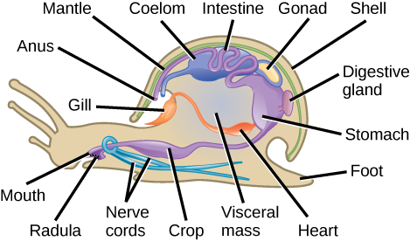

- Bivalves
- Includes clams, oysters, scallops and mussels
- mantle forms two shells (called valves) that encase the organism
- filer feeders – use incurrent and excurrent siphons to move water through their body and the gills to trap food particles
- can open and quickly close the valves to swim through the water
- clams use their muscular foot for digging through sand

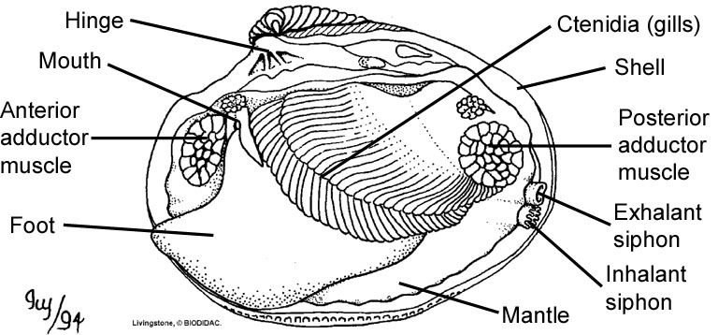

- Cephalopods
- head-footed molluscs – octopus, squid, nautilus and cuttlefish
- nautilus has an external shell
- squid and cuttlefish have an internal shell
- octopus has no shell
- well-developed brain, eyes and nervous system
- foot is divided into separate arms and tentacles
- radula forms a beak that is used to tear apart prey
- take water into the mantle cavity, then are able to forcibly expel it out through the siphon for movement
- squid, octopus and cuttlefish can use ink to confuse or escape predators
- some can also change their skin colouration for camouflage
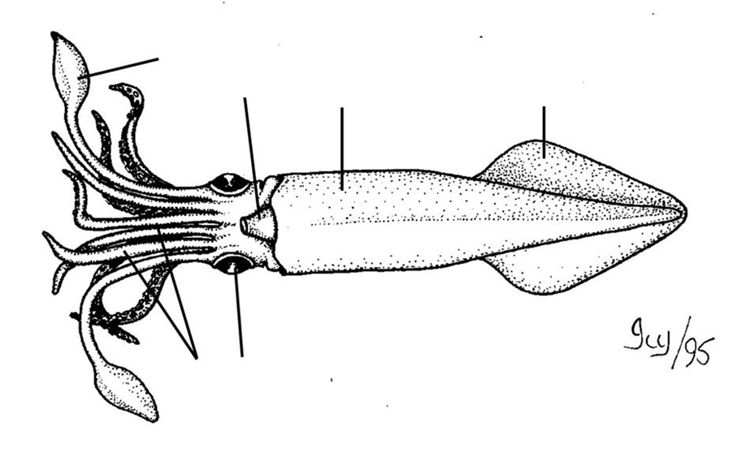
Eye
Fin
Mantle
Siphon
Tentacle
Arms

