Life Sciences 11
Flatworms

Phylum Platyhelminthes
Level of Organization Organ
Digestive System Sac or None
Symmetry Bilateral
Coelom Acoelomate
Segmentation None

Platyhelminthes
- have thin, flat ribbon-like bodies with a distinct head region
- 3 classes
- Turbellarians
- free-living use cilia to glide around
- eye spots to detect light
- feed on dead or slow moving organisms
- extend the pharynx out of the mouth and secrete digestive enzymes on food, then suck up the food particles
- sac digestive system waste materials excreted from the mouth
- auricles chemoreceptors capable of sensing stimuli from food
- Trematodes
- parasitic flukes
- have a 2 host life cycle
- Cestodes
- parasitic tapeworms
- lack a digestive system
- scolex (head) attaches to host’s intestinal wall
- nutrients are absorbed through the skin
- proglottids contain eggs for fertilization
- tail end proglottids break off releasing embryos that can infect blood and muscle of second host
- have simple organ systems
- excretory system (flame cells) that removes excess water and waste products through pores on side of body
- simple nervous system with a group of ganglia sends signals to the body
- reproduction
- sexual
- hermaphrodites
- eggs are fertilized internally
- cocooned zygote released into water to hatch

- asexual
- regeneration – can be cut in half and each part grows into a new organisms
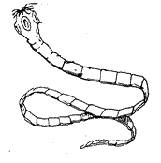
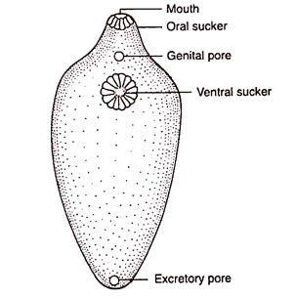
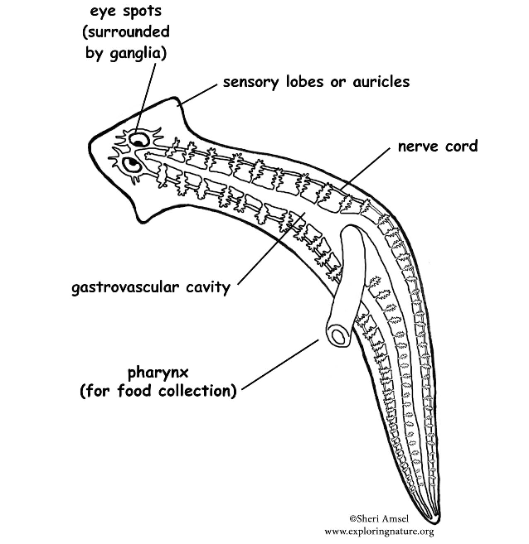
Tapeworm
Proglottid
Scolex
Liver Fluke
Turbellarian
(Planaria)

