Life Sciences 11
Cnidarians

Phylum Cnidara
Level of Organization Tissue
Digestive System Sac
Symmetry Radial
Coelom None
Segmentation None

Cnidarians
- many have 2 life stages – polyp (sessile) and medusa (free-living)
- 4 main classes
- Hydroids
- have both stages in their life cycle
- many form colonies
- example – Portuguese man-of-war
- Jellyfish
- 2 classes – round and box jellyfish
- dominant stage is the medusa
- Sea Anemones & Corals
- dominant stage is the polyp
- sea anemone – individual organisms
- corals – colonies of polyps surrounded by calcium carbonate & live symbiotically with photosynthetic protists (zooxanthellae)
- body is composed of 2 layers of tissues
- outer layer – protection
- inner layer - digestion
- capture food using stinging cells (cnidocytes) on tentacles
- cnidocytes contain nematocysts – capsule containing a poisonous barbed, thread-like structure
- food is then pulled into the gastrovascular cavity
- gastro – used for digestion
- vascular – used for gas exchange
- waste materials are expelled back out the mouth
- have a nervous system formed by a nerve net
- stimuli cause contraction of muscle-like cells in the two tissue layers
- results in movement of tentacles
- reproduction
- polyp
- asexual by budding or formation of strobila that produce ephyra (immature medusa)
- medusa
- sexual reproduction (egg and sperm)
- zygote develops into a planula (free-swimming larvae)
- planula settles on the ocean floor and grows into a polyp
- uses
- food for some organisms
- habitat for small marine organisms (clown fish)
- used in bone graft surgery
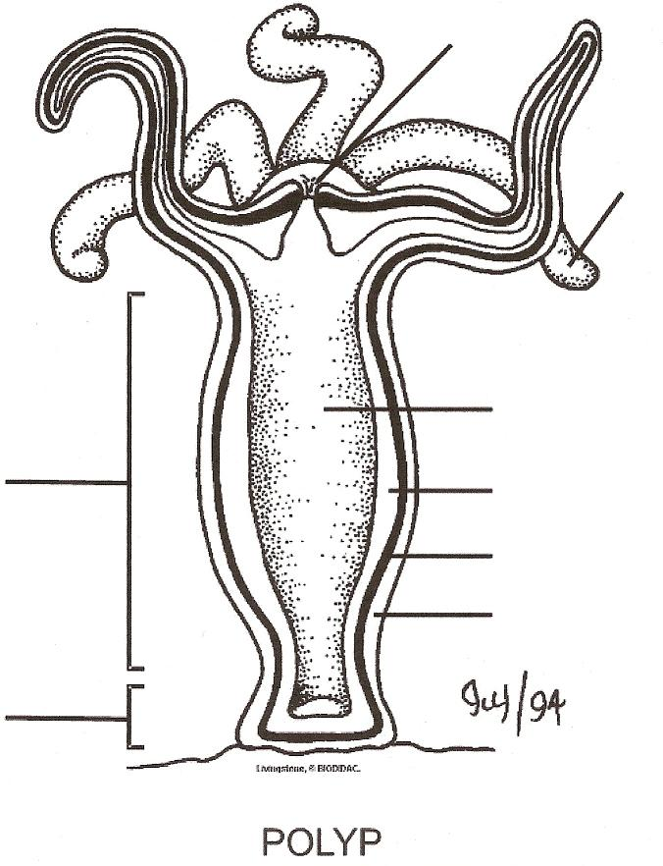
F

- Epidermis
- Mesoglea
E
- Endodermis
- Gastrovascular Cavity
- Tentacle
- Mouth
D
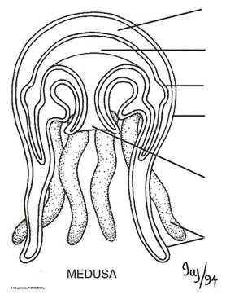
B
A
D
C
E
F
Body Column
C
B
A
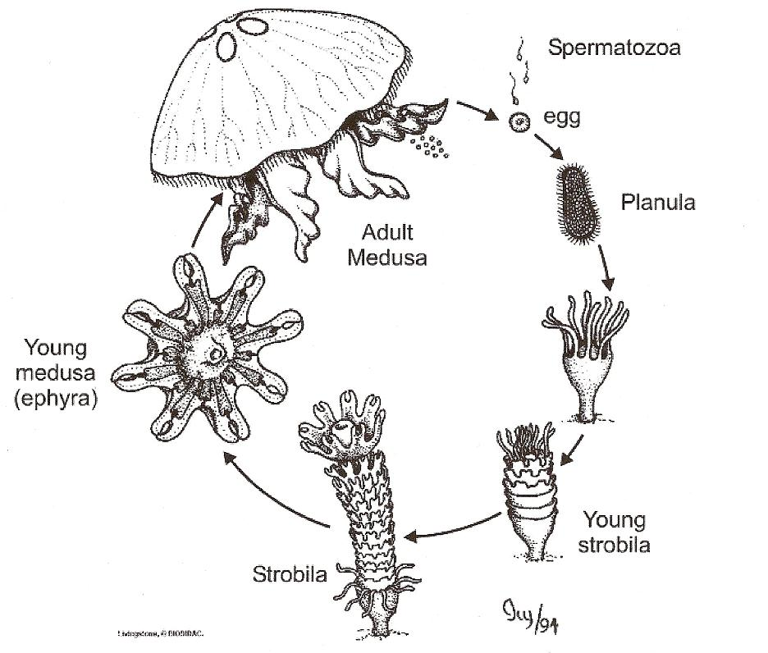
Pedal Disk

