Life Sciences 11
Sponges

Phylum Porifera
Level of Organization Cell
Digestive System None
Symmetry Asymmetrical
Coelom None
Segmentation None

Sponges
- composed of two layers of cells with a jellylike substance between
- outer layer of epithelial-like cells
- inner layer of flagellated collar cells
- sessile
- capture food by filter feeding
- flagella on collar cells create a current pulling water in through pores on the sides of the sponge
- food particles stick to cells on the inside of the sponge
- waste materials are expelled with water out through the osculum (opening at the top of the sponge)
- archaeocytes
- amoeba-like cells in the jellylike layer
- involved in digestion, production of egg and sperm cells, and excretion
- form spicules of calcium carbonate, silica or spongin (fibrous protein) for support determine the class of sponge
- reproduction
- asexually
- by fragmentation or budding
- gemmules
- used by some freshwater sponges
- small clusters of sponge cells protected by spicules that can survive drought, freezing, etc.
- sexual
- most are hermaphrodites produce both egg and sperm
- sperm is released out the osculum and collected by collar cells of other sponges
- zygote develops into a free-swimming larva attaches to a surface and grows into an adult sponge
- uses
- food for tropical fish and sea turtles
- habitat for small marine organisms
- household sponges
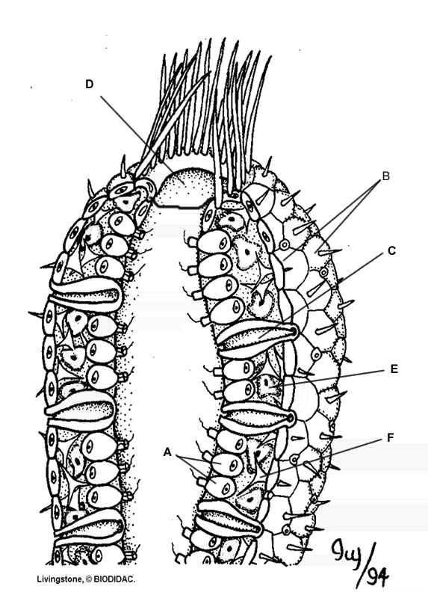
- some produce chemicals with possible medicinal properties

- Collar Cells
- Epithelial Cells
- Incurrent Pore
- Osculum
- Archaeocyte
- Spicule



