Life Sciences 11
Characteristics & Body Plans

Domain Eukarya
Kingdom Animalia

Five general characteristics of animals
- Feeding
- heterotrophic; ingest and digest food

- Support
- many have an exoskeleton or endoskeleton

- Movement
- muscle fibers allow for motion or locomotion

- Cell Structure
- multicellular
- no cell wall
- most have tissues and organs

- Reproduction
- diploid adult in life cycle
- sexual reproduction (embryo has developmental stages)
- some can reproduce asexually – budding, fragmentation, regeneration or parthenogesis

Animal Body Plans

- Level of Organization
- cell level, tissue level or organ level of organization
- based on the number of germ layers (layers from which other structures are derived) present
- no tissues cell level of organization
- only two germ layers (ectoderm and endoderm) tissue level of organization
- three germ layers (ecto-, endo- and mesoderm) organ level of organization

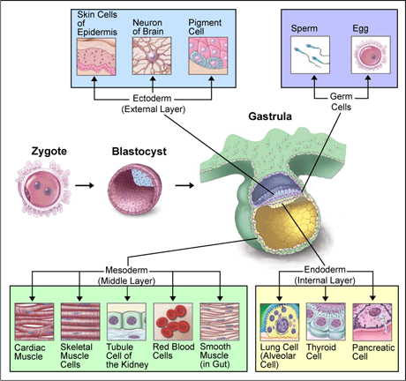

- Digestive System
- Sac Plan
- incomplete digestive system only one opening that the animal both brings food in and removes waste through
- Tube-Within-A-Tube Plan
- complete digestive system one opening for ingestion and one opening for removal of wastes
- allows for specialization of parts along the length of the digestive tract (ie: stomach, intestines, etc)
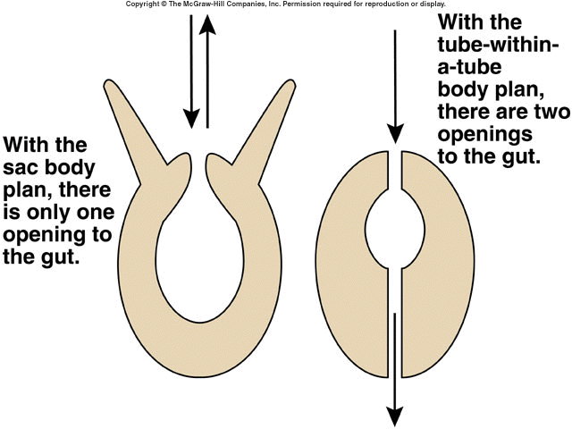
- Type of Symmetry
- Asymmetry
- no symmetry (no balanced distribution of duplicate body parts or shapes)
- Radial Symmetry
- circular symmetry (like a wheel)
- get two identical halves whenever the animal is cut longitudinally
- sometimes sessile (attached to substrate/ground)
- Bilateral Symmetry
- defined left and right sides
- only get identical halves when the animal is cut down the center
- animals tend to be active and move forward
- associated with cephalization localization of a brain and specialized sensory organs at anterior (head) end of animal
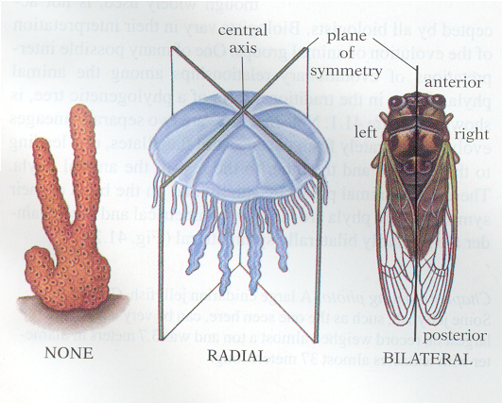

- Type of Coelom
- presence of all 3 germ layers allows for the formation of organs
- Acoelomates
- no body cavity solid body between digestive tract and body wall
- nutrients and wastes diffuse from one cell to the next
- allows for simple organ development
- Pseudocoelomates
- body cavity incompletely lined by mesoderm
- fluid filled cavity develops between the mesoderm and endoderm limits organ and organ system development

- Coelomates
- fluid-filled body cavity completely lined by mesoderm
- allows for specialized organs and organ systems to develop allows for larger animals with increased levels of activity
- developing embryo forms a ball with one opening; as the mesoderm layer develops, it creates a second opening opposite the first

 | First Embryonic Opening | Second Embryonic Opening
Protostome | Mouth | Anus
Deuterostome | Anus | Mouth

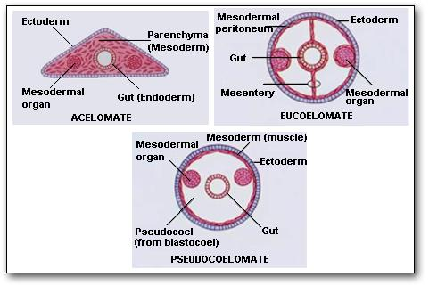

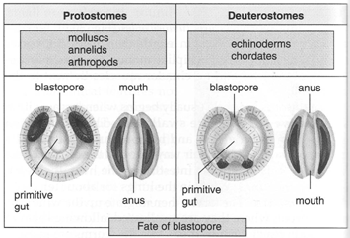
- Segmentation
- the formation of an animal from similar body parts
- segmentation allows for different body parts to develop for specific purposes
- two advantages
- increased survivability if one segment is damaged, another segment may be able to carry out the same function
- Increased movement segments can move independently

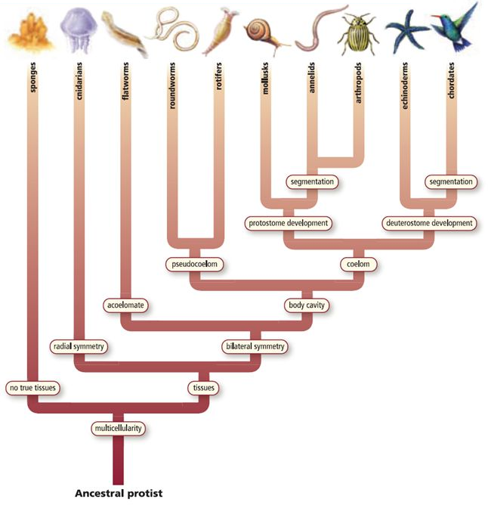

Animal Symmetry and Phyla


