Life Sciences 11
Gymnosperms

Seed Plants
- 2 types of seed plants gymnosperms and angiosperms
- characterized by producing seeds
- protected coat over an embryonic sporophyte and stored food
- sporophyte is dominant generation

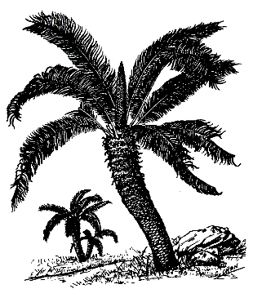
Gymnosperms
- Cycads (Cycadophyta)
- Palm-like plants found in the tropics and sub-tropics
- Have compound leaves
- Dioecious – plants have either male or female reproductive structures
- Sperm are motile
- Flourished during the time of the dinosaurs

- Ginkos (Ginkophyta)
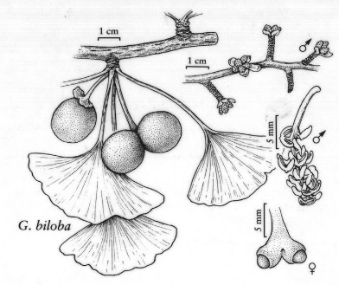
- Only one species left – maidenhair tree (G. biloba)
- Survive naturally in a small area of China
- Dioecious with motile sperm
- Considered to be a living fossil – latest fossils date back 270 million years (Permian)
- Very hardy tree – 6 trees survived the Hiroshima atomic bomb

- Gnetophytes (Gnetophyta)
- Only 3 genus alive today
- Has vessel elements associated with the xylem (characteristic of angiosperms)
- Ephedrine (stimulant, appetite suppressant and decongestant) derived from Ephedra plant

- Conifers (Pinophyta)
- Largest group of gymnosperms
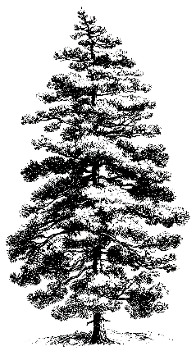
- Cone-bearing trees that have needle like leaves (small leaves help conserve water)
- Monoecious – plants that have both male and female reproductive structures
- Two sizes of cones
- Larger come is female
- Smaller cone is male usually lower on trees
- Used for:
- pulp & paper
- lumber
- medicine (taxol from Yew tree used to treat cancer)
- tanning hides (tannin from bark)
- resin products (turpentine, wine additives, disinfectants, vitamins, fragrances)


