Life Sciences 11
Seedless Vascular Plants

Tracheophytes
- considered true land plants because they are much less dependent upon water
- have developed vascular tissue, which aids in the transport of water and nutrients
- xylem is the tissue that is responsible for transporting water from the roots to all other tissues; has strong-walled cells that supports the body of the plant
- phloem is the tissue that is responsible for transporting the products of photosynthesis to all cells from the leaf
- have true roots, stems, and leaves
- leaves are covered by a waxy cuticle
- tiny pores on underside of leaves called stoma (pl. stomata) can be opened or closed to regulate water loss
- sporophyte generation is dominant

Seedless Vascular Plants
- still dependent on water for sexual reproduction
- flagellated sperm swim to archegonia to fertilize the egg
- spore dispersal by wind
- gametophyte and sporophyte generations independent of each other
- both sporophyte and gametophyte generations can photosynthesize
- gametophyte only lives for a short time and is non-vascular
- made up dense jungles during the Carboniferous period; formed the large coal deposits mined today

- includes whisk ferns (Psilotophyta), club mosses (Lycopodophyta) and horsetails (Equisetophyta)
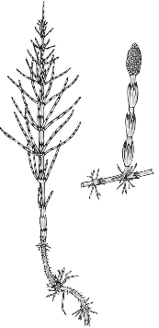
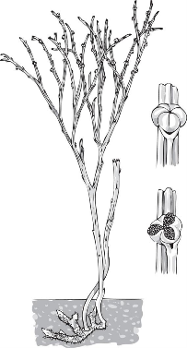
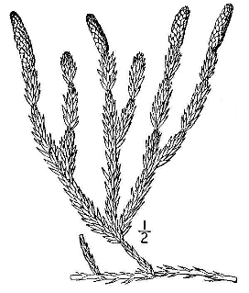

Horsetail
Club Moss
Whisk Fern

Ferns (Pteridophyta)
- have true leaves (called fronds), stems and roots
- sporophyte dependent on gametophyte until first fronds appear
- sporophyte have creeping underground rhizomes
- asexual reproduction
- over-winter food storage
- still linked somewhat to a damp environment due to the sperm having to swim to the egg
- range in size from low growing plants resembling mosses to tall trees
- fiddlehead – new leaf growing off a rhizome
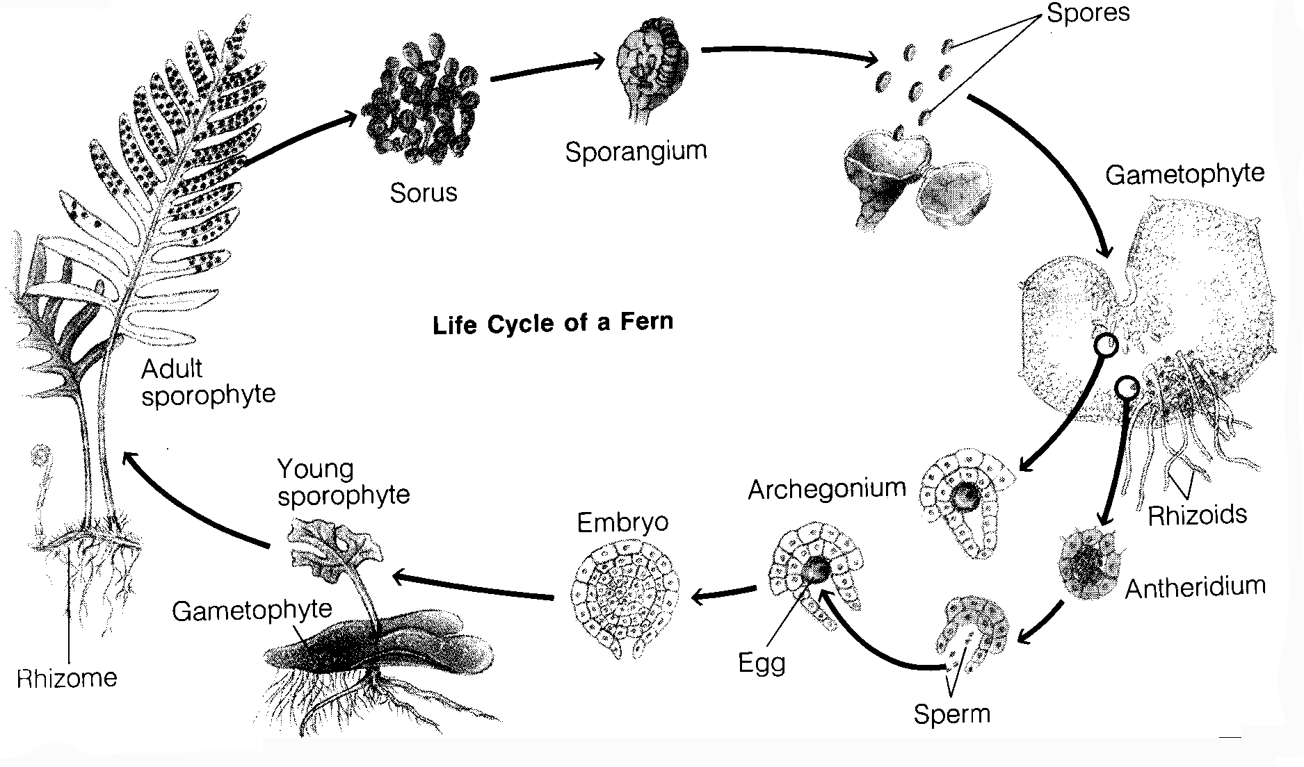

The Fern Life Cycle

