Life Sciences 11
Nonvascular Plants

General Characteristics
- gametophyte is the dominant generation
- do not have true roots, stems or leaves have root-like, stem-like and leaf-like structures
- flagellated sperm swim in a thin film of water to the egg zygote develops into a sporophyte that is attached to the gametophyte shoot for nutrients
- spores dispersed by the wind
- low lying plants lack efficient means to transport water very high

- includes hornworts (Division Anthocerotophyta) and liverworts (Division Hepatophyta)

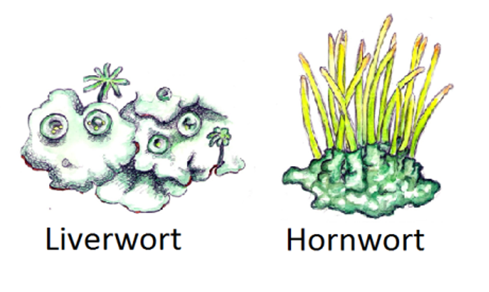

Division Bryophyta (Mosses)
- 12 000 species
- most found in damp, shaded locations require water for sexual reproduction
- can reproduce asexually by fragmentation
- their lack of conducting tissue prevents their growth to a few centimeters in height
- sporophyte is dependant upon the more conspicuous gametophyte; that means it is the gametophyte generation that photosynthesizes and the sporophyte generation draws its nourishment from the gametophyte generation
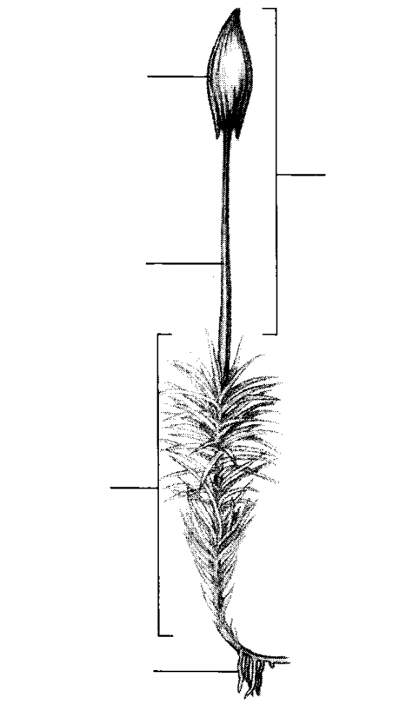
sporangium (capsule)
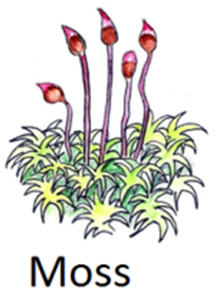
sporophyte)
stalk

gametophyte

rhizoid
- Moss Life Cycle
Also called a capsule

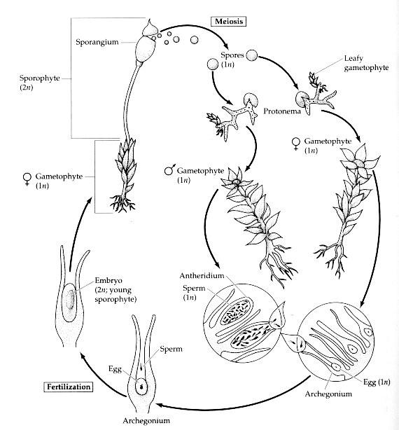
Zygote grows by mitosis into sporophyte
Water required for sperm to swim into archegonium
Flagellated sperm cells surrounded by sterile cells
Rhizoids – develop to anchor the gametophyte generation
A branching filament of cells

Adaptations & Uses of Nonvascular Plants
- able to colonize bare rock where they help to break down that rock into soils
- dead mosses in bogs (ex: Sphagnum moss) do not decay called peat or bog moss
- used by First Nations for baby hygiene
- used in gardens to improve water-holding capacity of soils

