Life Sciences 11
Microbiology Review

Viruses
- What is the definition of a virus? What two components do all viruses contain?
- List the living and non-living characteristics of a virus.
- What is the dominant theory on the evolution of viruses?
- Describe the Lock & Key Theory of Viral Specificity. Use the theory to explain why most viruses are species (or closely related species) specific.
- List the 4 steps of the viral lytic cycle.
- List the 4 steps of the viral lysogenic cycle.
- Define the term retrovirus.
- Explain what a vaccine is and how it works.

Microscope
- Know the parts of the microscope and describe their function.
- How is the apparent magnification calculated?
- How is the actual size of a specimen calculated?
- How is the drawing magnification calculated?

Bacteria
- What are the general characteristics of all bacteria?
- List the four phyla of bacteria and what is the major defining characteristic of each phylum?
- What are some beneficial uses of bacteria?
- What are some detrimental causes of bacteria?
- How can bacteria growth be slowed or destroyed?
- Definitions: colony morphology, coccus, baccilus, spirillum, diplo, strepto, staphlo, tetra, Gram positive, Gram negative, heterotrophic, autotrophic, chemotrophic, saprophytic, methanogen, binary fission, conjugation, pathogen, prokaryotic

Protists
- What type of cell are protists?
- What is the major difference between protists and bacteria (refer to question 1)?
- What trait is used to distinguish between animal-like and plant-like protists?
- What are the 4 animal-like protists phyla and what is the means of locomotion for each?
- What are the two ways that the animal-like protists obtain nutrition?
- What are the 7 plant-like protists phyla and one characteristic of each?
- What is the function of an eyespot in plant-like protists?
- What are some harmful relationships of protists?
- What are some beneficial relationships of protists?
- Definitions: pellicle, nucleus, gullet, food vacuole, anal pore, contractile vacuole, lysosome, cilia, flagellum, chloroplast, bioluminescence, red tide,
- Label the parts of the following protists:
- Paramecium
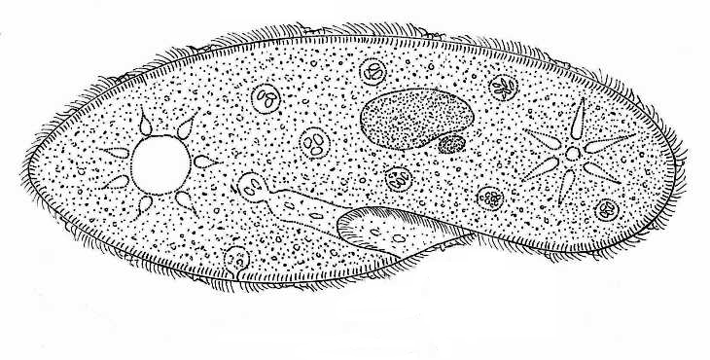
c d
a b e

f
g h i j k

- Euglena
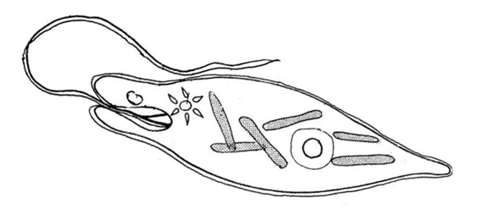
a
b c

d
e
f
g

- Amoeba
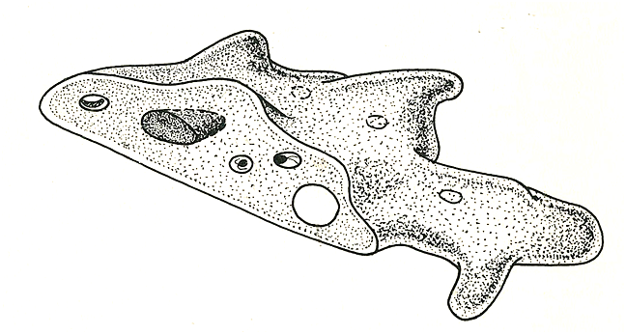
b c
a

d g
e

f

