Anatomy & Physiology 12
Parts of the Female Reproductive Systems

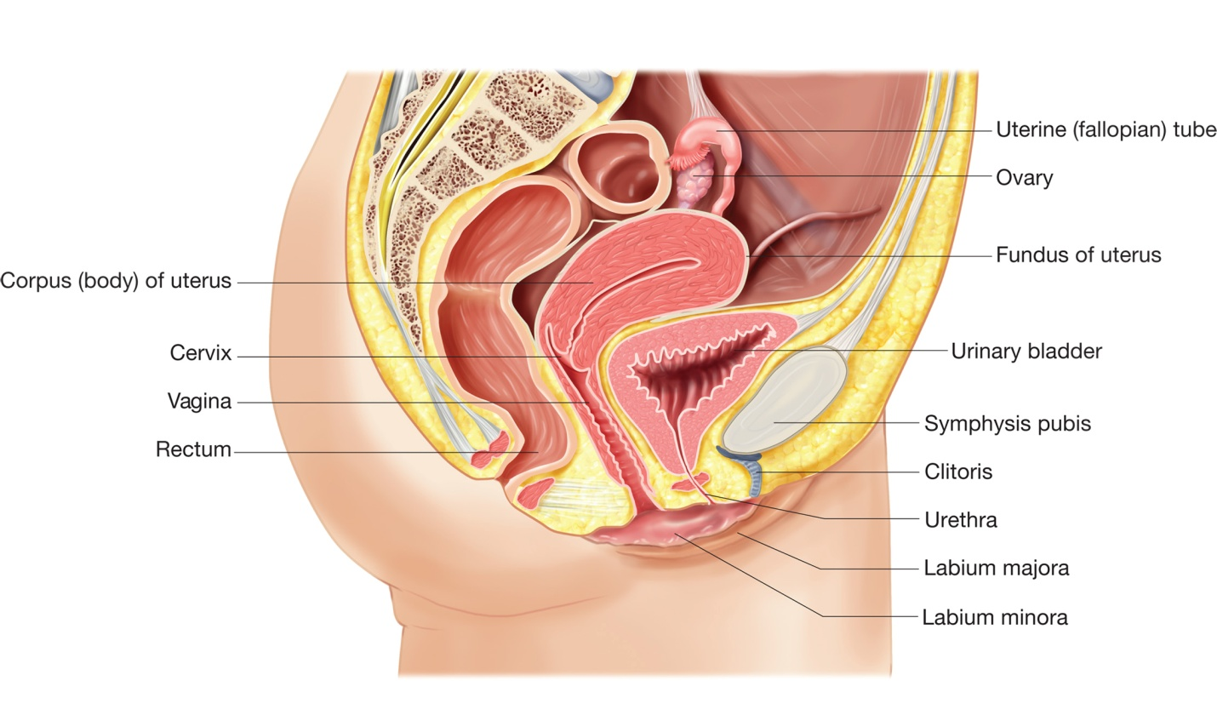
Fimbriae

Ovarian Cycle
- responsible for oogenesis - the production of an oocyte (egg)
- ovary is made up of two parts - outer cortex and inner medulla
- follicles are found in the cortex
- each follicle is composed of a layer of cells surrounding an immature oocyte
- females are born with approximately 700 000 follicles, but only about 400 will produce a mature oocyte
- Ovarian Cycle
- 2 stages
- Follicular Phase
- primary follicle starts to mature (outer layer of cells divide) into a secondary follicle and begins producing estrogen
- secondary follicle containing a primary oocyte continues to mature into a vesicular (or Graafian) follicle and continues to release estrogen and some progesterone
- in a vesicular follicle, a fluid filled cavity (antrum) forms between the primary oocyte and the follicular cells
- at this point, the primary oocyte undergoes meiosis I to form a secondary oocyte and the first polar body (atrophies)
- vesicular follicle continues to swell until it bursts out the side of the ovary releasing the secondary oocyte into the abdominal cavity where it is swept up by the fimbriae into the uterine (fallopian) tube - called ovulation
- once the secondary oocyte is released, the left-over follicle is called the corpus luteum

- Luteal Phase
- development of the corpus luteum causing the production of progesterone and some estrogen

Hormonal Control of Ovarian Cycle
- the hypothalamus produces GnRH which stimulates the anterior pituitary gland to produce FSH and LH
- FSH and LH drive the follicular and luteal phases of the ovarian cycle
- the increase in estrogen levels from the developing follicle, spiking at day 13, causes a large amount of GnRH to be released
- results in a spike of LH from anterior pituitary which causes ovulation
- increasing amounts of progesterone exert a negative feedback on the anterior pituitary reducing the amount of LH it produces
- results in the degeneration of the corpus luteum and a decrease in progesterone and estrogen production

Uterine Cycle
- the uterine cycle is responsible for preparing the endometrium (lining of the uterus) for implantation of a fertilized egg
- three stage cycle
- Days 1-5
- low levels of estrogen and progesterone (from degeneration of corpus luteum) cause the endometrium to disintegrate and the blood vessels in it to rupture
- release of this tissue and blood out of the uterus and vagina is called menstruation
- the enzyme fibrinolysin prevents normal blood clotting
- prostaglandins in the uterus cause it to contract to aid in menstruation - possibly the source of menstrual cramps
- Days 6-13
- increased estrogen levels from the maturing of a new follicle causes the endometrium to start to thicken and become vascular
- called the proliferative phase
- Day 14
- ovulation occurs - not actually part of the uterine cycle
- Days 15-28
- increasing levels of progesterone from the corpus luteum cause the endometrium to double or triple in thickness
- uterine glands produce a thick mucus secretion - glycoproteins used to nourish the developing embryo until it has implanted into the endometrium
- called the secretory phase

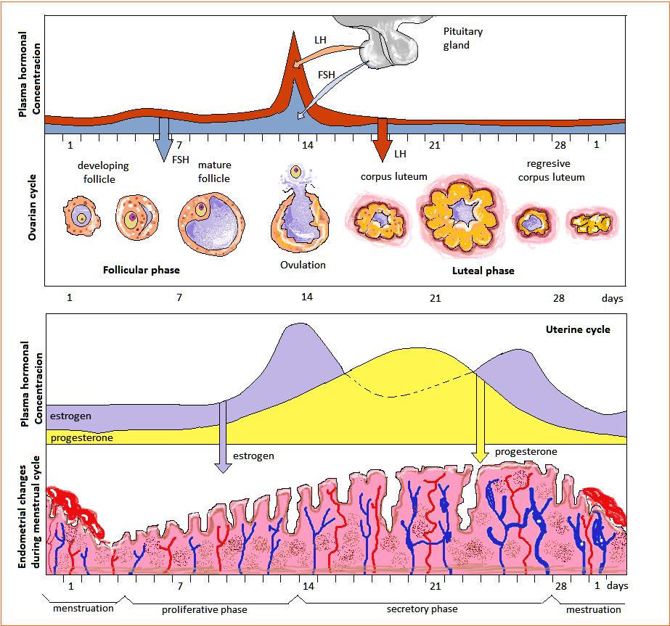

Fertilization and Pregnancy
- the released secondary oocyte is moved down the fallopian tube by cilia and tubular muscle contractions
- secondary oocyte survives for 6 to 24 hours unless it is fertilized
- if fertilization occurs, the secondary oocyte completes meiosis II releasing a second polar body before the sperm nucleus combines with the oocyte nucleus to produce a zygote
- embryo implants into the endometrium after several days and starts to form the placenta
- placenta produces human chorionic gonadotropin (HCG) that maintains the corpus luteum in the ovary until the placenta can start producing estrogen and progesterone
- placental estrogen and progesterone prevent the anterior pituitary from starting the maturation a new follicle and maintains the endometrium
- pregnancy tests detect the presence of HCG in the urine
- mucus plug forms at the entrance to the cervix to prevent bacteria and sperm from entering the uterus during pregnancy

https://www.msichicago.org/fileadmin/assets/online_science/games/make_room/v2/mrfb.html

Birth
- a few weeks prior to birth, large amounts of estrogen produced by the placenta cause cells in the uterus to form oxytocin receptors and decreases the quieting effect of progesterone on the uterine muscles - causes irregular, weak uterine contractions to occur (Braxton Hicks contractions)
- fetus starts to produce oxytocin which causes the placenta to produce prostaglandins
- both of these hormones cause the uterine muscles to begin contracting with force
- the stresses of the uterine muscle contractions activates the mother's hypothalamus which signals the posterior pituitary to produce more oxytocin (positive feedback loop)
- prostaglandins in semen can also aid in the initiation of labour contractions

Menopause
- period during which the ovarian and uterine cycles cease
- ovaries become unresponsive to FSH and LH so they no longer secrete estrogen and progesterone
- changes in hormone levels can produce physical symptoms associated with menopause

