Anatomy & Physiology 12
Homeostatic Controls
(Pg. 418)

- Blood pH Regulation
- absorption or secretion of H+ acts to maintain blood pH levels
- if the blood is acidic, H+ is excreted in the DCT
- if the blood is alkaline, H+ are reabsorbed in the PCT

- Urine Composition Regulation
- reabsorption of water in the distal convoluted tubule and collecting duct is regulated by the hypothalamus and the juxtaglomerular apparatus

- Hypothalamus
- ADH is produced in the hypothalamus and stored in the posterior pituitary land
- hypothalamus measures blood volume using osmoreceptors
- low blood volume causes ADH to be released
- ADH increases the permeability of the distal convoluted tubule and collecting duct by moving aquaporins into the membrane and opening gated aquaporins already in the membrane
- kidneys produce less urine that is more concentrated and blood volume is increased

- Juxtaglomerular Apparatus
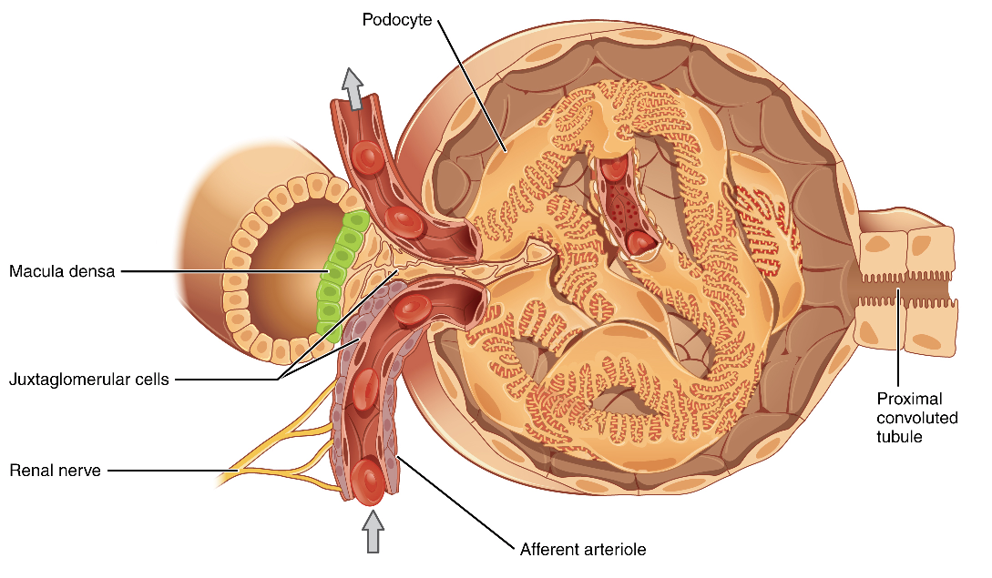

- macula densa cells in distal convoluted tubule measure filtrate volume
- juxtaglomerular cells in afferent arteriole measures blood volume
- if either are low, renin (hormone) is release by the kidneys
- renin acts on the adrenal gland located on top of the kidneys causing the release of aldosterone
- aldosterone causes more Na+ to be reabsorbed in the distal convoluted tubule which increases water reabsorption in the distal convoluted tubule and the collecting duct

