Anatomy & Physiology 12
The Kidneys
(Pg. 414 – 421)
Proximal Convoluted Tubule
Efferent Arteriole

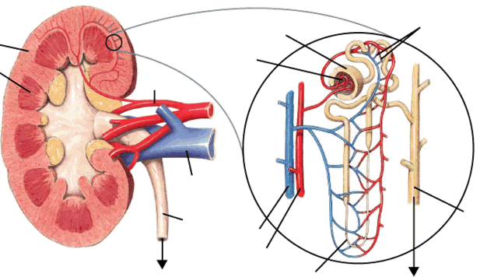
Bowman’s Capsule
Renal Cortex
Renal Medulla
Peritubular Capillary Network
Distal Convoluted Tubule
Afferent Arteriole
Glomerulus
Renal Pelvis
Collecting Duct
To Bladder
Renal Artery
Renal Vein
Ureter
Renal Vein
Renal Artery
Loop of Henle
To Renal Pelvis

Kidney Function
- the nephron (renal tubule) is the functioning unit of the kidneys over 1 million nephrons per kidney

Glomerulus & Bowman’s Capsule
- afferent arteriole carries blood into the Bowman’s capsule and leaves through the efferent arteriole
- capillary network inside the Bowman’s capsule is called the glomerulus
- pressure filtration occurs within the Bowman's capsule higher blood pressure in glomerulus causes approximately 50% of all small molecules to be pushed from the glomerulus into the Bowman's capsule
- large molecules (proteins) and formed elements (RBC's) are unable to pass through

Filterable Components | Non-Filterable Components
water  nitrogenous wastes  nutrients  salts | red blood cells  white blood cells  platelets  proteins

- the filterable components form a filtrate that contains small dissolved molecules in the same concentration as in the blood plasma in the glomerulus

Proximal Convoluted Tubule
- the filtrate then moves into the proximal convoluted tubule
- the process of selective (tubular) reabsorption (including passive and active reabsorption) occurs
- active reabsorption uses active transport (lots of ATP used)
- carrier proteins selective move most of the “good” materials back into the blood
- passive reabsorption (transport) of some “good” molecules
- Na+ is actively moved causing Cl- to passively move
- water passively moves by osmosis solute concentration difference is due to large proteins and actively moved molecules

Reabsorbed | Not Reabsorbed
water (65%)  nutrients (monomers)  vitamins  required salts (Na+, Cl-) | nitrogenous wastes  excess salts  histamines  drug products (antibiotics, pain medications)

Loop of Henle
- filtrate enters the loop of Henle
- the loop of Henle consists of an ascending and a descending limb surrounded by vessels called the peritubular capillary network
- ascending limb is permeable to salts (Na+, K+ and Cl-) creates a salty medulla
- not permeable to water
- descending limb is permeable to water water moves out into salty medulla by osmosis
- 15% of water reabsorption
- not permeable to salts

Distal Convoluted Tubule
- concentrated filtrate enters the distal convoluted tubule
- remaining “bad” materials are selectively secreted into the distal convoluted tubule
- urea, histamines, excess H+, excess salts, ammonia and drugs (penicillin, ibuprofen, etc.)
- Na+ is still actively reabsorbed
- Causes more water reabsorption (10%)

Collecting Duct
- urine enters the collecting duct
- water is reabsorbed (9%) as it moves through the hypertonic medulla
- 99% of all water initially filtered out is reabsorbed



