Anatomy & Physiology 12
Excretion
(Pg. 412 – 413)

Excretion vs. Defecation
- the removal of liquid and dissolved waste products of metabolism
- defecation is the removal of solid wastes which have never been a part of metabolism (eg: undigested food and bacteria)

Organs of Excretion
- Skin
- sweat glands excrete perspiration which contains water and salts

- Liver
- liver excretes bile pigments that are incorporated into bile, a substance stored in the gall bladder before it passes into the small intestine by the way of ducts
- yellow pigment found in urine, called urochrome is also derived from the breakdown of heme, but this pigment is deposited in the blood and excreted by the kidneys

- Lungs
- main product of respiration is carbon dioxide
- this is removed by the process of expiration (breathing out)

- Large Intestine
- salts such as iron and calcium salts are excreted into the large intestine by epithelium cells lining it
- the salts leave the body in the feces

- Kidneys
- part of the urinary system
- makes the kidney the main organ of excretion as it filters the blood of the waste products of metabolism which have collected there from the tissues
- excrete urine, a fluid which contains these products
- includes water (95%) and solids (5%)
- solids include organic wastes such as urea, creatinine, ammonia and uric acid
- also include ions (salts) such as sodium, potassium, magnesium, calcium, chlorides, sulphates and phosphates

Water Balance
- water enters the body when food and/or liquids are consumed
- leaves through the skin via perspiration, through the anus via the feces, out the mouth during exhalation, and out the urethra via urination

Major Structures of the Urinary System
- four major structures of the urinary system are the kidneys, ureters, bladder and the urethra
- kidneys produce urine by the filtration of the blood
- ureters transports urine from the kidneys to the bladder
- bladder stores urine until it can be excreted appropriately
- urethra allows passage of urine from the bladder to the external environment
To Heart
From Heart
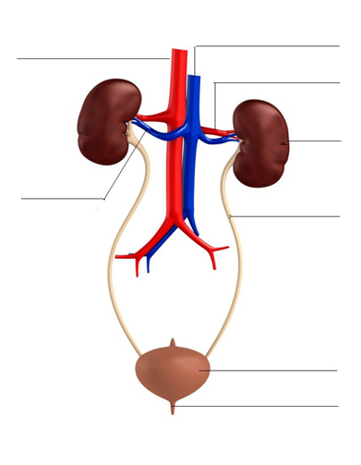
Urethra
Bladder
Renal Vein
Ureter
Kidney
Descending Aorta
Renal Artery
Inferior Vena Cava

