Anatomy & Physiology 12
Gas Exchange in the Respiratory System
(Pg. 354 - 355)

- involves the exchanges of gases in the lungs and also the exchange of gases in the tissues
- because the alveoli are very thin walled there is little resistance to the passage of gases
- the movement of oxygen and carbon dioxide into or out of blood is controlled by the principles of diffusion

External Respiration
- refers to the exchange of gases between air in the alveoli and blood in the pulmonary capillaries
- high CO₂ in blood and high O₂ in alveoli
- carbon dioxide diffuses out of the blood
- oxygen diffuses into the blood
- CO₂ is carried in the blood plasma as bicarbonate ion (HCO₃⁻)
- HCO₃⁻ moves into RBC’s (balanced by Cl⁻ moving out of RBC’s)
- in RBC’s CO₂ is released using the following reaction
- catalyzed by carbonic anhydrase with Zn²⁺ co-enzyme
carbonic anhydrase

H⁺ + HCO₃⁻ ------> H₂CO₃ -------> H₂O + CO₂
hydrogen  ion | bicarbonate  ion | carbonic  acid | water | carbon  dioxide

- some CO₂ is carried by hemoglobin (Hb) as carbaminohemoglobin (HbCO₂)
- H⁺ comes from reduced hemoglobin (HHb)
- Hb is then free to bind to O₂ to becomes oxyhemoglobin (HbO₂)

Hb + O₂ --------------------> HbO₂
 | hemoglobin | oxygen | oxyhemoglobin

Internal Respiration
- refers to the exchange of gases between blood in the systemic capillaries and body tissues
- O₂ is continually being used up in cellular respiration low O₂ and high CO₂ concentrations in body tissues
- O₂ diffuses out of RBC’s in systemic capillary beds
HbO₂ -----------------------> Hb + O₂
 | oxyhemoglobin | hemoglobin | oxygen

- most of the CO₂ combines with water to form carbonic acid
- catalyzed by the enzyme carbonic anhydrase
- dissociates to form H⁺ and HCO₃⁻
carbonic anhydrase

CO₂ + H₂O ----------> H₂CO₃ ----------> H⁺ + HCO₃⁻
carbon  dioxide | water | carbonic acid | hydrogen  ion | bicarbonate  ion

- Hb then combines with the excess H⁺ ions to form HHB
- some of the CO₂ entering into the blood is taken up by HB to form HbCO₂

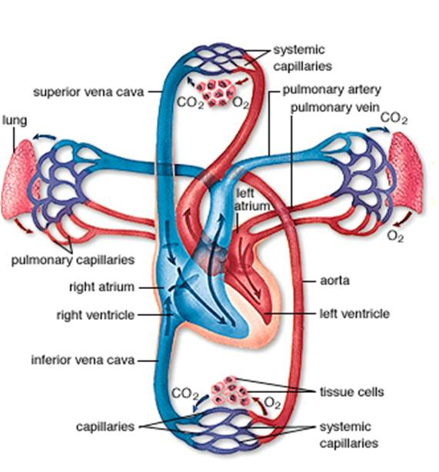

External Respiration (Lungs)
Capillaries of Lungs Alveoli of Lungs
Plasma
O₂
CO₂
CO₂
Hb + O₂
CO₂
HbCO₂
HHb
HbO₂
HCO₃⁻ + H⁺
CO₂
+ H₂O
Carbonic Anhydrase
H₂CO₃
HCO₃⁻
RBC

Internal Respiration (Tissues)
Capillaries in Tissue Tissue Cell
Plasma
RBC
O₂
CO₂
CO₂
Hb + O₂
CO₂
HbCO₂
HHb
HbO₂
HCO₃⁻ + H⁺
CO₂
+ H₂O
Carbonic Anhydrase
H₂CO₃
HCO₃⁻
Mitochondria
(Cellular Respiration)

