Anatomy & Physiology 12
The Respiratory System
(Pg. 346 - 353)

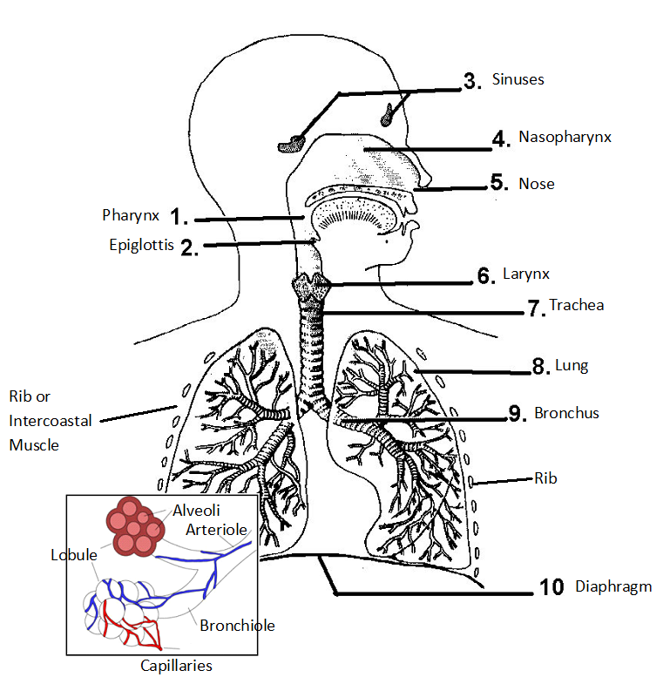
Function of the Respiratory System
- primarily responsible for allowing oxygen from the air to enter the bloodstream and carbon dioxide from the blood to enter the air
- breathing in is called inhalation or inspiration
- breathing out is called exhalation or expiration
- together, they are called ventilation

The Respiratory Tract
- during inhalation air will enter the buccal cavity via the nostrils or the lips
- the air from these two passageways merge at the pharynx
- air will then pass through the voice box or larynx
- function of the voice box is to create various frequencies of sound waved in order to cause speech
- it does this by vibrations of the vocal chords which stretch from the back to the front of the larynx at the sides of the glottis
- air being expelled past these cords causes the vibrations while stretching or relaxing of the cords causes changes in frequencies
- the voice box is really the beginning of a specialized tube called the windpipe or trachea
- the windpipe has rings of cartilage which function to keep the trachea open, and cilia to sweep up debris
- the windpipe then branches off into the left and right bronchus
- further branch into bronchioles
- finally, air will diffuse into the circulatory system through thin-walled, spherical, blind ducts called alveoli

Lungs, Pleural Membrane and Thoracic Cavity
- the lungs are located in the chest or thoracic cavity
- this cavity is completely sealed by the ribs which make up the sides and top of the chest cavity while the diaphragm makes up the floor of the chest cavity
- the pleural membranes completely enclose the lungs and adhere them to the chest and diaphragm
- the two pleural membranes lie very close to each other and are separated by a thin layer of serous fluid
- functions to allow the two layers to slide against one another.

Structure & Function of Alveoli
- alveolar sacs are made up of only one layer of squamous epithelium tissue surrounded by blood capillaries
- a film of lipoproteins lines the alveoli thereby reducing their surface tension and preventing them from closing up
- there may be as many as 274-790 million alveoli in the human lung
- the surface area and capability for gas exchange is tremendous
- their small size, spherical shape, and thin walls which lie close to the blood supply makes alveoli structurally suited for their function

Inspiration & Expiration
- while relaxed, the diaphragm is dome shaped
- inhalation
- diaphragm contracts and lowers
- intercostal muscles between the ribs contract causing the rib cage to move upwards and outwards
- these two muscular reactions cause the volume of the thoracic cavity to increase and the lungs to expand
- this causes the air pressure in the lungs (and alveoli) to decrease
- in comparison to the outside air pressure, the lungs have a negative pressure and air will flow naturally into the lungs via the mouth and nose
- humans breathe by negative pressure because air does not force the lungs open, but is sucked in by the partial vacuum created by increasing the size of the thoracic cavity

- exhalation
- a passive phase of breathing
- intercostal muscles between the ribs relax allowing the rib cage to move down and inwards
- diaphragm moves upwards
- causes a decrease in the volume in the thoracic cavity and forces air out of the lungs
- alveoli are kept open by the presence of surfactants within the alveoli and a decrease in the pleural pressure

Control of Breathing
- two prime stimuli that cause us to breathe are the concentrations of hydrogen ions and carbon dioxide in the blood
- when these levels become high they are detected by chemoreceptors in the breathing (respiratory) center in the medulla oblongata (the stem portion of the brain)
- rib (intercostal) muscles and the diaphragm are caused to contract via the efferent (phrenic) nerve
- nerve impulses from the expanded lung's stretch receptors in the alveoli by way of the afferent (vagus) nerve then inhibit the respiratory center
- lack of stimulation will also cause the rib muscles and diaphragm to relax causing exhalation

