Anatomy & Physiology 12
Digestive System

The Digestive Tract (pg. 266-273)
The 3 functions of the digestive tract are:
- Ingestion and breakdown of food particles into monomers
- Absorption of nutrients and water
- Elimination of indigestible materials

Two types of digestion:
- Mechanical Digestion - the physical breakdown of food into smaller particles to increase the amount of surface area available for digestive enzymes to work on
- Chemical Digestion - the chemical breakdown of nutrient polymers into monomers that can then be absorbed by the digestive tract

Parts of the digestive tract.

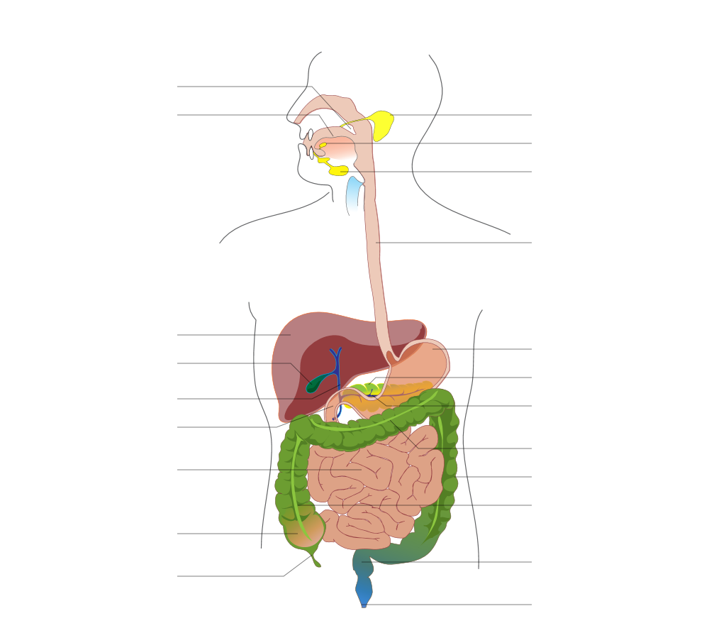
Small Intestine
Jejunum & Ileum
Pharynx
Liver
Gall Bladder
Common Bile Duct
Duodenum
Cecum
Appendix
Tongue
Pancreatic Duct
Pancreas
Esophagus
Stomach
Large Intestine
Transverse Colon
Descending Colon
Ascending Colon
Anus
Rectum
Salivary Glands

Pathway of Food

- Mouth
- Location where food enters the body
- Lips hold food in the mouth
- Tongue moves food particles around so that the teeth can work on it
- Mechanical digestion of food as the teeth start to physically break it down into smaller parts and mixes saliva in to the food
- Saliva starts the chemical digestion of starches and some lipids
- Separated from the nasal cavity by the hard and soft palates

- Pharynx
- Area at the back of the throat where the esophagus and the trachea divide at the glottis (opening to the trachea)
- When swallowing, the soft palate moves up blocking off the opening to the nasal cavity and the trachea moves up so that the epiglottis (skin-covered cartilage) blocks off the glottis forcing food down the esophagus

- Esophagus
- Muscular tube that connects the pharynx to the stomach
- the food bolus is pushed down the esophagus by rhythmic, muscular, wave-like contractions called peristalsis
- Bolus passes through the esophageal or cardiac sphincter (ring of muscle) to enter into the stomach

- Stomach
- Mechanical digestion continues as the strong muscular stomach walls churn the food bolus together with gastric digestive juices
- Chemical digestion of proteins starts in the stomach
- Absorption of alcohol and some liquids are absorbed by the stomach
- pH of the stomach is between 1.5 to 3.5 (highly acidic) which helps to kill most bacteria and other microbes in the food we eat
- Lining of the stomach is covered in deep folds called rugae that allow for the stomach to expand as it fills with food
- Mixture of food and digestive juices if now called chyme
- Movement of chyme out of the stomach and into the small intestine is regulated by the pyloric sphincter

- Small Intestine
- Called the small intestine because of its narrow diameter (2.5 cm); approximately 6 m in length
- Inner lining of the small intestines is covered in folds called villi, which in turn are covered in smaller folds called microvilli, that function to increase the surface area to maximize the absorption of nutrients

- Duodenum
- First 25 cm of the small intestine
- Receives bile from the gall bladder through the common bile duct
- Receives enzymes and sodium bicarbonate from the pancreas through the pancreatic duct
- Secretes some digestive enzymes as well
- Chemical digestion of carbohydrates, fats, proteins and nucleic acids continues here

- Jejunum and Ileum
- Absorption of sugars, glycerol, fatty acids, amino acids, phosphate groups, bases and fat soluble vitamins (A, D, E, and K) occurs here
- Sugars and amino acids absorbed by the villi directly enter into blood capillaries of the circulatory system
- Glycerol and fatty acids absorbed by the villi are shunted into a lacteal (part of the lymphatic system) before being secreted into the veins of the circulatory system

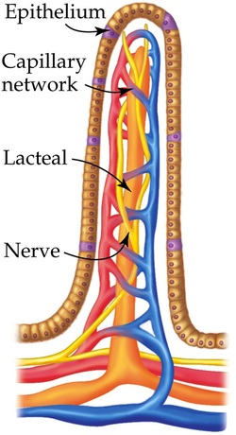
- Large Intestine
- Called the large intestine because it is larger in diameter (6.5 cm), but only about 1.5 m long
- Absorbs water, salts and water soluble vitamins (B and C)
- Appendix attaches in the small pouch at the start of the large intestines called the cecum; may be a "warehouse" for helpful bacteria that colonizes the large intestine
- Bacteria feed on the undigested materials and produce some of the vitamins that we need
- Escherichia coli (E. coli)
- Produces vitamin K used by the liver to produce blood clotting proteins.
- Prevents pathogenic bacteria from colonizing the intestines.
- Other bacteria help us to partially digest cellulose from plant cell walls and produce some of the B complex vitamins.
- About 40-50% of fecal matter is composed of bacteria and other microbes
- Last 20 cm of the large intestine where feces is stored until it is eliminated from the body is called the rectum

- Anus
- Exit of the digestive tract
- Defecation is controlled by 2 sets of anal sphincter muscles that relax when signaled by the nervous system

