Anatomy & Physiology 12
Circulation – The Heart

The Heart
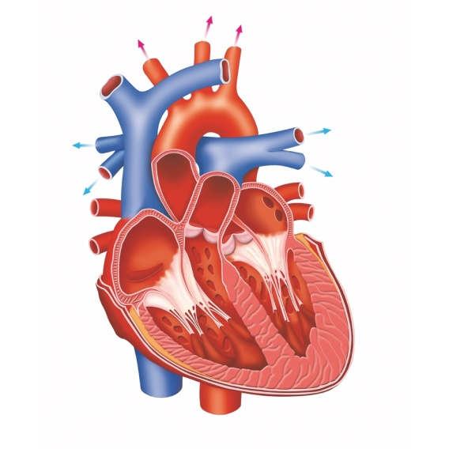
Papillary Muscles
Right Ventricle
Posterior Vena Cava
Left Ventricle
Septum
Pulmonary Valve (Semilunar Valve)
Tricuspid Valve (Atrioventricular Valve)
Right Pulmonary Vein
Papillary Muscles
Chordae Tendineae
Chordae Tendineae
Apex
Aortic Valve (Semilunar Valve)
Bicuspid Valve (Atrioventricular Valve)
Left Pulmonary Vein
Left Pulmonary Artery
Right Pulmonary Artery
Left Atrium
Aorta
Right Atrium
Superior Vena Cava
Pulmonary Trunk

- pine cone-shaped shaped organ located in the thoracic cavity between the lungs and behind the sternum
- major portion of the heart is the myocardium which is made up of cardiac muscle
- endocardium is found on the inner surface of the heart
- outside of the heart is covered with an epithelial tissue called pericardium, which forms a sac called the pericardial sac
- separated into two halves by a thick-walled structure called the septum
- inside is separated into four chambers
- upper chambers are called atria (or auricles) that have thin walls
- lower chambers are called ventricles that are larger in size and have thicker walls
- heart valves prevent backflow of blood through the chambers
- atrioventricular valves lie between the atrium and ventricles and are supported by fibrous strings called chordae tendineae that prevent the valves from inverting when the ventricles contract
- atrioventricular valve on the right side is called the tricuspid valve
- atrioventricular valve on the left side is called the bicuspid or mitral valve
- semilunar valves occur between the ventricles and the vessels

Heartbeat
- heartbeat is intrinsic meaning that it can beat independently of any outside nervous stimulation
- a special type of tissue called nodal tissue has characteristics of both muscular and nervous tissue and is responsible for this ability
- 2 nodes that control the heartbeat
- the pacemaker or sinoatrial (SA) node is found at the upper dorsal wall of the right atrium
- the atrioventricular (AV) node is found at the base of the right atrium near the septum
- the pacemaker sends out an excitation impulse every 0.85 seconds to cause the atria to contract
- when the impulse reaches the AV node, the ventricles are signaled to contract via atrioventricular and Purkinje fibers
- when the SA node fails to work properly, the heart beats slower or irregularly
- when this occurs, an artificial pacemaker must be implanted

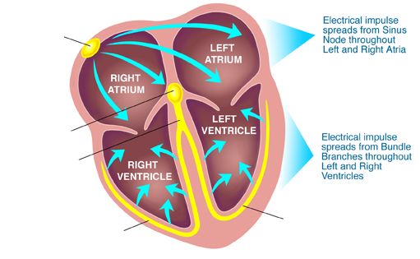
SA Node
Purkinje fibers
AV Node
Bundle of His
Purkinje fibers
- the heart beats an average of 72 times per minute - equals 2.65 billion beats in 70 years
- all mammal’s hearts (except humans) beat roughly 1 billion times
- smaller the animal – the faster the heart beats – the shorter the life span

Pathway of Blood Through the Heart
- from the body, blood enters the right atrium of the heart via the superior and inferior vena cava
- blood is pumped into the right ventricle as the atria contract
- when the ventricles contract, blood is pushed out of the heart and into the pulmonary arteries to travel to the lungs where it exchanges carbon dioxide for oxygen
- blood comes back from the lungs through the pulmonary vein and enters the left atrium
- from there, blood travels down into the left ventricle, and then out to the rest of the body through the aorta

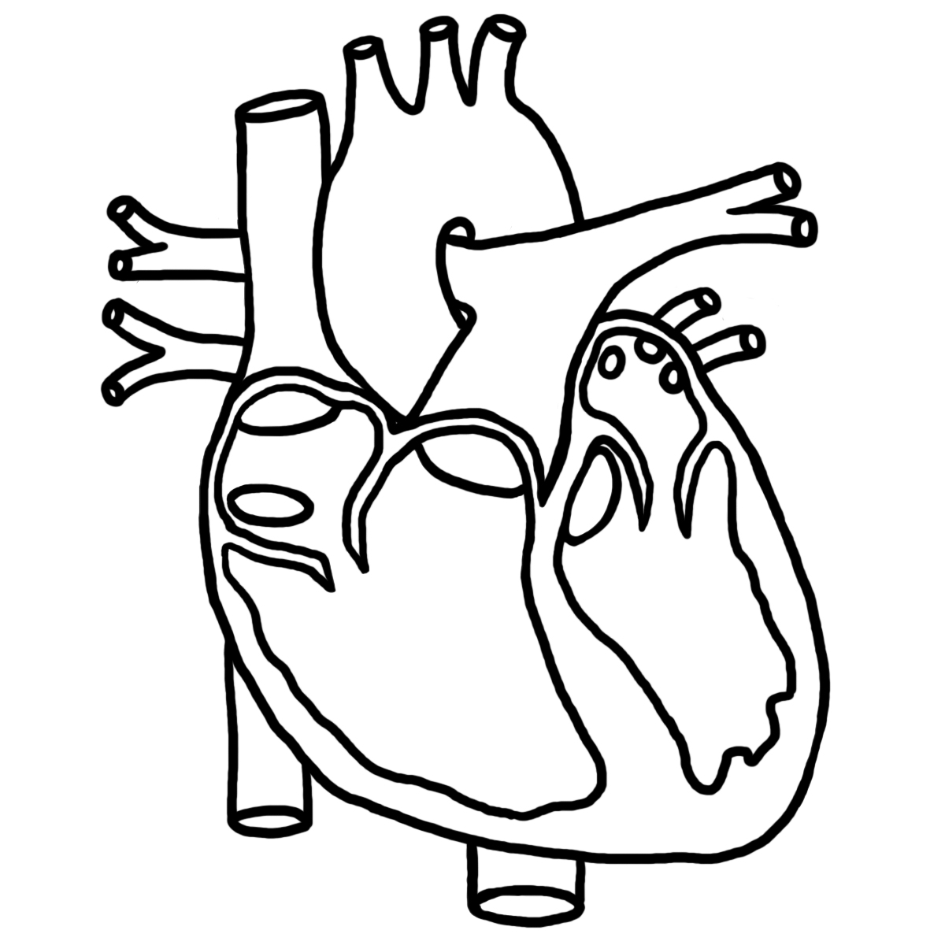
From Lungs
From Lungs
LV
LA
RV
RA
From Body
From Body
To Body
To Lungs
To Lungs

- the contraction of the left ventricle can be felt in the fifth intercoastal rib space along the mid-clavicular line

Blood Supply to the Heart
- the heart tissue is supplied with oxygen and nutrients by its own system of blood vessels
- Coronary Arteries (Right and Left)
- the first two arteries off of the aorta
- come off just superior to the aortic valve
- feed the two sides of the heart separately
- Cardiac Veins
- left side of heart drains into the great cardiac vein
- right side of heart drains into the small cardiac vein
- both cardiac veins drain into the coronary sinus, which drains directly into the right atrium through a valve

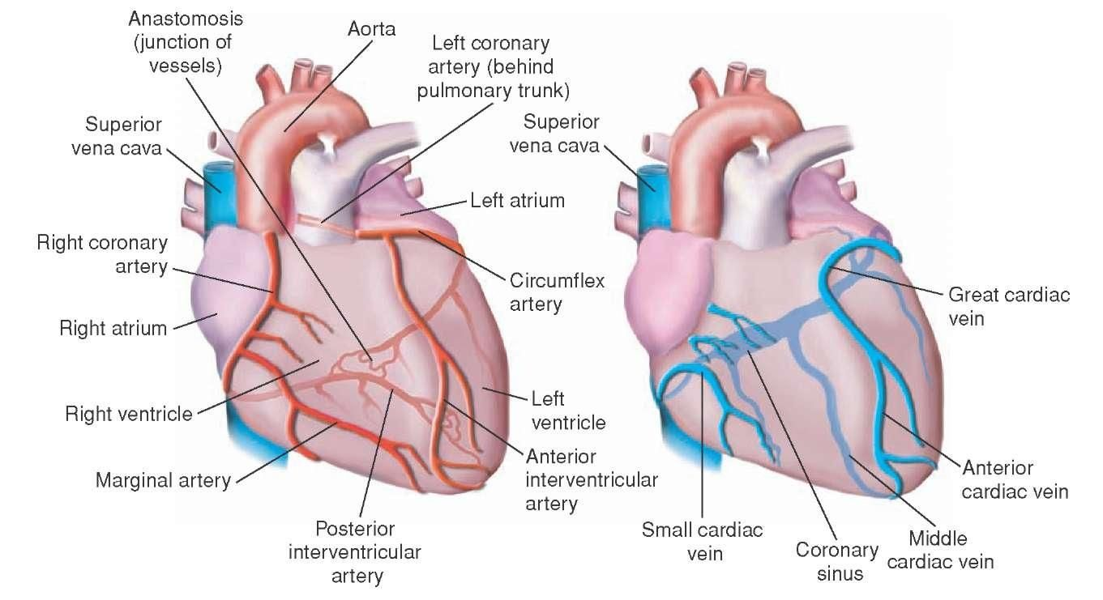

Nervous System Control of the Heartbeat
- the medulla oblongata can alter the heart rate by way of the autonomic nervous system (controls involuntary muscles)
- the autonomic nervous system is made up of two divisions called the parasympathetic and the sympathetic nervous systems
- at times of stress, the sympathetic nervous system regulates the heart rate and speeds it up
- at times of normalcy, the parasympathetic nervous system regulates the heart rate and slows it down
- factors such as low levels of oxygen in the blood will stimulate receptors in the medulla oblongata to increase the heart rate

Blood Pressure
- the pressure of the blood against the wall of a vessel created by the pumping action of the heart is called a pulse
- this pressure is measured by a device called a sphygmomanometer
- two pressures are recorded
- the systolic pressure indicates the pressure in the arteries when the heart is contracting
- the diastolic pressure and indicates the pressure in the arteries when the heart is relaxed and refilling with blood
- the normal pressure of a person at rest is approximately 120/80
- factors that can affect blood pressure are:
- physical activity
- CO₂ levels increase, O₂ levels decrease causes an increase in heartbeat
- distance from the left ventricle
- more area serviced decrease in pressure
- diet (eg: salt)
- increased salt levels more water moves into blood out of cells increased blood volume and pressure
- atherosclerosis
- buildup of plaque on the inside of the arteries narrowing of the passage for blood causes increased blood pressure
- arteriosclerosis
- hardening of the arterial walls (not as elastic) cannot expand as much during ventricular contraction increased blood pressure

