Anatomy & Physiology 12
Circulation – Blood

Do intro activity pg. 296.

Blood (pg. 299-305)
- A liquid connective tissue that has many functions
- transports nutrients, water and metabolic waste products around the body
- transports hormones
- helps regulate body temperature
- helps regulate blood pressure
- helps protect against invasion by pathogens
- helps heal cuts and other wounds

Two Parts of Blood
- Plasma
- 55% of blood is plasma
- 90% of plasma is water
- 7-8% of plasma are plasma proteins
- because they are too large to leave the capillaries, the solute concentration in the capillaries is higher than in tissue cells, so water diffuses into the capillaries --> helps maintain blood volume
- used in transporting large organic molecules such as cholesterol and bilirubin
- antibodies for fighting infection
- fibrinogen used for blood clotting
- also contains nutrients, gases, hormones, vitamins, and waste products
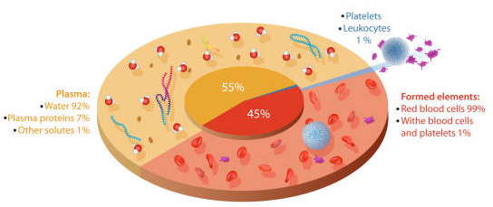
https://www.istockphoto.com/vector/blood-composition-diagram-gm1547970269-526198389?searchscope=image%2Cfilm
- Formed Elements
- 45% of the blood
- composed mainly of red blood cells (> 44%), and white blood cells and platelets (< 1%)
- Red Blood Cells
- approximately 7-8 um in diameter
- made by bone marrow
- has no nucleus life span of 120 days
- contain hemoglobin --> red iron-containing pigment that carries oxygen
- biconcave shape
- maximize surface area:volume ratio maximizes diffusion of oxygen across the cell membrane
- maximizes flexibility
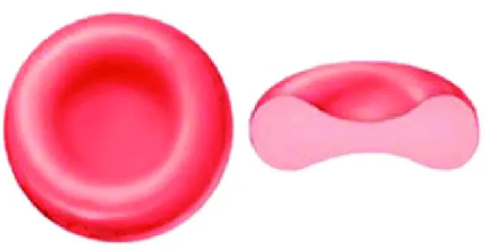

- White Blood Cells
- important in fighting off infections

Blood Clot Formation
- also referred to as coagulation
- three components necessary for this process
- platelets
- manufactured by the fragmentation of large cells called megakaryocytes located in the bone marrow
- prothrombin (a globular protein)
- manufactured in liver
- Vitamin K is necessary for the production of prothrombin, therefore the lack of it in the diet is linked to hemorrhagic (bleeding) disorders
- fibrinogen
- manufactured in the liver

- when a blood vessel has been damaged
- platelets clumping together at the site of injury partially seals the puncture
- injured tissues release a chemical called prothrombin activator converts prothrombin to thrombin (requires Ca²⁺)
- thrombin acts as an enzyme to convert fibrinogen to fibrin by severing two short amino acid chains from each fibrinogen molecule
- the amino acid chains link end-to-end to form long threads
- these threads wind around the platelet plug to form a framework which traps red blood cells

Blood Typing
- two possible antigens present on red blood cells antigen A and B
- if A antigen present type A blood
- if B antigen present type B blood
- if both antigens present type AB blood
- if neither antigen present type O blood
- within the plasma of a person there are antibodies to these antigens
- type A blood has the B antibody
- type B blood has the A antibody
- type AB blood has neither antibody
- type O blood has both antibodies
- if the donor's blood type matches the antibodies in the recipient’s blood, then it is not compatible and agglutination will occur donor’s blood cells clump together inside the blood vessels
- this is dangerous because this condition may lead to heart attack or stroke

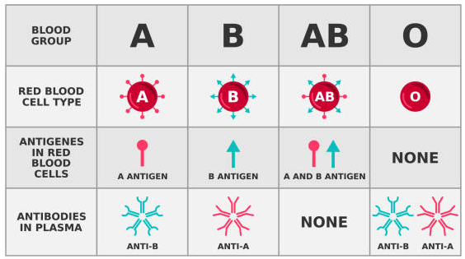
https://www.istockphoto.com/vector/abo-blood-group-system-blood-groups-with-anitigens-and-antibodies-gm2135107973-568202244?searchscope=image%2Cfilm

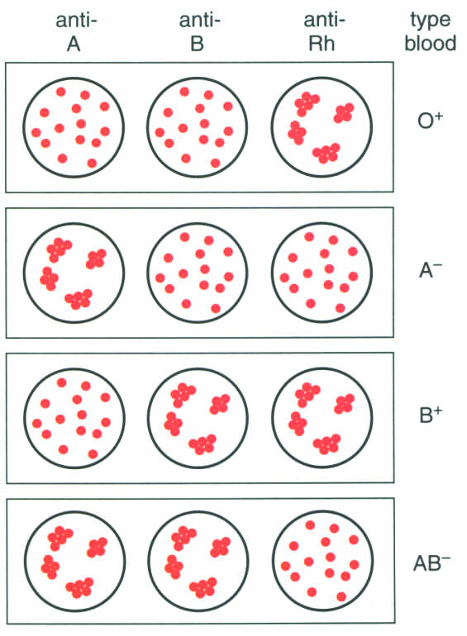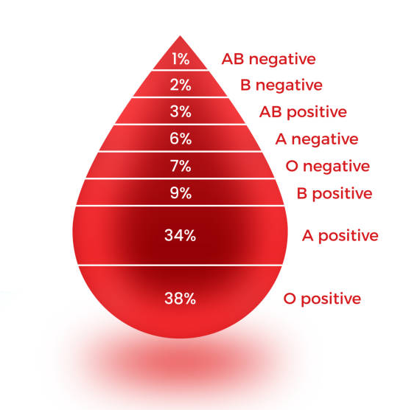
www.istockphoto.com/vector/blood-types-infographic-gm1319647358-406450512?searchscope=image%2Cfilm

Questions
- What is the shape of a red blood cell? What is this shape helpful for a red blood cell to have?
- What is the name of the oxygen carrying pigment in blood?
- Name the three types of Granular Leukocytes and state the main function of each?
- Name the two types of Agranular Leukocytes and state the main function of each?
- Indicate successful blood transfusions:
A to B | __________ | A to AB | __________ | A to O | __________
A to A | __________ | B to B | __________ | B to AB | __________
B to O | __________ | B to A | __________ | AB to B | __________
AB to AB | __________ | AB to O | __________ | AB to A | __________
O to B | __________ | O to AB | __________ | O to O | __________
O to A | __________

- In the three circles below, draw in the results of blood typing for someone who is blood type A+.
 | Anti A | Anti B | Anti Rh

