Anatomy & Physiology 12
Circulation – Blood Vessels

Blood Vessels (pg. 298-299)
The five types of blood vessels in your body are:
- Arteries carries blood away from the heart
- Veins carries blood towards the heart
- Capillaries exchanges materials with the tissues
- Arterioles small branches off of the arteries
- Venules small branches off of the veins

- called a closed circulatory system circulating blood is always contained in the above vessels and the heart
- total length of blood vessels in the average human body equals approximately 96,000 km - this would circle the Earth about 2.4 times

- arteries and veins are composed of three layers
- inner layer of simple squamous epithelium connected to a layer of connective tissues that contain elastic fibres
- middle layer made up of smooth muscle that contract to help regulate blood flow
- outer layer of fibrous connective tissue near the middle layer and loose connective tissue near the outside
- the thickness of the layers varies depending on the type of blood vessel

- Arteries
- thickest middle layer containing smooth muscle; can contract to regulate blood flow and blood pressure
- blood flow is maintained by the pumping of the heart

- Arterioles
- average about 0.5 mm in diameter
- middle layer composed mainly of smooth muscle with some elastic fibres

- Veins
- thicker layer of outer connective tissue, but thinner layer of middle smooth muscle overall is thinner than an artery, but can expand more than arteries
- blood flow is due primarily to contractions of skeletal muscles
- valves in the veins prevent backflow of blood against the force of gravity
- if a valve weakens or damaged, pooling of blood can occur causing expansion of the vein called varicose veins
- contains about 70% of the blood in the human body
- muscles beside the veins can contract to provide more blood to the rest of the body

- Venules
- connect capillaries to veins
- similar to arterioles in composition

- Capillaries
- one cell wide in diameter (8-10 um)
- walls are composed of a single layer of epithelium with some basement membrane
- join arterioles to venules
- form capillary beds in almost all tissues (approximately 6000 m² in the human body)
- capillary beds are the location where oxygen and nutrients are given to cells in exchange for carbon dioxide and metabolic wastes
- not all capillary beds are open at the same time
- precapillary sphincters can close off capillary beds forcing the blood to travel directly from an arteriole to a venule along a arteriovenous shunt (or anastomoses)

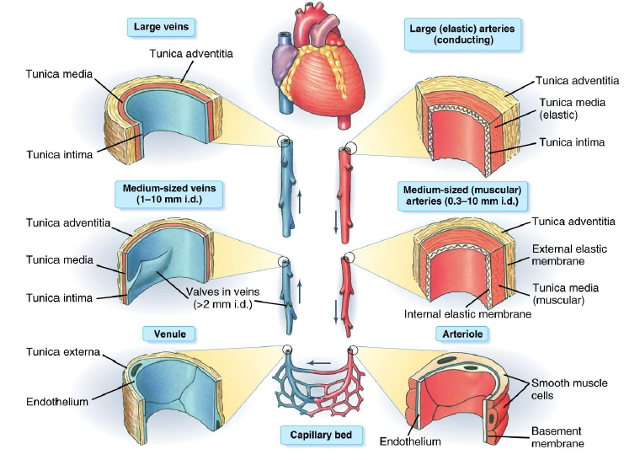

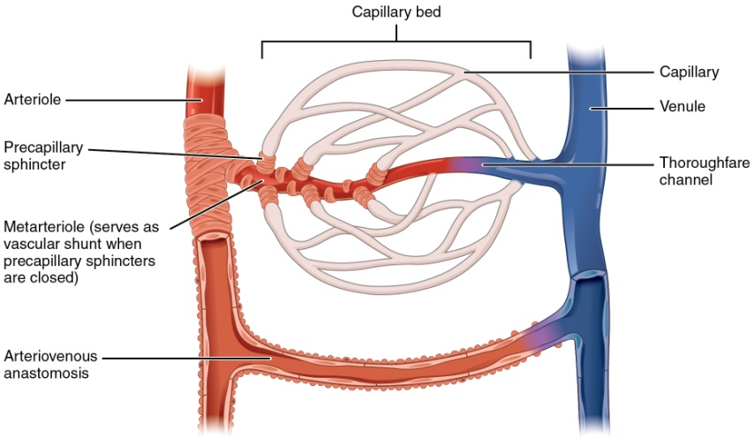
General Path of Blood Through Body (pg. 311-313)
- Pulmonary System
- brings blood from the right side of the heart to the lungs to become oxygenated and then back to the left side of the heart

- Systemic System
- brings blood from the left side of the heart to the body and then back to the right side of the heart

Head
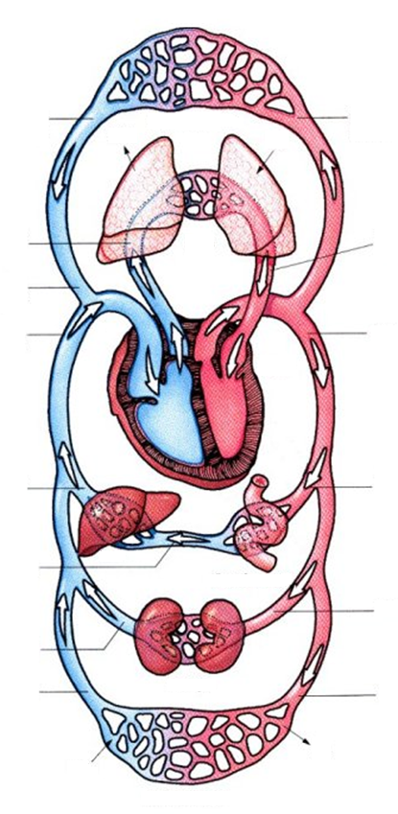
Subclavian Artery
Subclavian Vein
Pulmonary Vein
Pulmonary Artery
Inferior / Posterior Vena Cava
Portal Vein
Hepatic Portal Vein
Renal Vein
Iliac Vein
Iliac Artery
Renal Artery
Mesenteric Artery
Heart
Aorta
Superior / Anterior Vena Cava
Carotid Artery
from arms
to arms
Jugular Vein
Digestive Tract
CO₂
O₂
Trunk and Legs
Kidneys
Liver
Lungs
O₂
CO₂

- Portal Systems
- part of the systemic system
- where a capillary bed is drained by venules that then connects into another capillary bed

Questions
- What is the largest artery in the human body? What are the largest veins?
- List several specific substances that diffuse across capillary walls.
- What is the definition of an artery? Of a vein?
- When would precapillary sphincters of the digestive system capillary beds be relaxed (open)?
- When would precapillary sphincters of the muscle system capillary beds be relaxed (open)?

