Sexual Reproduction and Meiosis

Key Concepts
- I can describe sexual reproduction as the combining of male and female reproductive cells to produce a zygote.
- I can describe how sexual reproductive cells are formed by the process of meiosis.

Sexual Reproduction
- Requires two parents.
- Produces offspring that are genetically different from each other, from either parent, and from any other member of their species.
- Most common life cycle in multicellurlar eukaryotic cells such as animals, plants and fungi
- Variation, or inherited genetic differences, is called genetic diversity.

Sex Cells
- Sex cells are also known as gametes.
- Gametes: male or female reproductive cells.
- The male parent contributes one gamete, the sperm cell.
- The female parent contributes the other gamete called the ovum or egg shell.

Fertilization
- Fertilization: the combining of male and female reproductive cells.
- The nuclei of the two gametes fuse together to produce a single cell called a zygote.
- The zygote is the first cell that develops into a new organism containing genetic information from both the sperm cell and the egg cell.
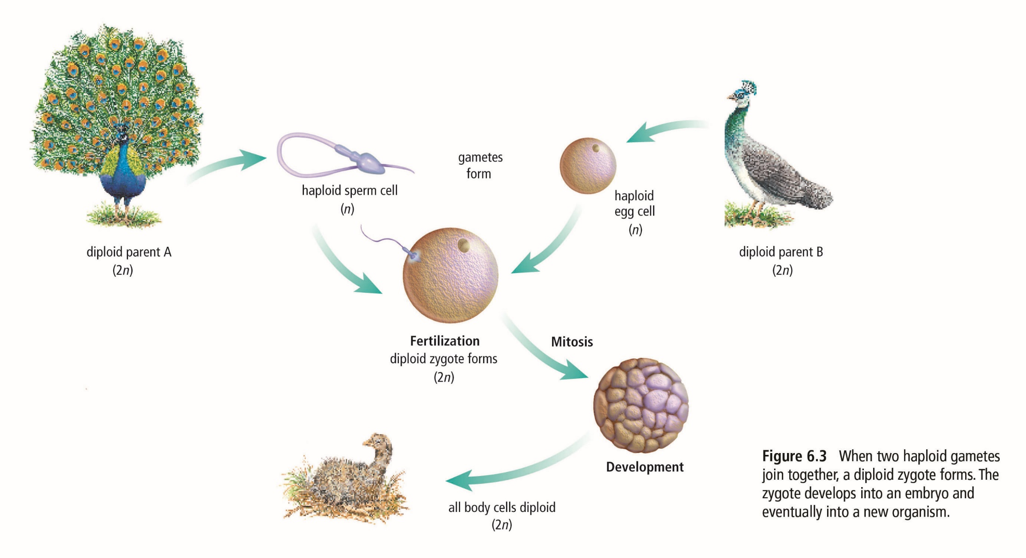
The Role of Gametes
- Humans have 46 chromosomes that are organized into 23 pairs.
- Chromosomes that are paired are called homologous chromosomes.
- They have similar features and carry similar genetic information.
- During fertilization, each parent contributes one chromosome of each pair.
- Cells with half the normal number of chromosomes, such as gametes, are called haploid cells.
- Our body cells, which have a full number of chromosomes, are called diploid cells.
- Diploid cells (2n) are called such as they contain 2 full sets of chromosomes (in humans, 23 chromosomes form 1 complete set)
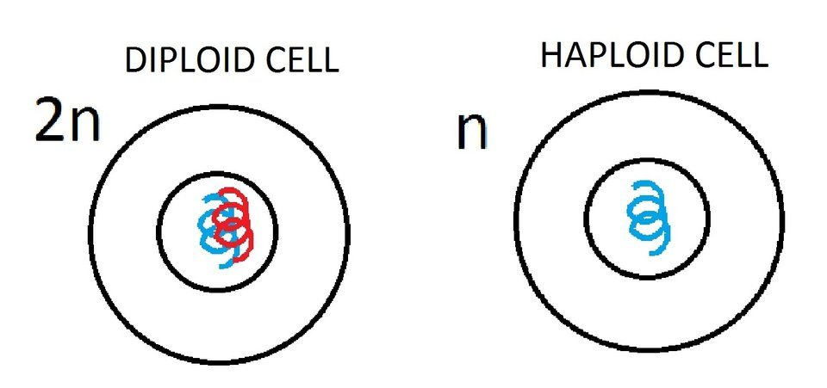

Meiosis
- Has 2 stages Meiosis 1 and Meiosis 2
- a diploid cell dividing twice to produce four haploid cells.
- Offspring are genetically different from their parents and from one another because the gametes that a parent produces are not all genetically the same.
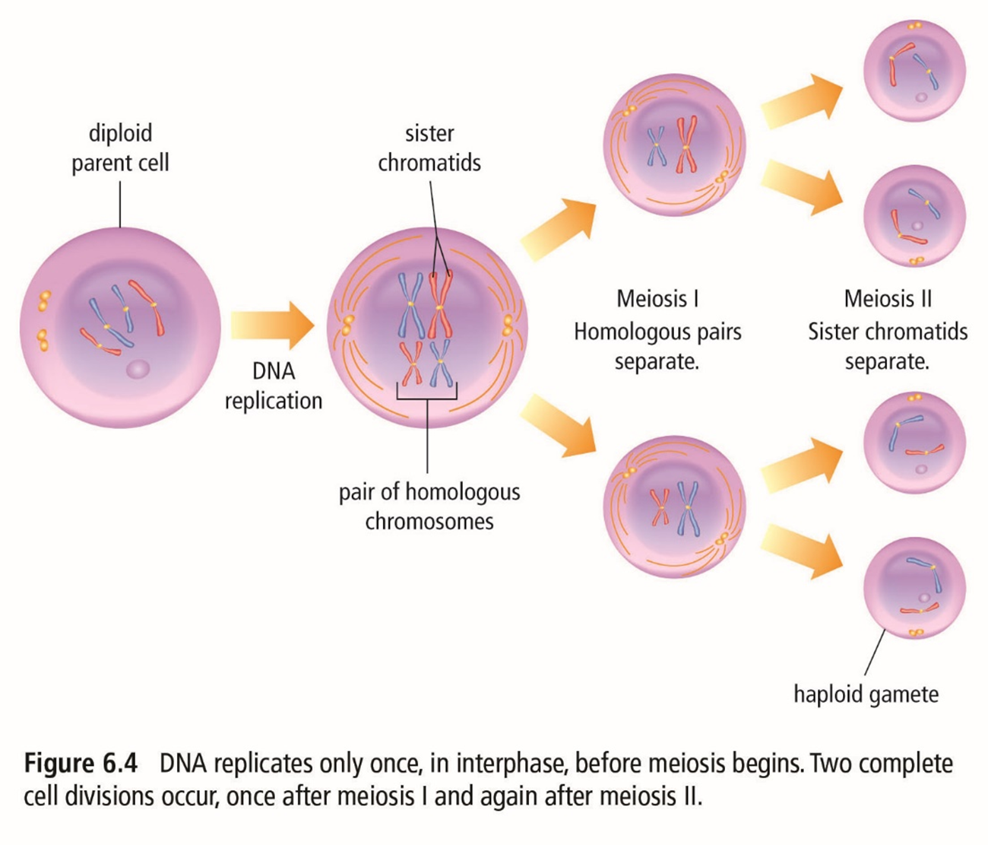
- Meiosis I
  - Prophase I
    - Nuclear membrane begins to disappear.
    - DNA condenses into duplicated chromosomes and homologous chromosomes are paired.
  - Metaphase I
    - Spindle fibres guide chromosome movement.
    - Homologous chromosome pairs line up along the middle of the cell.
  - Anaphase I
    - Homologous chromosome pairs separate and go to each end of the cell.
  - Telophase I
    - Two nuclei form and each nucleus contains a complete copy of the cell’s DNA.
    - The cell divides.
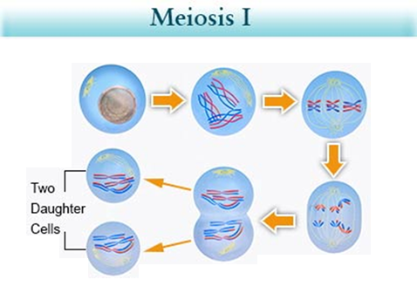
Cytokinesis
Anaphase I
Telophase I
Metaphase I
Prophase I
Interphase
- Meiosis II
  - Prophase II
    - Nuclear membrane begins to disappear.
    - DNA exists as chromosomes.
  - Metaphase II
    - The chromosomes line up along the middle of the cell.
  - Anaphase II
    - The copies of DNA are separated and go to each end of the cell.
  - Telophase II
    - Four nuclei form.
    - The cells divide, forming four new cells.

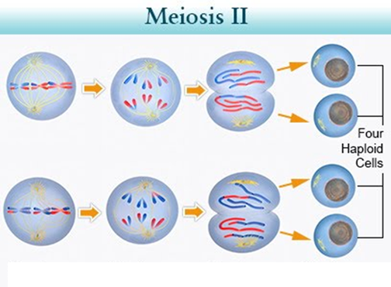
Telophase II
Anaphase II
Metaphase II
Cytokinesis

Assignment:
- Worksheets
- Pg. 48 #1-2
- Pg. 51 #1-2

