Asexual Reproduction

Key Concepts
- I can describe the process of budding and identify what type of organisms use it to reproduce.
- I can describe how spores are produced and what type of organisms use them to reproduce.
- I can describe the different methods plants use to reproduce asexually.

Budding
- Involves the formation of an outgrowth or bud from a parent cell
- Breaks or pinches off from parent
- New cell is smaller than original to start
- Eventually grows to the same size as other cells

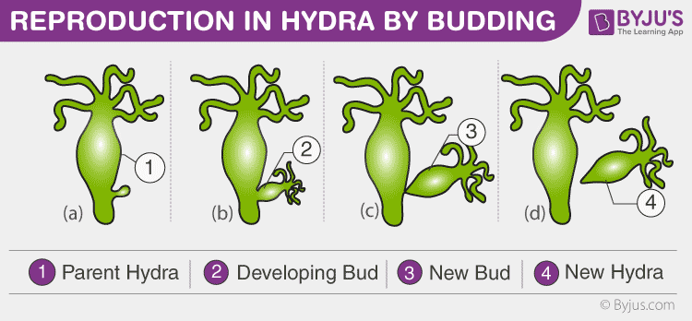

- Yeasts are unicellular eukaryotic cells and most commonly reproduce by budding
- Yeasts: used to make pizza dough, bread, pretzels, cheese, vinegar, etc.
- Examples: yeast, hydra, sponges, worts

Spores
- Spores: a structure that produces a new organism by asexual reproduction.
- Moulds release spores into the air from a structure called a sporangium.
- When a spore lands in a favourable conditions (warm and moist environment) – such as a piece of bread– it begins to grow and divide by mitosis and cytokinesis, and eventually produces more mould.
- Have thick cell walls that protect them until conditions are optimum for growth. Can survive a long time in this state.
- Examples: moulds, fungi, mushrooms, algae, puffballs
- Moulds are unicellular eukaryotic cells. Can break down food to use as nutrients

Vegetative Propagation
- A new plant grows from a portion of a root, stem or leave of an existing plant
- New plants are copies or clones of the parent plant
- A clone is an exact copy of a cell or organism
- Plants can reproduce both asexually and sexually.
- Examples daffodil bulbs, aspen shoots, strawberry runners, potatoes
- Potatoes: new roots and shoots grow from the eyes of a potato
- Can plant this potato and a new potato plant will develop, identical to the parent plant.
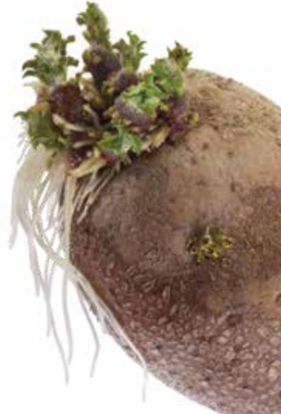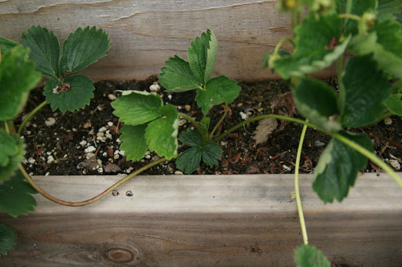

Artificial Vegetative Propagation
- Used by farmers, gardeners to produce plants with specific characteristics
- Can produce a large number of plants quickly and consistently to meet specific needs.
- Common methods: splitting, grafting, cutting, simple layering, air layering and tissue culture.
- Grafting: a bud, stem or root is cut from one plant and joined to another.
- Used to produce trees with high quality fruit or resistance to disease.

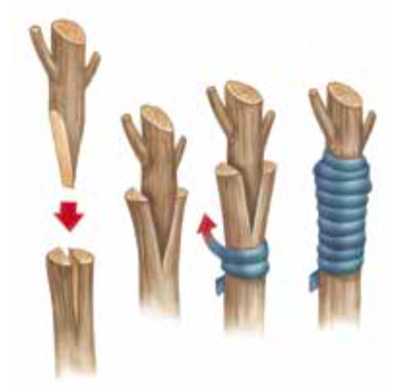
Fragmentation
- Small part of animal breaks off and grows into new organism
- The fragment must contain enough genetic material to grow into a new organism
- Examples: sea stars, planaria
- Note: Fragmentation is not regeneration!

Characteristics of Asexual Reproduction
- Only one organism is required
- Quick (single organism can result in huge numbers of offspring)
- All offspring are clones (genetically identical)
- Prokaryotes only reproduce this way
- Some eukaryotes reproduce this way. (simple plants

Assignment:
- Pg. 29 #1-2
- Pg. 30 #1
- Pg. 33 #1-2
- Pg. 35 #1-4, 6, 8
- Worksheet

