Bacterial Reproduction

Key Concepts
- I can explain how bacteria reproduce by binary fission.

Prokaryotic Cells
- A prokaryotic cell does not have a separate nucleus.
- In addition to lacking a nucleus, they are simpler than the other type of cells.
- They have fewer internal structures.

Bacteria are prokaryotic cells
- Has a cell wall, cell membrane, DNA, and ribosomes.
- Some have flagella.
- Bacteria is in, on, and all around us.
- Bacteria used to make cheese and yogurts (dairy products).
- Bacteria in the digestive tract help to break down plant products and make vitamins.
- Found in hot springs.
- Diseases like strep throat are caused by bacteria.
- Bacteria can rot teeth.

Characteristics of Asexual Reproduction
- Only one organism is required
- Quick (single organism can result in huge numbers of offspring)
- All offspring are clones (genetically identical)
- Prokaryotes only reproduce this way
- Some eukaryotes reproduce this way. (simple plants

Reproduction by Binary Fission
- Binary Fission: a type of asexual reproduction in which a parent cell splits into two daughter cells that have identical genetic information (DNA)
- One cell becomes two independent, identical cells.
- Examples of organisms that reproduce this way are: bacteria, algae, amoeba and protozoa.

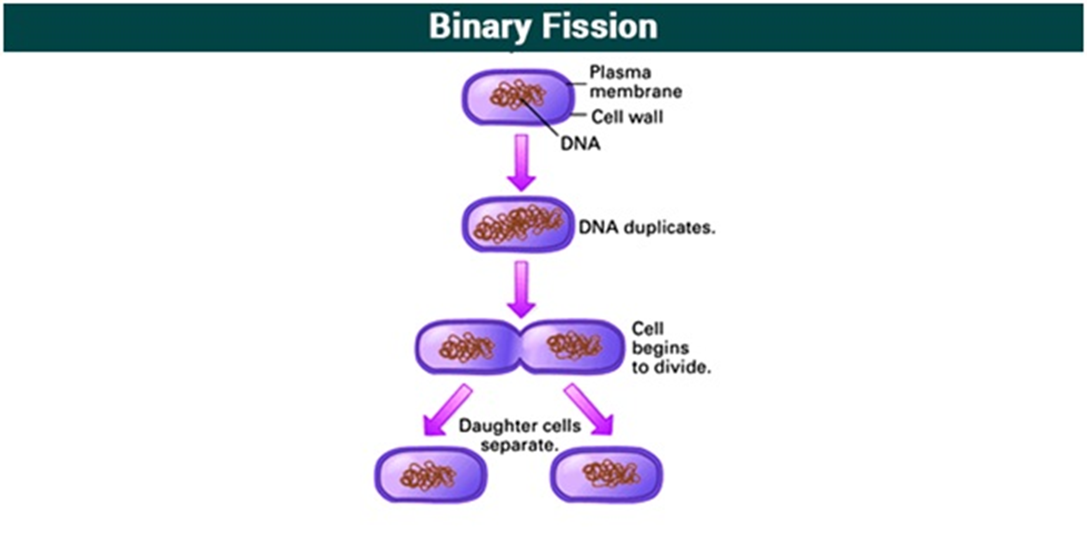
Exponential Growth!
- Every time bacteria reproduces, the number of bacteria doubles.

Questions:
- If a population of bacteria starts with one bacterium and divides every 15 minutes. How many bacteria will we have after an hour?

- If a population of bacteria starts with one bacterium and divides every 10 minutes. How many bacteria will we have after 2 hours?

Assignment:
- Pg. 36 Activity 1-D #1-4, 6
- Pg. 23 #1
- Worksheet

