Cell Cycle and Mitosis
Key Concepts
- The cell cycle has 3 major phases
- Mitosis has 4 major phases

The cell cycle
- There are three main stages:
- Interphase
- Mitosis
- Cytokinesis

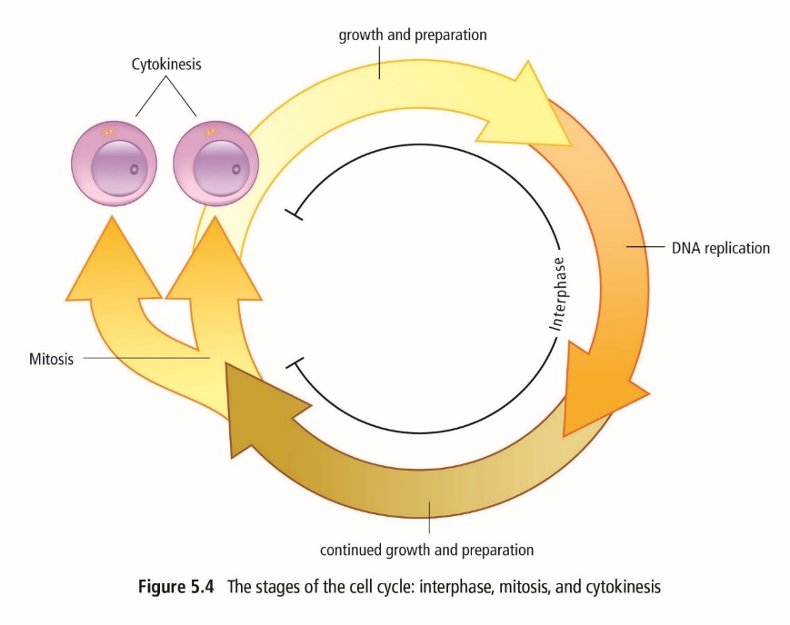

- Interphase:
- cells carry out functions necessary for survival and cells that divided prepare for reproduction
- longest stage in the cell cycle
- cell roughly doubles everything in the cytoplasm
- early in interphase, cell increases in size and makes the proteins and molecules necessary for cell to function. Some organelles begin to duplicate.
- DNA then copies or makes a “replica” of itself in a process called replication
- To replicate itself, the 2 sides of the DNA ladder break apart and each side becomes a template where a new side forms.
- The process results in 2 new DNA molecules.

- Mitosis: divides the duplicated contents of the cell’s nucleus into 2 equal parts
- Shortest stage
- Contents of the cell’s nucleus divide
- 2 daughter nuclei form, each with the same number and kind of chromosomes as the original cell.
- Consists of 4 phases: prophase, metaphase, anaphase and telophase

- Cytokinesis:
- separates the two nuclei and cell contents into two daughter cells.
- The new cells are identical to the original parent cell

