Ionic Bonding

Ions
- Charged atoms; gains or loses to fill its valence shell (outer electron orbital)
- These extra electrons come from other atoms that are trying to fill their valence shells

Chemical bonds - the relatively strong force of attraction that hold atoms together in a molecule.
- Orally: There are two types of chemical bonds that we will focus on this chapter. Ionic and covalent. Today the focus is ionic bonding.

Ionic Bonding
- Bonding of two or more oppositely charged ions.
- Metal atoms have electrons to give from the outer valence forms a positive ion called a cation.
- Non-metal atoms need to accept electrons to fill the outer valence forms a negative ion called an anion.
- When this happens, the ions become bonded together (opposite charges attract.)
- Example: lithium and fluorine

9 1-
F
Fluorine
19.0
____ P
____ N
____ P
____ N
3 1+
Li
Lithium
6.9

____ P
____ N
____ P
____ N

- Example: beryllium and fluorine (charges must balance)

9 1-
F
Fluorine
19.0
4 2+
Be
Beryllium
9.0

Lewis Diagrams

- An easier way of showing bonding between atoms is using Lewis diagrams use solid dots to represent valence or outer electrons.

Orally:
Question: Why only show the valence shell electrons?
Answer: Because these are the electrons that are directly involved in bonding.
The pattern that exists for the number of valence electrons and the group number of a given element is given by:

A simple way to remember the number of valence electrons in an atom is to use the last digit in the group number (i.e., the column number from the periodic table).
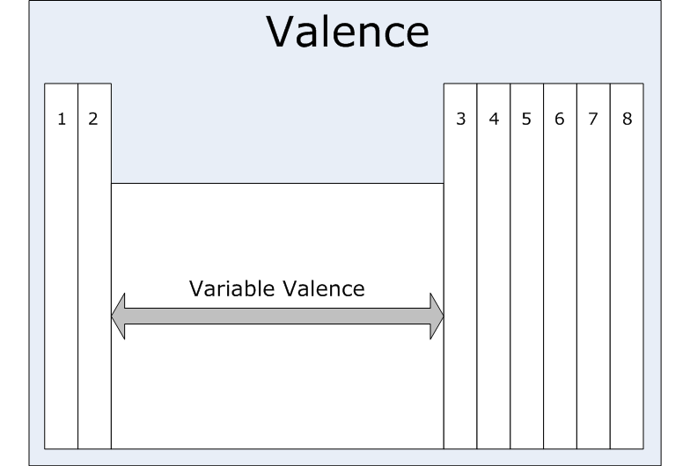

- Example: Oxygen atom
____ P
____ N
8 2-
O
Oxygen
16.0

Example: Sodium atom
____ P
____ N
11 1+
Na
Sodium
23.0

When forming compounds, the key is to make sure that the ion charges cancel (equal 0).

- Example: lithium and fluorine
1-
1+
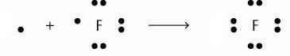
Li

Li

(1+) + (1-) = 0

** Note that for the positively charged cations, there are no electrons drawn in for the Lewis Diagram.

- Example: calcium and chlorine

- Example: magnesium and sulfur

Homework: Ionic Lewis Diagram worksheet

