Bond Energy and Energy in Chemical Reactions

All physical and chemical changes in matter involve ________________________________. During chemical reactions, energy is exchanged between the materials involved in the reaction and the surroundings. All the materials involved in the chemical reactions is called the system.
A ____________________________________ refers to the chemicals that are participating in a reaction.
The ________________________________ are anything that is not part of a chemical system.
Conservation of Energy and Chemical Reactions
Energy cannot be created or destroyed during chemical reactions. The ____________________ ______________________________________ states that the total energy of the universe (system and surroundings) is constant. Therefore, in chemical reactions, energy that __________________ the chemical system must enter the surroundings, and the energy that ____________________ the system must come from the surroundings.
One way of classifying chemical reactions is whether they __________________________ or ____________________________.
Heat represents the ________________________________ from ________________________ to ____________________________. Heat flows from a ________________________ substance to a _____________________________ substance until they reach a new common temperature.
E.g., An ice cube is placed in a drink. Heat flows from the drink to the ice. The result is that the drink cools down and the ice warms up.
Heat transfer is associated with physical processes like melting, freezing, condensing and vaporizing but is also common to ALL chemical reactions.
Some chemical systems release energy to the surroundings and some absorb energy, but all chemical systems require ____________________________ to start the reaction.
The energy needed to start a reaction is called ___________________________________.
Why do all reactions require activation energy?
- Electrons from one particle repel electrons from other particles as they approach. Energy needs to be provided to overcome the electron-to-electron repulsion so that new bonds can be made.
- Sometimes old connections (bonds) between atoms need to be broken before new compounds can be made. The energy needed to break a bond is the ________________ _____________. This is also the amount of energy released when the same bond forms.
Endothermic Reaction
- Heat energy is ________________________ from the surroundings. The reaction will _________________________________.
- The energy required to break existing bonds is ____________________________ than the energy that is __________________________________ when new bonds form.
- Once the reaction has begun, it _____________________________________ energy to be absorbed to keep the reaction going because no excess heat is produced.
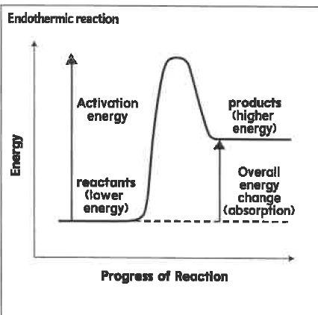
Examples: chemical cold pack,

Exothermic Reactions
- Energy is _________________________ and transferred from the __________________ to the ________________________________.
- The energy released is often in the form of ____________________________________.
- Energy is released because the energy needed to start the reaction is ____________________ than the energy _________________________by the reaction.

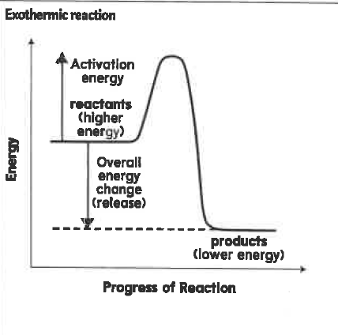

Where does the energy produced come from?
Energy is stored in chemical bonds (potential energy). Breaking bonds require energy to be absorbed while bond formation releases energy.

