Atomic Theory

Review

Classification of Matter

Matter: Anything that has mass and volume.

Properties: The characteristics of a substance.

e.g., colour, density, state at room temperature, etc.

Element: Substance that cannot be chemically separated into simpler substances.

Atom: The smallest unit of matter that retains the properties of a given element.

- Different types of matter are made up of different types or combinations of atoms.

e.g., Cabon dioxide is made by combining 1 Carbon atom with 2 Oxygen atoms. (CO₂)

Atomic Theory
- Atoms are made up of smaller, subatomic particles
 | Symbol | Charge | Location | Relative Mass | Atomic Mass Units
Proton | p | +1 | nucleus | 1836 | 1
Neutron | n | 0 | nucleus | 1837 | 1
Electron | e | -1 | orbits nucleus | 1 | 0*

* Because the mass of electrons is so small compared to the mass of protons and neutrons, they are considered to have a mass of zero; therefore, only the nucleus of an atom is considered to have mass.

Note: Some tables will show the most common charge or charges of an element after they react, but atoms do not have charge before they react so the number of protons = the number of electrons for all atoms.

- Atomic Number = number of protons
- Atomic Mass = # protons + # neutrons
- Nuclear Charge = # protons (since neutrons have no charge)

- Example: Beryllium

Atomic Number = 4 # protons = 4
4 2+
Be
Beryllium
9.0
Atomic Mass = 9 # electrons = 4
Nuclear Charge = 4 # neutrons = 5

*Provide the practice page (Protons, neutrons and electrons )and do several examples together.

Ion – an atom that has acquired a positive or negative charge in a chemical reaction due to a transfer of electrons. Metals tend to lose electrons in a chemical reaction and become positive ions called cations. Non-metals tend to gain electrons and become negative ions called anions.

Charge = number of protons – number of electrons.

*Provide practice page (Ions and subatomic particles)

Periodic Table
- All of the known elements are arranged on the Periodic Table of Elements based on their atomic number in rows (periods).

- Elements within a column (group or family) have common characteristics. For example, all of the elements in family 1 react with water.

- Group #1: Alkali metals. Very reactive metals that form _____+1_____ ion.

- Group #2: Alkaline Earth metals. Reactive metals that form ____+2___ion.

- Group #17: Halogens. Very reactive non-metals that form _____-1_____ion

- Group #18: Noble gases. Non-reactive non-metal gases.

- 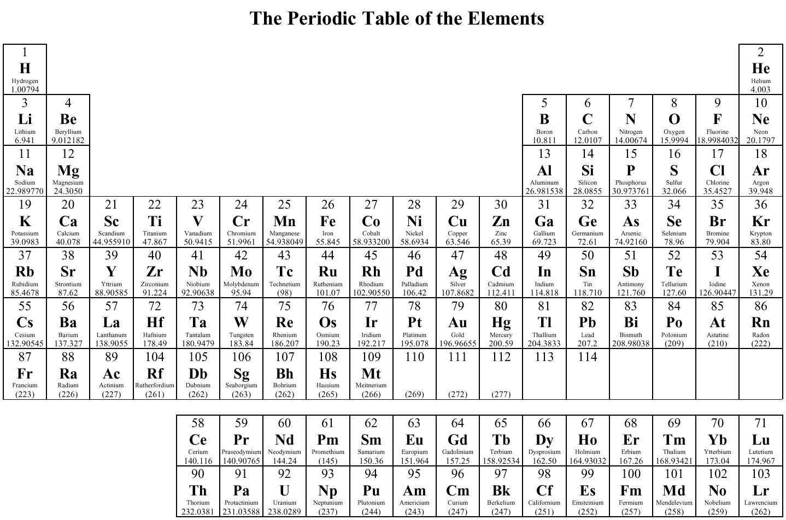
___Columns_____Groups______Families___________

- __Rows____
- __Periods___

- Go over the Periodic Table highlighting:
- Metalloids
- Liquid elements at room temperature
- Gaseous elements at room temperature
- Diatomic elements (We will come back to this later in the course)

Activity Periodic Table Scavenger Hunter (BC Science10 BLM Chapter 4:2-8)
Assignment: worksheets on atom and ions.

