1.4 Deductions and Net Pay

Net pay
benefits
taxable income

Lifestyle Benefits
Some workplaces provide lifestyle benefits to their employees that are connected to the nature of the business or organization. For example, educational institutions may offer free tuition to their employees for courses they offer. What other lifestyle benefits might be offered to employees at a ski resort or a golf course?

You have a 16-week contract as a lift operator at Marmot Basin in Jasper, and you will be working between 12 and 20 hours a week. Your employer offers you a choice in how you are paid: a straight wage of $10.50/h or $8.50/h plus a weekday season pass that has a value of $679.00. Which one would you choose? What factors would you consider in your choice?

Why have deductions?
Pros Cons

Examples:
- John’s group life insurance is 1.5% of his salary of $450.00 every two weeks. How much does he pay for group life insurance?

- Jan had a gross income of $785.00. Her net income was $625.42. What percentage of her gross pay were her deductions?

*Some benefit deductions are not taxable. For example, union dues and pension contributions are not taxable income. To calculate the taxable income, first subtract the dues and pension contributions from the gross pay.

- Alf has a gross income of $852.00 per week. His before-tax deductions include union dues of 2.5% of his gross income and a company pension plan contribution of 3%. His federal tax rate is 16.2% and his provincial tax rate is 5.4%. He pays 4.95% to the CPP and 1.8% for EI. Calculate his net income.

- Consider the following pay statement.
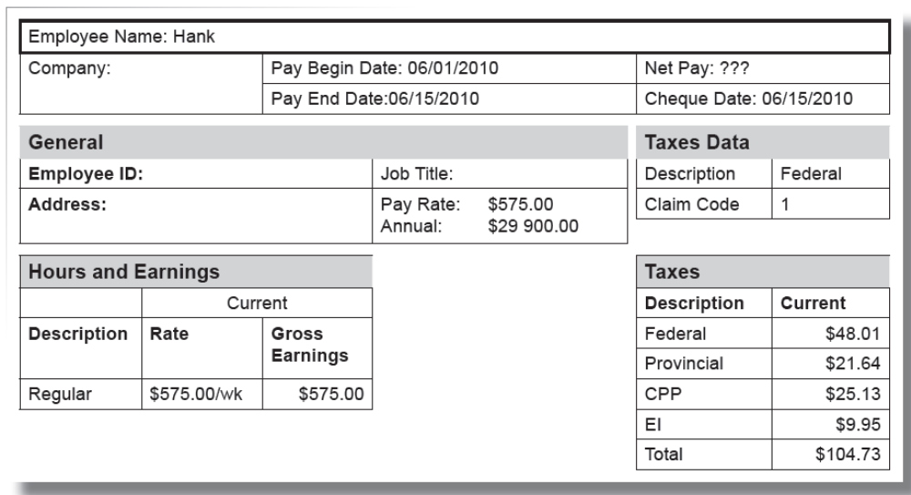

- What is Hank’s gross weekly income?

- What is his net income?

- What percent of his taxable income did he pay in federal taxes?

*You can also use on-line calculators, specialty software, and downloadable tax tables to find the amounts of deductions. Be sure to use the tax tables for the correct pay periods and province/territory that is stated in the question.

- Amanda lives in Smithers, BC and earns $400.00 per week. Her federal claim code is 3 and her provincial claim code is 2. Find her CPP, EI, federal and provincial taxes and Amanda’s net pay for one week of work.

