- For the graph of $f(x)$ shown state:
- the zeros of the function and the minimum multiplicity of each zero.

- the minimum degree of the function

- a possible factored equation of the function

- intervals for which $f\left(x\right)<0$

- intervals for which $f\left(x\right)>0$

- For the graph of $f(x)$ shown state:
- the zeros of the function and the minimum multiplicity of each zero.

- the minimum degree of the function

- a possible factored equation of the function

- intervals for which $f\left(x\right)<0$

- intervals for which $f\left(x\right)>0$

- Sketch the graph of each polynomial function:

- $y={\left(x+2\right)}^{2}\left(x-1\right)(x-2)$
- $y=-x^{3}(x-2)(x-4)$

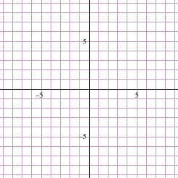

- $y=x^{5}-3x^{4}-x^{3}+7x^{2}-4$

