PreCalc12 Unit 5#2

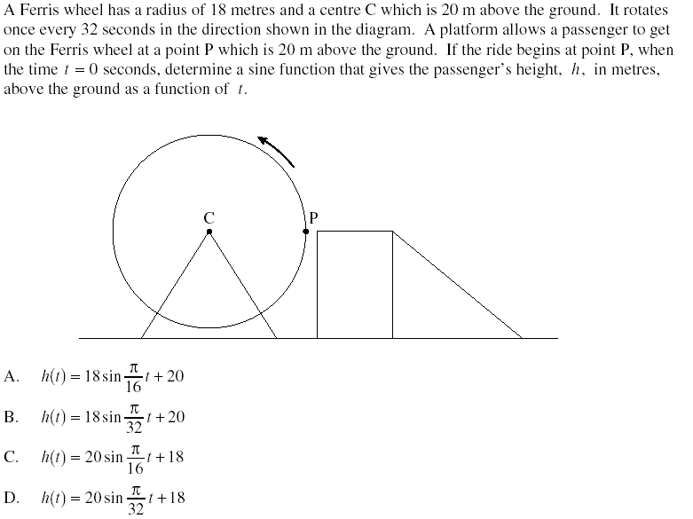
1.

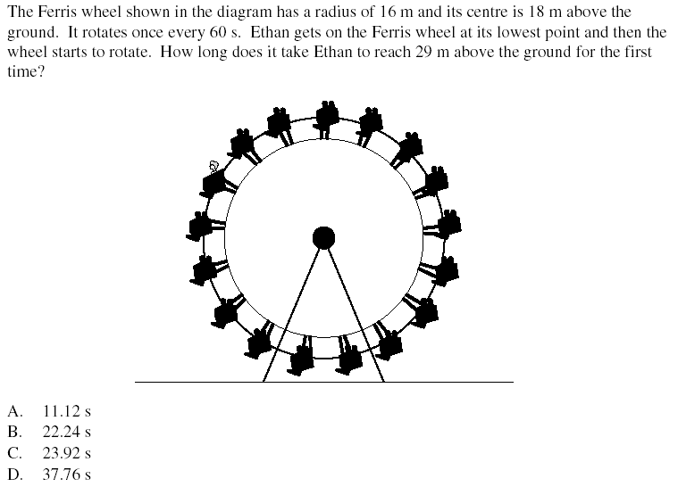
2.

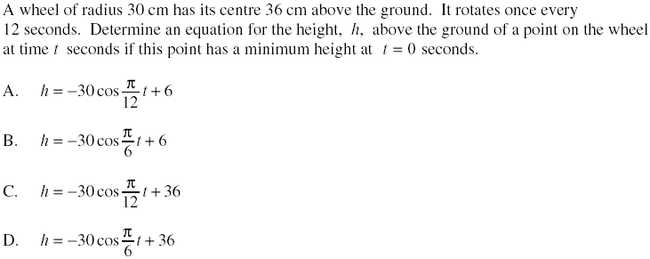
3.

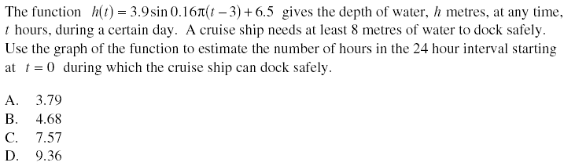
4.

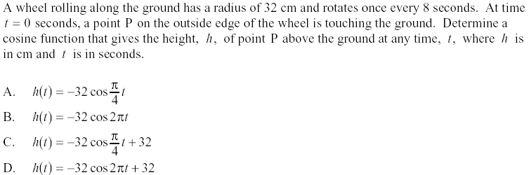
5.

KEY

- A
- B
- D
- D
- C

