Unit 5: Trigonometry & The Unit Circle
5.3 The Tangent Function
*web applets: http://www.univie.ac.at/future.media/moe/galerie/fun2/fun2.html
http://www.ronblond.com/MathGlossary/Division04/TrigCircle/

$P(x, y)$
$\tan{θ}=\frac{y}{x}$
$r=1$
$y$

$θ$ we also know from 4.2 that on the unit circle $P\left(x, y\right)=\left( , \right)$
$x$
Thus, $\tan{θ}=\frac{ }{ }$

When $\sin{θ}=0$, what is $\tan{θ}$?

When $\cos{θ}=0$, what is $\tan{θ}$?

$$θ$$ | 0 | ${ π}/4$ | $${ π}/2$$ | $${ 3π}/4$$ | $$π$$ | ${ 5π}/4$ | $${ 3π}/2$$ | $${ 7π}/4$$ | $$2π$$
$$\tan{θ}$$
$y=\tan{θ}$
* include $\frac{π}{4}$ reference angles in our table.

$∞$ = undefined

At undefined values there are asymptotes: boundary lines that the graph approaches but will never touch/cross. (we dash these asymptotes)

Graph $y=tan$ * $\frac{π}{4}$ scale on $θ$ axis
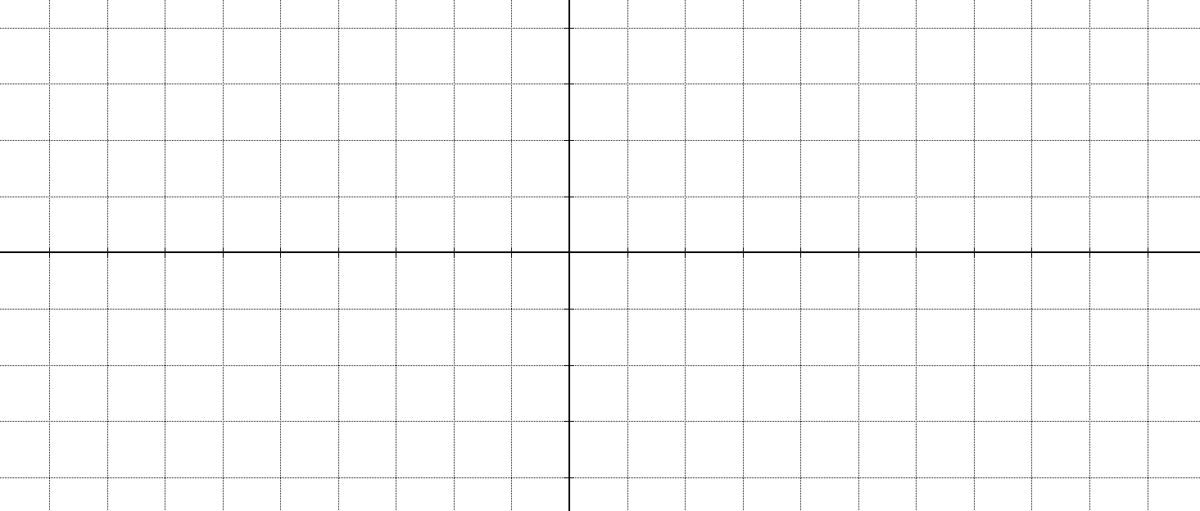

period:
amplitude?
x-intercepts:
asymptotes:
Domain:
Range:

Ex. A small plane is flying at a constant altitude of 6000m directly toward an observer. Assume that the ground is flat in the region close to the observer.
- Determine the relation between the horizontal distance in meters, from the observer to the plane and the angle, in degrees, formed from the vertical plane.


- Sketch the graph of the function.

- Where are the asymptotes located in the graph? What do they represent?

- Explain what happens when the angle is equal to 0°.

