Unit 5: Trigonometry & The Unit Circle
5.2 Transformations of Sinusoidal Functions
recall: $y=\sin{θ}$ $y=cosθ$
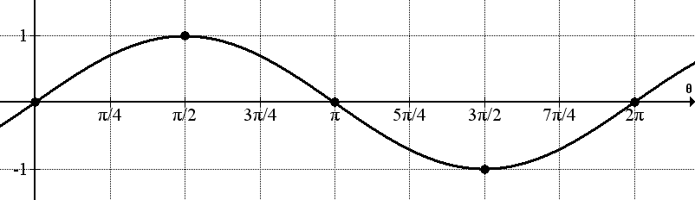
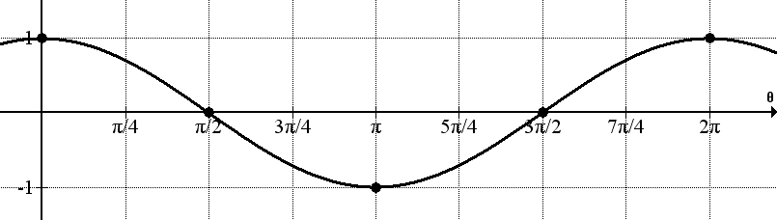

*starts middle$→$max$→$middle$→$min$→$middle *starts max$→$middle$→$min$→$middle$→$max
Vertical displacement (translation): moves the graph up or down.
$y=\sin{θ}+q$ $y=cosθ+q$ *$q=vertical displacement$
Shifts the graph $q$units vertically: $q>0$ translate up $q<0$ translate down
Ex. Sketch each function on the grid below for two periods:

- $y=\sin{θ}+2$
- $y=2\cos{θ-1}$

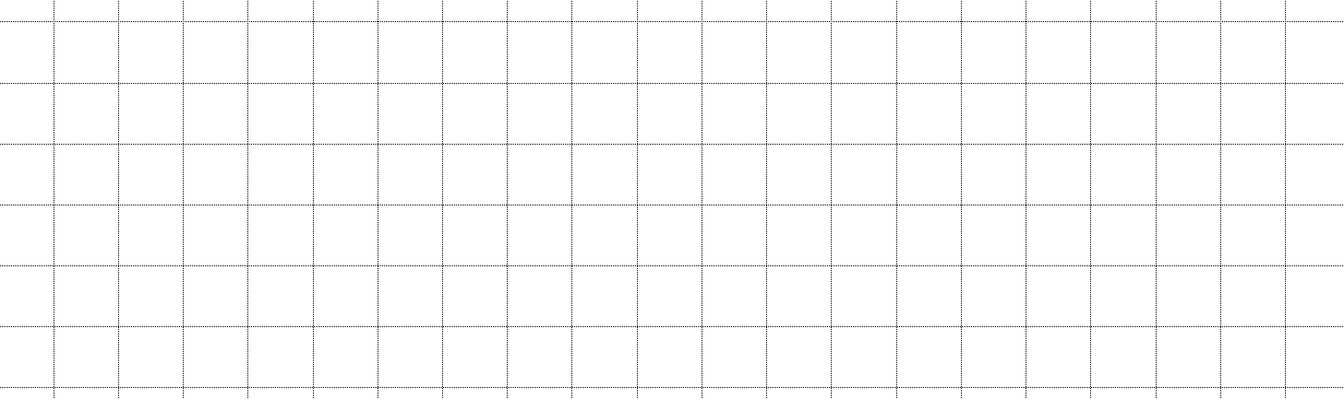

Note: the vertical displacement is always the new middle of the graph
Phase shift (horizontal translation): moves the graph left or right
$y=\sin\left(θ-p\right)$ $y=\cos\left(θ-p\right)$
Shifts the graph $p$ units horizontally: $p>0$ translate right $p<0$ translate left
Ex. Sketch each function for the stated number of cycles on the grid below:

- $y=-cos\left(θ+\frac{π}{3}\right)$; 2 cycles
- $y=\sin{2\left(θ-\frac{π}{2}\right)}$; 3 cycles

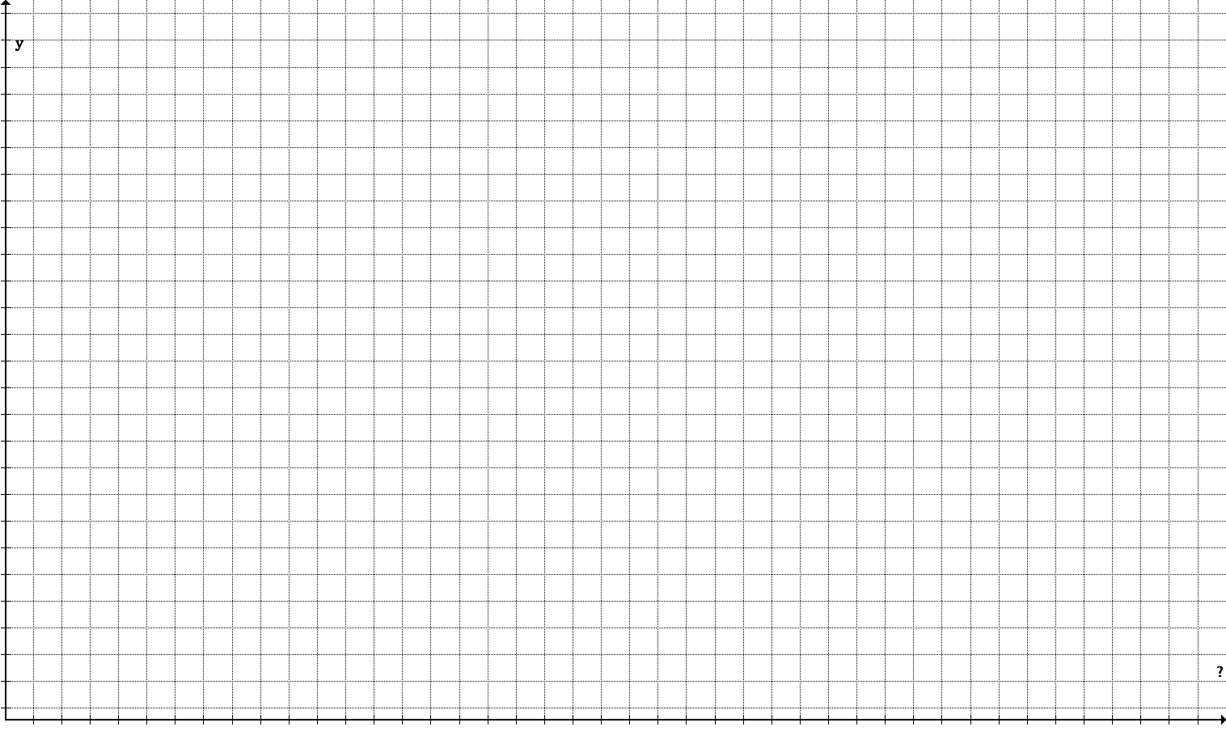

Ex. Sketch the graph of $y=-3\sin{3\left(θ-\frac{π}{4}\right)+1}$ for 3 cycles.
amp $=$_____ $\text{period}=_________$ phase shift $=$_______ vertical displacement $=__________$
$∴range:$ *use a scale that has a common denominator with the period and the phase shift

Ex. Sketch the graph of $y=4\cos\left(\frac{θ}{3}+\frac{π}{2}\right)-2$ for 2 periods.
amp $=$_____ $\text{period}=_________$ phase shift $=$_______ vertical displacement $=__________$
$∴range:$

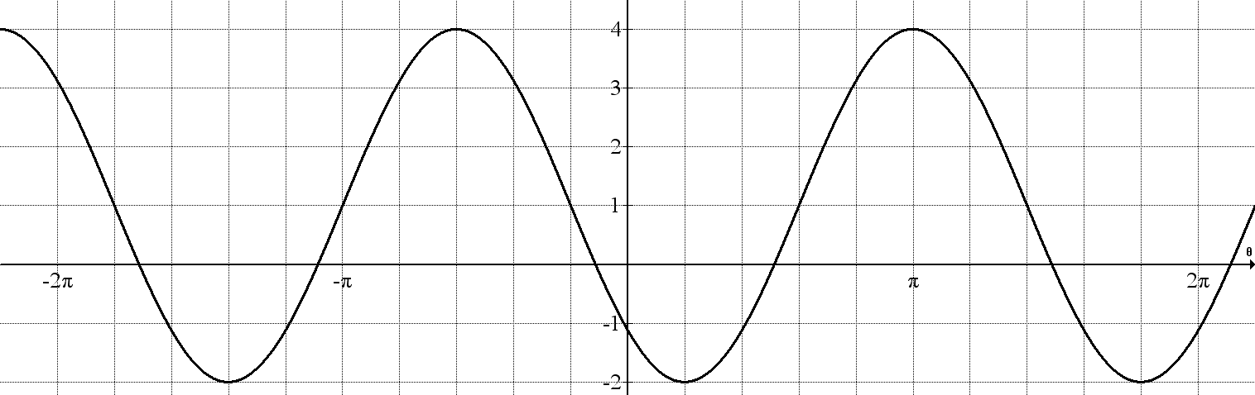
Ex. Determine the equation of the graph shown with minimal phase shift if the function is:

- a sine curve with $a>0$

- a sine curve with $a<0$
- a cosine curve with $a>0$

- a cosine curve with $a<0$

