Unit 5: Trigonometry & The Unit Circle
5.1 Graphing Sine & Cosine Function
*web applets: http://www.univie.ac.at/future.media/moe/galerie/fun2/fun2.html
http://www.ronblond.com/MathGlossary/Division04/TrigCircle/
$y=\sin{θ}$ * $\sin{θ}=\frac{y}{r}$ $y=\cos{θ}$ * $\cos{θ}=\frac{x}{r}$
$$θ$$ | 0 | $${ π}/2$$ | $$π$$ | $${ 3π}/2$$ | $$2π$$
$$\sin{θ}$$
$$θ$$ | 0 | $${ π}/2$$ | $$π$$ | $${ 3π}/2$$ | $$2π$$
$$\cos{θ}$$

Graph $y=\sin{θ}$
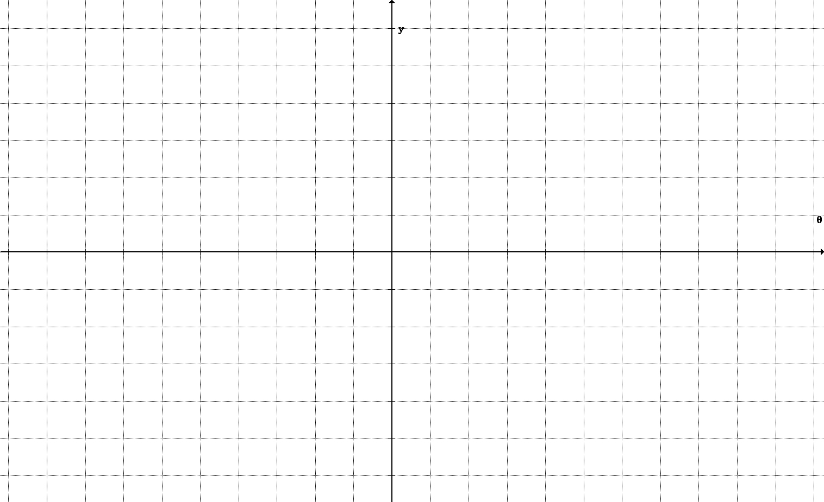

Graph $y=\cos{θ}$

Periodic Function: a function that repeats itself over regular intervals (cycles) of its domain
Period:
• the length of the interval of the domain over which a graph repeats itself
• the horizontal length of one cycle on a periodic graph
The period for both $y=\sin{θ}$ & $y=\cos{θ}$ is __________.
Sinusoidal curve:
• the name given to a curve that fluctuates back and forth like a sine graph
• a curve that oscillates repeatedly up and down from a centre line
Amplitude (of a sinusoidal function): the maximum vertical distance the graph of a sinusoidal function varies above and below the horizontal central axis of the curve
The amplitude for both $y=\sin{θ}$ & $y=\cos{θ}$ is __________.
 | $$y=sinθ$$ | $$y=cosθ$$
Max/Min
Zeros of the function
y-intercept
Domain
Range
The amplitude can be changed by vertically expanding or compressing the graph.
$y=a\sin{θ}$ $y=a cosθ$ *$\left|a\right|=amplitude$
Graph is expanded or compressed vertically $×\left|a\right|$.
$0<\left|a\right|<1 ⟹$ compression $\left|a\right|>1 ⟹$ expansion also: if $a<0 ⟹$ reflection in/over the x-axis

Ex. Sketch the graphs of $y=2\sin{θ}$ and $y=-\frac{1}{2}\cos{θ}$ on the axis below.

By expanding or compressing the graph horizontally the period is changed.
$y=\sin{bθ}$ $y=\cos{bθ}$
Graph is expanded or compressed horizontally $×\frac{1}{\left|b\right|}$
$\text{period }= \frac{\text{original period}}{\left|b\right|}$ * $b≠\text{period}\text{‼}$ $∴$ for sine & cosine: $\text{period }= \frac{\text{2π}}{\left|b\right|}$
Ex. Sketch the graphs of $y=\sin{\frac{1}{2}θ}$ and $y=\cos{2θ}$ on the axis below.

Ex. Sketch the graph of $y=-4sin{3θ}$ on the axis below.

